**NEEM ROOT MEDIATED-BIOSYNTHESIS OF SILVER NANOPARTICLES: ANTIMICROBIAL ACTIVITIES AND APPLICATION AS DETERGENT ADDITIVE**

Adelere, I. A1*., Lateef, A2., Adabara, N. U1., Babayi, H1., and Aboyeji, D. O1.

1Department of Microbiology, Federal University of Technology, PMB 65, Minna, Nigeria

2Department of Pure and Applied Biology, Ladoke Akintola University of Technology, PMB 4000, Ogbomoso, Nigeria

E-mail: isiaka.ade@futminna.edu.ng

**Abstract**

This study reports the biosynthesis of silver nanoparticles (AgNPs) using the aqueous extract of neem root. The synthesis was carried out under ambient conditions by mixing 1mM silver nitrate with the aqueous extract of neem root (10:1) under ambient conditions. Characterization was done by UV- Vis spectroscopy, Fourier transform infrared spectroscopy (FTIR), and scanning electron microscopy (SEM). The antibacterial and algicidal activities of the biosynthesized AgNPs were investigated against some clinical bacterial isolates and a bloom forming cyanobacterial strain, respectively. Their potential application as an antimicrobial detergent additive was also evaluated. The biosynthesized AgNPs displayed maximum absorbance at wavelength 425 nm. The particles are predominantly spherical in shape with size ranging from 20 to 60 nm. Data obtained from FTIR indicated that protein molecules in the extract played very active role in the reduction of silver ions to form AgNPs. The particles demonstrated considerable antibacterial activities against clinical isolates of *E. coli, Streptococcus sp,* and *K. pneumoniae* as they induced inhibition zone of 12-23 mm. The algicidal activity displayed by the particles against the bloom forming cyanobacterial strain was appreciable. Similarly, the incorporation of AgNPs as additive in the locally made detergent led to total inhibition of growth of *E. coli*, *K. pneumonia, Candida* sp, and *A. flavus*. Results obtained in this study therefore suggest the promising applications of the particles as an antimicrobial agent in the water treatment and drug development. The particles also exhibited potential application as an antimicrobial additive in detergent production.

Key words: silver nanoparticles, biosynthesis, antimicrobial activities, algicidal activities, detergent additive

Introduction

Nanobiotechnology is one of the most fascinating technologies in recent times which was developed due to the increasing need to develop efficient, reliable, and environmentally benign process in nanoparticles production and applications. It is a process that involves the use of various biological resources for the production of nanoparticles. It offers advantages like energy efficiency, eco-friendliness, lower production cost, compatibility for very diverse areas of applications such as agriculture, environmental management, biomedical, catalysis, electronics, and in the manufacture of personal care products among others (Keat et al., 2015), as it does not require use of high temperature, organic solvents and toxic chemicals. Further, it also allows production of large quantities of nanoparticles with a defined size and morphology that are also free of contamination. Various biological resources that have been exploited for the synthesis of nanoparticles include bacteria, actinomycetes, fungi, plant extracts and photosynthetic algae (Ahmad et al., 2003; Basavaraja et al., 2008; Asmathunisha and Kathiresan, 2013; Lateef et al., 2015; Adelere et al., 2017).

Plants are highly diverse in nature and their biodiversity have been harnessed for biotechnological applications. They are very rich in natural products like alkaloids, flavonoids, saponins, steroids, tannins and some other nutritionally important compounds. These metabolites are found in various plant parts such as stems, leaves, roots, flowers, barks, and seeds. They are used as reducing and capping agents for the bioreduction of metal ions to produce their correspomding metallic nanoparticles such as silver, copper, gold, palladium, platinum, zinc, and iron (Kuppusamy et al., 2014; Adelere and Lateef, 2016). The potent antimicrobial activities of AgNPs makes it most important and have received unprecedented attentions in recent times. Several authors have reported the synthesis of AgNPs with remarkable antimicrobial activities using a varieties of phyto-metabolites obtained from diverse plant sources (Madhumitha and Roopan, 2013; Devadiga et al., 2015; Lateef et al., 2016; Adelere et al., 2017).

Neem tree (*Azadirachta indica*) is a tropical evergreen tree that belongs to *Meliceae* family which grows rapidly in the tropic and semi-tropic climate. The plant is also capable of surviving in very dry and arid conditions (Liauw et al., 2008). Neem is a large tree growing up to about 25 m height with semi-straight to straight trunk, 3 m in girth and spreading branches forming a broad crown. The plant parts such as fruits, seeds, leaves, bark and roots contain various biomolecules with potent insecticidal, antiseptic, antiviral, antipyretic, anti-inflammatory, antiulcer and antifungal activities (Girish and Shankara, 2008; Dua et al., 2009). This study evaluates the use of aqueous extract of dried neem root for the synthesis of AgNPs and the antimicrobial activities of the synthesized particles were also investigated against some clinical bacterial isolates and a bloom forming cyanobacterial strain. Furthermore, the synthesized AgNPs were evaluated for their potential application as antimicrobial additive in detergent production.

MATERIALS AND METHODS

Collection of neem root and preparation of extract

Fresh neem roots were collected from a farm in Gidan Kwano area of Minna, Niger state Nigeria. The roots were thoroughly washed with clean tap water to remove extraneous materials, chopped into smaller pieces, air dried at ambient conditions (30 ± 2 oC) for two weeks and finally milled into powdery form using electric blender. The root aqueous extract was prepared by dispersing 1 g of the dried neem root sample into 10 ml of deionized water and heated in water bath at 60 ᵒC for 1 h. The extract was centrifuged at 5000 rpm for 20 min and then filtered using Whatman No. 1 filter paper. The filtrate was collected and stored in refrigerator at 4 ̊C for further studies (Adelere et al., 2017).

**Synthesis and characterization of silver nanoparticles**

The aqueous extract of neem root was used for the synthesis of AgNPs following a method described by Lateef et al. (2016) with little modification. Approximately 1 ml of neem root extract was mixed with 10 ml of 1 mM silver nitrate solution (AgNO3) and allowed to stand at room temperature (30 ± 2 oC) for about 3 h. The reaction was visually monitored by observing possible color change due to the reduction of silver ion by the extract for the formation of AgNPs. The control experiment consisted of only aqueous solution of 1 mM silver nitrate was also set up for easy comparison with the test experiment. Preliminary characterization was carried out by determining the absorbance characteristic of the resulting product using UV-vis spectrophotometry analysis.

Fourier transform infrared (FTIR) spectroscopy analysis was carried out on the sample of AgNPs using CRY 630 Spectrophotometer (Agilent Technologies, USA) according to Bhat *et al*. (2011). The AgNPs solution was centrifuged at 10,000 rpm for 20 min, the pellet obtained was freeze dried and mixed with KBr pellets. The mixture was thereafter used for FTIR measurement. Also, the sample was analysed using scanning electron microscopy (SEM) method. A small quantity of AgNPs suspension was air died and the powder obtained was placed on the specimen stub coated with copper and imaged by Phenom ProX scanning electron microscope (PHENOMWORLD, NETHERLAND).

**Antibacterial Activities of Synthesized AgNPs**

Agar well diffusion method was used to evaluate the antibacterial activity of the AgNPs. Clinical bacterial isolates including *Escherichia coli*, *Streptococcus Sp, Klebsiella pnuemoniae* obtained from General Hospital, Minna were used as test organisms. These organisms were cultivated in peptone water and incubated at 37 ̊C for 18 h and then seeded on Mueller-Hinton agar plates. The seeded plates were allowed to stand for about 1hr before creating wells on them by cork borer of 6 mm diameter. Each well was loaded with approximately 50 µl of graded concentration of AgNPs (50 µg ml-1, 100 µg ml-1 and 150 µg ml-1) prepared by dilution with sterile distilled water. The plates were then incubated at 37 oC for 24 h and examined for zone of inhibition which was measure in mm.

**Evaluation of Algicidal Activity of the AgNPs**

The algicidal property of the biosynthesized AgNPs was investigated using the modified method of Chaturvedi and Verma, (2015). Freshwater algae collected from a water logged area of Federal University of Technology, Minna, Bosso Campus was transported in a clean plastic bottle directly to the laboratory for the study. Freshwater algae of 10 ml was measured into McCartney bottle each and 1ml of graded concentration of AgNPs (50 µgml-1, 100 µg ml-1 and 150 µg ml-1) was added. A bottle containing only 10ml of freshwater algae (OD600 0.01) was used for the control experiment. The bottles were allowed to stand close to visible light in a well aerated place and the algal growth in each bottle was measured using UV-vis spectrophotometer on daily basis for 5 days.

Evaluation of antifungal properties of synthesized AgNPs as additive in detergent

The potential application of the synthesized AgNPs as antifungal additive in detergent was investigated by incorporating the AgNPs into the locally made detergent. One litre of a locally made detergent soap purchased from a retailer outlet in Bosso Market, Minna was used for this study. Detergent of 19 ml was dispensed into McCartney bottles, autoclaved at 121 oC for 15 min and thereafter incorporated with 1 ml (150 μg/ml) of biosynthesized AgNPs. After cooling, 0.5ml of 48-h old culture of fungal strains including *Aspergillus niger, Aspergillus flavus* and *Mucor* sp was inoculated each into the bottles. The control experiments consisted of the detergent and test organisms only. The bottles were incubated at 30 ± 2 oC for 48 h, thereafter, 1mL was drawn from the contents of each bottle and inoculated into freshly prepared potato dextrose agar plates using pore plate technque. The plates were then incubated at ambient temperature for 48 h and thereafter observed for growth.

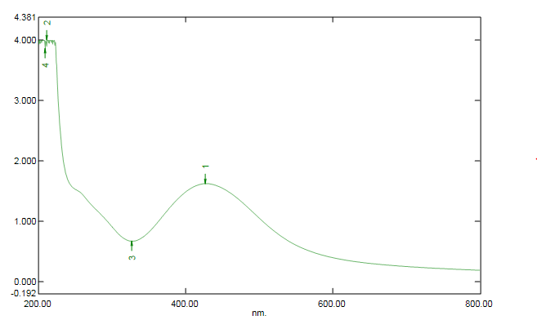

425 nm

Wavelength

absorbance

**Results and Discussion**

The aqueous extract of neem root mediated the synthesis of AgNPs within 15 min under ambient temperature (30 ± 2 oC). The biosynthesized AgNPs exhibited dark yellow coloration after 15 min of reaction which later turned to stable brown about 10 min after (Figure 1) whereas, the control silver nitrate solution showed no color change. Authors have reported variations in the color of previously biosynthesized AgNPs due to the complexity nature of biomolecules. The color formation in AgNPs synthesis is attributed to the excitation of surface plasmon resonance (SPR) on the metallic nanoparticles (Selvi and Sivakumar, 2012). The AgNPs showed maximum UV-vis absorbance at the wavelength of 425 nm (Figure 2) which is within the range of 391-460 nm AgNPs absorbance characteristics earlier reported (Thirumurugan *et al.,* 2011; Zaki *et al.,* 2011; Priyadarshini *et al.,* 2013; Lateef *et al*., 2015; Adelere *et al*., 2017). Creighton *et al*. (1979) affirmed that the UV-vis absorbance characteristics of AgNPs is also the function of their surface plasmon resonance.

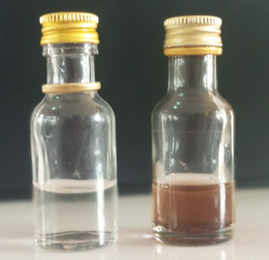

**A**

**B**

Fig. 1: Biosynthesized AgNPs using aqueous extract of neem root: A, silver nitrate solution as control; B, synthesized AgNPs within 25 min.



425 nm

Wavelength

absorbance

Fig. 2: UV-vis absorption spectrum of AgNPs synthesized from aqueous extract of neem root

The FTIR measurement was carried out to identify the possible biomolecules responsible for the capping and stabilization of the synthesized AgNPs. The FTIR spectrum showed peaks at 3268 and 1636 cm-1 (Figure 3). The two bands correspond to N-H bond of amines, and C=C stretch of alkenes or C=O stretch of amides, respectively (Shankar *et al.,* 2014). This is an indication that protein molecules played significant role in capping and stabilization of the AgNPs. Mandal *et* *al*. (2005) reported that proteins are involve in the stabilization and capping of nanoparticles by binding either through their free amine groups or cysteine residues.

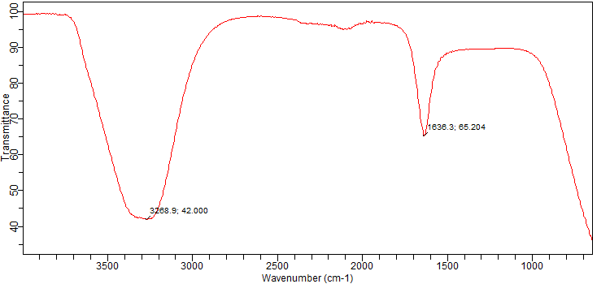

Fig. 3: FTIR spectrum of AgNPs synthesized from aqueous extract of neem root.

The image obtained from the microscopic analysis using SEM showed that the biosynthesized AgNPs were predominantly spherical in shape (Figure 4) with size ranging from 20-60 nm and this corroborate some previously reported findings (Lateef *et al.,* 2015; Adelere *et al.,* 2017). The uniqueness of physico-chemical properties of nanoparticles such as size, morphology and chemical compositions make suitable for diverse areas of application.

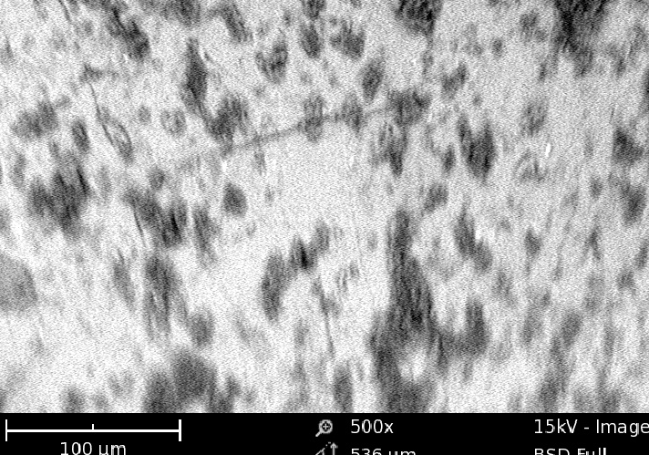

Fig. 4: SEM image of AgNPs synthesized from aqueous extract of neem root

The biosynthesized AgNPs exhibited considerable inhibitory activity against some clinical bacterial isolates (Figure 5). The AgNPs at concentrations of 150 and 100 µg**/**ml remarkably inhibited strains of *Streptococcus* sp, *E. coli*, and *K. pneumoniae*. The maximum and minimum inhibitory activities exhibited were 22 and 10 mm, respectively (Table 1). It is obvious from the data obtained that the antibacterial activity of the synthesized AgNPs is dose dependent as the activity increases linearly with increase in concentration. Moreover, the antibacterial activities as reported herein agree with some results obtained in the previous similar studies (Salem *et al.,* 2014; Lateef *et al.,* 2015; Adelere *et al.,* 2017). Studies have suggested that size, morphology and chemical compositions play active role in the antimicrobial activity of nanoparticles. Moreover, silver ions release from dissociation of AgNPs make them most potent antimicrobial type of nanoparticles as it attack and disrupt cell wall and cytoplasmic membrane through electrostatic attraction (Raffi *et al.,* 2008). Also its affinity for sulphur and phosphorus facilitates the interference with the electron transport chain and destruction of molecules like DNA, lipids and proteins (Feng *et al.,* 2000; Song *et al.,* 2006; Inbakandan *et al.,* 2016). Since AgNPs is capable of attacking many structures in the bacterial cell, hence, it can therefore be suggested to be a suitable alternative for the treatment of infections caused by antibiotic resistance bacterial pathogens.

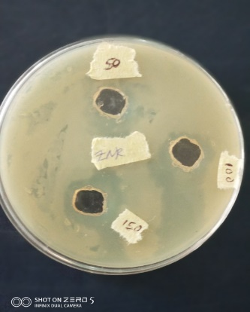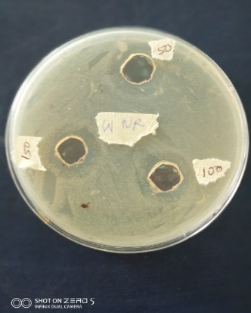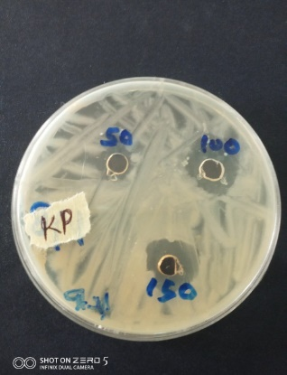

**A**

**B**

**C**

Fig. 5: Antibacterial activities of biosynthesized AgNP against clinical isolates of *Escherichia* *coli* (A), *Micrococcus* sp (B) and *Klebsiella* *pneumoniae* (C)

Table 1: Antibacterial activity of biosynthesized AgNPs and zones of inhibition (mm) against clinical isolates

|  |  |  |
| --- | --- | --- |
| **Organisms** | **Conc. of AgNPs (µg/ml)** | **Zone of inhibition (mm)** |
| *Streptococcus* sp | 150  100  50 | 22  20  17 |
| *E. coli* | 150  100  50 | 19  16  14 |
| *K. pneumoniae* | 150  100  50 | 22  21  10 |

The biosynthesized AgNPs demonstrated algicidal property against a blooming forming cyanobacterial strain. The AgNPs effectively inhibited the growth of cyanobacterial strain in the test experiment while the control test was characterized with profuse algal growth as shown in Figure..and Table...This result corroborates the algicidal activity of a flame of forest mediated AgNPs reported by Chaturvedi and Verma (2015). Similarly, Roychoudhury et al. (2018) recently reported the algicidal activity and DNA binding affinity of AgNPs synthesized from another algal species. Consequently, the exploitation of nanoparticles in controlling algal growth will reduce their adverse environmental problems like odoriferous, unsightly scums, toxicity of water bodies, and eutrophication (Anusha et al., 2017).

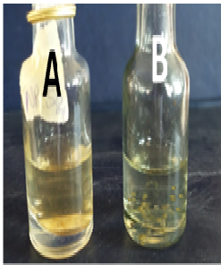

Fig. 6: Algicidal activity of AgNPs against a bloom forming cyanobacterial strain. A, inhibition of algal growth by the synthesized AgNPs: B, algal growth in control experiment without AgNPs after 5 days

Table 2: Algicidal activity of AgNPs

|  |  |  |
| --- | --- | --- |
| **Days** | **Control (OD600)** | **Test (OD600)** |
| 0 | 0.01 | 0.01 |
| 1 | 0.09 | 0.05 |
| 2 | 0.31 | 0.08 |
| 3 | 0.69 | 0.12 |
| 4 | 0.85 | 0.16 |
| 5 | 0.96 | 0.17 |

The evaluation of biosynthesized AgNPs for potential application as detergent additive showed excellent result. The locally made detergent fortified with the AgNPs completely inhibited the growth of microbes including Escherichia coli, Staphylococcus aureus, Aspergillus flavus, and Candida sp. while dense growths were recorded in the control experiments except the E. coli plate that has a very low growth (Fig). The bactericidal and fungicidal activities displayed in the detergent by the AgNPs may be due to the attack of cellular metabolism and nucleic acid molecules by the silver ions released upon dissociation.

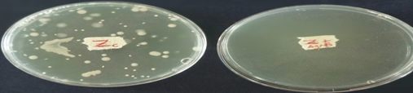

**A**

**B**

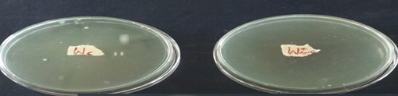

**C**

**D**

Fig. 7: Antibacterial activities of synthesized AgNPs on bacteria inoculated into liquid detergent: A, control plate of S. aureus without AgNPs; B, complete inhibition of S aureus in the detergent by AgNPs; C, control plate of E. coli without AgNPs; D, complete inhibition of E. coli in the detergent by AgNPs.

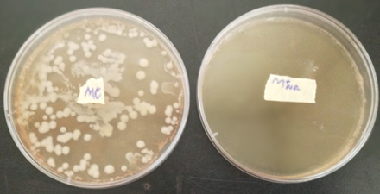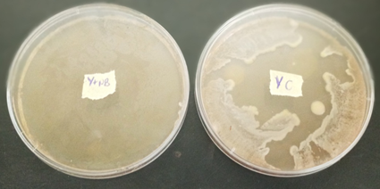

**A**

**B**

**C**

**D**

Fig. 8: Antifungal activities of synthesized AgNPs on fungi inoculated into liquid detergent: A, control plate of Candida sp without AgNPs; B, complete inhibition of Candida sp in the detergent by AgNPs; C, complete inhibition of A. flavus in the detergent by AgNPs; D, control plate of A. flavus without AgNPs

Conclusion

The green synthesis of AgNPs was achieved using the aqueous extract of neem root under ambient conditions. The biosynthesized nanoparticles showed appreciable antibacterial and algicidal activities against some clinical bacterial isolates and a bloom forming cyanobacterial strain, respectively. Also, the particles successfully inhibited microbial growth when used as additive in detergent. Hence, the excellent activities demonstrated by the AgNPs as obtained in this study suggest their potential application in consumer products, medical and environmental management.

References

1. Adelere, I. A., Lateef, A. (2016). A Novel Approach to the Green Synthesis of Metallic Nanoparticles: The use of agro-wastes, enzymes and pigments. *Nanotechnol Review,* **5**(6): 567–587. **DOI:**<https://doi.org/10.1515/ntrev-2016-0024>
2. Adelere, I. A., Lateef, A., Aboyeji, D. O., Abdulsalam, R., Adabara N. U., Bala, J. D. (2017). Biosynthesis of Silver Nanoparticles Using Aqueous Extract of *Buchholzia Coriacea* (Wonderful Kola) Seeds and Their Antimicrobial Activities. *Annals. Food Science and Technology*, **18**(4): 671-679.
3. Ahmad, A., Senapati, S., Khan, M. I., Kumar, R., Ramani, R., Srinivas, V., & Sastry, M. (2003). Intracellular synthesis of gold nanoparticles by a novel alkalotolerant actinomycete, Rhodococcus species. *Nanotechnology*, *14*(7), 824.
4. Anusha, L., Devi, C. S., & Sibi, G. (2017). Inhibition effects of cobalt nano particles against fresh water algal blooms caused by Microcystis and Oscillatoria. *American Journal of Applied Scientific Research*, *3*(4), 26-32.
5. Asmathunisha, N., & Kathiresan, K. (2013). A review on biosynthesis of nanoparticles by marine organisms. *Colloids and Surfaces B: Biointerfaces*, *103*, 283-287.
6. Basavaraja, S., Balaji, S. D., Lagashetty, A., Rajasab, A. H., & Venkataraman, A. (2008). Extracellular biosynthesis of silver nanoparticles using the fungus Fusarium semitectum. *Materials Research Bulletin*, *43*(5), 1164-1170.
7. Bhat, R., Deshpande, R., Ganachari, S.V., Huh, D.O., Venkataraman, A. (2011). Photo-irradiated biosynthesis of silver nanoparticles using edible mushroom *Pleurotus florida* and their antibacterial activity studies. *Bioinorganic Chemistry and Applications,* (2011): 1-7. http://dx.doi.org/10.1155/2011/650979
8. Chaturvedi V., Verma, P. (2015). Fabrication of silver nanoparticles from leaf extract of Butea monosperma (flame of forest) and their inhibitory effect on bloom-forming cyanobacteria. Biores Bioproc **2**(1):18. <https://doi.org/10.1186/s40643-015-0048-6>"
9. Creighton, J. A., Blatchford, C. G., and Albrecht, M. G. (1979). Plasma resonance enhancement of Raman scattering by pyridine adsorbed on silver or gold sol particles of size comparable to the excitation wavelength. *Journal of the Chemical Society, Faraday Transactions* II, **75**: 790-798.
10. Devadiga, A., Shetty, K. V., Saidutta, M. B. (2015) Timber industry wasteteak (*Tectona* *grandis* Linn.) leaf extract mediated synthesis of antibacterial silver nanoparticles. *International Nano Letter,* **5**: 205–214. <https://doi.org/10.1007/s40089-015-0157-4>.
11. Dua, V. K., Pandey, A. C., Raghavendra, K., Gupta, A., Sharma, T., & Dash, A. P. (2009). Larvicidal activity of neem oil (Azadirachta indica) formulation against mosquitoes. *Malaria journal*, *8*(1), 124.
12. Feng, Q. L., Wu, J., Chen, G. Q., Cui, F. Z., Kim, T. N., Kim, J. O. (2000). A mechanistic study of the antibacterial effect of silver ions on Escherichia coli and Staphylococcus aureus. *Journal of biomedical materials research*, **52**(4), 662-668.
13. Girish, K., & Shankara, B. S. (2008). Neem–a green treasure. *Electronic journal of Biology*, *4*(3), 102-111.
14. Inbakandan, D., Kumar, C., Bavanilatha, M., Ravindra, D. N., Kirubagaran, R., Khan, S. A. (2016). Ultrasonic-assisted green synthesis of flower like silver nanocolloids using marine sponge extract and its effect on oral biofilm bacteria and oral cancer cell lines. *Microbial pathogenesis*, **99**, 135-141. doi: 10.1016/j.micpath.2016.08.018.
15. Keat, C. L., Aziz, A., Eid, A. M., Elmarzugi, N. A. (2015). Biosynthesis of nanoparticles and silver nanoparticles. *Bioresour. Bioprocess,* **2**: 47. https://doi.org/10.1186/s40643-015-0076-2.
16. Kuppusamy, P., Yusoff, M. M., Maniam, G. P., Govinda, N. (2016). Biosynthesis of metallic nanoparticles using plant derivatives and their new avenues in pharmacological applications – an updated report. *Saudi Pharmaceutical Journal,* **24**: 473–484. <https://doi.org/10.1016/j.jsps.2014.11.013>.
17. Lateef, A. Adelere, I. A., Gueguim-Kana, E. B., Asafa, T. B., Beukes, L. S. (2015). Green synthesis of silver nanoparticles using keratinase obtained from a strain of *Bacillus safensis* LAU 13. *International Nano Letter,* **5**: 29-35. https://doi.org/10.1007/s40089-014-0133-4.
18. Lateef, A., Azeez, M. A., Asafa, T. B., Yekeen, T. A., Akinboro, A., Oladipo, I. C., Azeez, L., Ojo, S.A., Gueguim-Kana, E.B., Beukes, L.S. (2016). Cocoa pod husk extract-mediated biosynthesis of silver nanoparticles: its antimicrobial, antioxidant and larvicidal activities. *Journal of Nanostructure and Chemistry,* **6***:* 159–169. <https://doi.org/10.1007/s40097-016-0191-4>.
19. Liauw, J., Hoang, S., Choi, M., Eroglu, C., Choi, M., Sun, G.H., Percy, M., Wildman-Tobriner, B., Bliss, T., Guzman, R.G. and Barres, B.A. (2008). Thrombospondins 1 and 2 are necessary for synaptic plasticity and functional recovery after stroke. *Journal of Cerebral Blood Flow & Metabolism*, *28*(10), 1722-1732.
20. Madhumitha, G., Roopan, S. M. (2013). Devastated crops: multifunctional efficacy for the production of nanoparticles. *Journal of Nanomaterial.* Article ID 951858, doi: 10.1155/2013/951858.
21. Mandal, S., Phadtare, S., Sastry, M. (2005). Interfacing biology with nanoparticles. Current Applied Physics, 5:118-127.
22. Priyadarshini, S., Gopinath, V., Priyadharsshini, N. M., Ali, D. M., Velusamy, P. (2013). Synthesis of anisotropic silver nanoparticles using novel strain, *Bacillus flexus* and its application. *Colloids and Surfaces B: Biointerfaces,* **102**: 232-237. doi: 10.1016/j.colsurfb.2012.08.018.
23. Raffi, M., Hussain, F., Bhatti, T. M., Akhter, J. I., Hameed, A., Hasan, M. M. (2008). Antibacterial characterization of silver nanoparticles against E. coli ATCC-15224. *Journal of materials science and technology*, **24**(2), 192-196.
24. Roychoudhury, P., Bose, R., & Pal, R. (2018). Algicidal activity and DNA binding affinity of silver nanoparticle-biofabricated by green alga, Rhizoclonium riparium. Journal of Algal Biomass Utilization, 9(1): 67-77.
25. Salem, W. M., Haridy, M., Sayed, W. F., Hassan, N. H. (2014). Antibacterial activity of silver nanoparticles synthesized from latex and leaf extract of Ficus sycomorus. *Industrial Crops and products*, **62**, 228-234. <https://doi.org/10.1016/j.indcrop.2014.08.030>
26. Selvi, K. V., Sivakumar, T. (2012). Isolation and characterization of silver nanoparticles from *Fusarium oxysporium. International Journal of Current Microbiology and Applied Science,* **1**(1): 56-62.
27. Shankar, S., Jaiswal, L., Aparna, R. S. L. Prasad, V. (2014). Synthesis, characterization, in vitro biocompatibility, and antimicrobial activity of gold, silver and gold silver alloy nanoparticles prepared from *Lansium domesticum* fruit peel extract. *Material Letters,* **137**: 75-78. <https://doi.org/10.1016/j.matlet.2014.08.122>
28. Song HY, Ko KK, Oh LH., Lee BT. Fabrication of silver nanoparticles and their antimicrobial mechanisms. *Euro Cells and Materials,* **11**(2006): 58. DOI: 10.5772/intechopen.74623.
29. Thirumurugan, A., Tomy, N.A., Kumar, H.P., Prakash, P. (2011). Biological synthesis of silver nanoparticles by *Lantana camara* leaf extracts. *International Journal of Nanomaterials and Biostructures,* **1**(2): 22–24. <https://doi.org/10.1155/2019/8642303>.
30. Zaki, S., El-Kady, M.F., Abd-El-Haleem, D. (2011). Biosynthesis and structural characterization of silver nanoparticles from bacterial isolates. *Materials Research Bulletin,* **46**: 1571–1576. <https://doi.org/10.1016/j.materresbull.2011.06.025>.