INTEGRATED GEOLOGY, MINERALOGY AND GEOCHEMISTRY INVESTIGATIONS OF THE MINNA-TEGINA-MAKERA ROAD NORTH WESTERN NIGERIA: IMPLICATION ON FAILED PORTION

**\*Alabi A. A., Unuevho C., Jimoh M. O., Akande W. G., Ejepu S. J., Asema A. I.**

Department of Geology Federal University of Technology

*Corresponding author: [alabiadekola@futminn.edu.ng](mailto:alabiadekola@futminn.edu.ng)

GSM No. 08064326403

ABTRACT

Minna - Tegina - Makera federal road links the north to the southwest and serve as major route for transportation of goods and services. The road has been repaired severally, but continues to fail at particular portion a short time after repair. This study therefore integrated geology, mineralogy and geochemistry to investigate the cause of the failure. The area is underlain by basement and sedimentary rocks of varying texture, mineralogy and geochemistry. The stable portion is underlain by granite-gneiss, granites, amphibolites schist quartz schist and sandstone while the failed road sections are underlain by mica schist, phyllite and coarse grain granite It is evidently clear from this finding that low grade metasedimentary rocks constitute the foundation of the failed section, the presence of clayey and sandy (weathered product) and interaction with climate have contributed to road failure witnessed on the study road section.

1.0 INTRODUCTION

Roads in Nigeria are constructed on monotonous basement and sedimentary terrains with failed portions been attributed to inadequate engineering study and poor construction materials. Shear strength, compaction and compressibility studies have shown that basement and sedimentary rocks could respond considerably to stress and environmental influence as a result of their variation in mineralogical and chemical composition. The understanding of the lithology of the underlying parent rocks and soils used in the construction of road play important role in the stability and performance of any road. However, bad portion of roads are as a result of incompetent base materials and basement rocks or poor construction. This is responsible for fatal road carnage, wearing down of vehicles and waste of valuable time during transportation of goods and services.

Adewoye *et al*., (2012) attributed the failure of Oyo – Ogbomoso federal road to environmental factors, while Osinowo (2011) identified anomalous low resistivity zone and delineated major and minor linear fractures that aid in the interaction of water with basement rocks and greatly reduced the base-rock and subsoil shear strengths resulting into incessant road carnage. Akintorinwa *et al.* (2011) studied the cause of road failure along Ilesa – Akura highway using remotely sensed and geotechnical data and concluded that linear (geological) features are zone of weakness that enhance the accumulation of water leading to failure of some segments in the study road. Integration of geological, mineralogical and geochemical investigation of the underlying parent rocks to compliment geotechnical study in foundation engineering problems cannot be overemphasized. This study therefore integrated geology, mineralogy and geochemistry to investigate the cause of failure of Minna - Tegina - Makera federal high way north western Nigeria.

2.0 LOCATION AND GEOLOGY OF THE STUDY AREA

The Minna - Tegina - Makera federal road is located within Latitudes 9° 10'N - 10° 05'N and 4° 50'E - 6̊° 10'E, and is approximately 155 kilometers long trending in southeast – northwest and northwest-southwest directions (Figure 1) and underlain by Precambrian Basement Complex of northwestern Nigeria and Cretaceous sedimentary rocks of the Bida basin. The basement rocks occur in the southern and northern part of the study area and falls within the Ushama and Birnin Gwari formations while the sedimentary rock is to the northeast and falls within the Bida sandstone formation. The Birnin Gwari formation is composed of metamorphosed clastic sedimentary rocks, mainly phyllites and mica schist with which metagreywackes, pebbly occur as fragments. The phyllites are finely laminated which is defined by alternation of quartz-rich and sericite/chlorite-rich layers that vary in width from 0.5 millimeters to 5 millimeters, while the Ushama formation is consist of mica schist, quartz schist, and quartzite with some amphibolites layers composed of quartz, muscovite, biotite and plagioclase (Ajibade, *et al* 2008). Alabi (2016) identified the presence thin beds of kaolinitic clay overlain by lateritic soil and sandstone/ferruginous sandstone within the Bida sandstone formation, and suggest basement provenance of the kaolinitic clay.



Figure 1: The study road network extracted from Nigeria road network (Reuben, 1978).

**3.0 RESEARCH METHODOLOGY**

Geological mapping was carried in the study area with more emphasis on outcrops along the study road network. All the rock types encountered were studied in hand specimen for their mineralogy composition, texture, structure, color and their relationship with each other. Rock samples were obtained at different locations (stable and failed road sections) using geological hammer and their coordinate recorded. Ten representative basement rock and two representative sedimentary rock samples from the study area were taken to the laboratory at the Department of Geology, Federal University of Technology Minna and prepared for whole-rock chemical analyses and rock mineral analysis. The samples were broken into smaller pieces using geologic hammer, crushed using jaw crusher and pulverizedusing using FRITSCH Pulverisette. Pulverized rock samples of 7. 5grams that pass through 20 mesh for mineralogical and geochemical analysis, using X-ray Diffraction (XRD) and Inductively Coupled Plasma mass spectrometry (ICP-MS) methods at Activation Laboratory Ontario, Canada.

**4.0 RESULTS AND DISCUSSION**

**4.1 Geology and Mineralogy**

The rock types along the study road network includes; granite-gneiss, medium grain biotite and muscovite granite, phorphyritic granite, mica schist, amphibolites schist quartz schist phyllite and sandstone as revealed through geological mapping (Figure 2).



Figure 2: Geological map of the study area showing the studied road network

The rock that underlain the stable road sections are made up of granite-gneiss, granites, amphibole schist and quartz schist and sandstone while the failed road sections are underlain by mica schist, phyllite and coarse grained granite (Fig. 4). Structurally, most of the granites are open jointed (Figure 3) and in some areas dissected by quartzo-feldspartic veins. The granitic rock underlies about 45% of the study area while phyllite, schist and smphibolite schist are about 45% and sandstone 5%. Schist is strongly foliated ranging from muscovite schist to biotite schist, trending in NE - SW and occurred mostly in the northern section of the study road network. In hand specimen the schist varies from leucocratic to melanocratic, the leucocratic show effects of chemical weathering (Figure 5). Amphibolite schist occurred in Zungeru inter-layered with quartz schist and mylonite, this rock is restricted to Zungeru area and a times seen intruding the schist (Figure 6). Phyllite are also common in the northeast and northwest sections of the study area and are closely associated with schist, characterized by a silky sheen on the cleavage surface and show evidence of intensive weathering at the surface where they outcrop. Field evidence along the study road network show that the failed road section is underlies by mica schist, porphyritic granite and phyllite. The fairly stable section is underlain by granite while the stable section is underlain by medium graine granite/granite-gneiss, amphibolite schist and sandstone.

**4.2 Mineralogy**

X-ray diffraction patterns of the basement rocks samples indicate predominance presence of quartz, biotite, muscovite, feldspar, and actinolite (Plate 9a – i) while quartz, kaolinite, muscovite and anatase for sandstone/mudstone (Plate 9j). Percentage mineralogical composition of granitnitic rocks from XRD result shows average composition of 33.5% quartz, 28.3% feldspar and 21.06% actinolite, muscovite schist show average composition of 31.9% quartz, 30.3% feldspar and 22.4% muscovite while muscovite schist show 33.1% quartz, 47.1% feldspar and 19.2% muscovite. Amphibolite schist shows 31.9% quartz, 27.1% feldspar and 21.06% actinolite. Phyllite shows average mineralogy composition of 44% quartz, 57% feldspar and 21% muscovite. Sandstone/mudstone shows average composition of 75% quartz, 22.1% Kaolinite, 2.2% muscovite and anatase 2.5%.

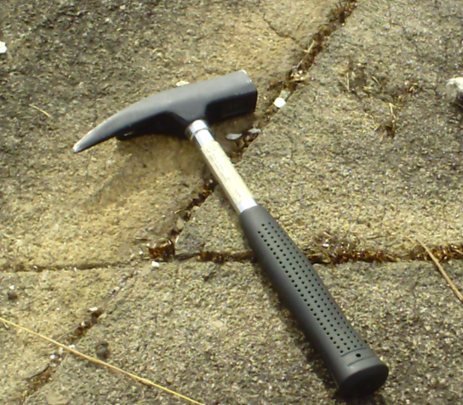 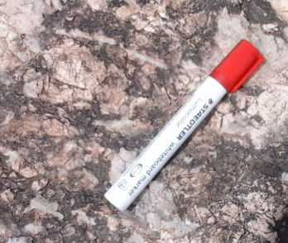

Figure 3: Jointed granite in Maikunkele area Figure 4: Coarse grain granite in Gobarawa

area

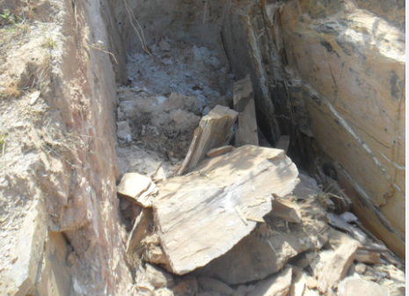

Figure 5: Weathered Leucocratic schist Figure 6: intruded amphibolites

Percentage mineralogical composition of the rocks that underlain the failed section revealed high proportion of feldspar minerals (microcline, orthoclase and albite) ranging between 30.3% and 57%, and quartz ranges between 32.1% and 34.9% (Table 1). The high feldspar content of these rocks coupled with the interaction of water will facilitate the chemical weathering of these rocks that may eventually yield clay minerals.

Table 1: Percentage mineralogical composition of Basement Complex and sedimentary rock in the

study area

|  |  |  |  |  |  |  |  |  |  |  |  |  |  |
| --- | --- | --- | --- | --- | --- | --- | --- | --- | --- | --- | --- | --- | --- |
| **Location** | **1** | **2** | **3** | **4** | **5** | **6** | **7** | **8** | **9** | **10** | **11** | **12** | **Total** |
| Granite (Maikunkele) | 33 | 15 | n.d | n.d | 12.8 | n.d | n.d | 23.5 | n.d | 15.5 | n.d | n.d | 99.8 |
| Muscovite schist (Beji) | 33.4 | n.d | 19.2 | 23.9 | n.d | n.d | n.d | 23.4 | n.d | n.d | n.d | n.d | 99.9 |
| Muscovte schist (Kodo) | 32.1 | n.d | 18.8 | 28.5 | n.d | n.d | n.d | 20.6 | n.d | n.d | n.d | n.d | 100 |
| Muscovite schist (Tegina 1) | 33.6 | n.d | 26.1 | n.d | n.d | n.d | n.d | 40.3 | n.d | n.d | n.d | n.d | 100 |
| Muscovite schist (Gobrwa2) | 38.1 | n.d | 32.2 | n.d | n.d | n.d | n.d | 29.5 | n.d | n.d | n.d | n.d | 99.8 |
| Ampbibolite (Zungeru 2) | 17.5 | 13 | n.d | n.d | 34.4 | n.d | n.d | 34.9 | n.d | n.d | n.d | n.d | 99.8 |
| Phyllite (Zungeru 1) | 34.9 | 21.0 | n.d | n.d | nd | 23.6 | n.d | 20.4 | n.d | n.d | n.d | n.d | 99.9 |
| Granite (Gobarawa ) | 32.5 | n.d | n.d | n.d | 20.6 | n.d | n.d | 27.9 | 18.8 | n.d | n.d | n.d | 99.8 |
| Granite gniess (Tegina 2) | 48.2 | 20.8 | n.d | n.d | nd | n.d | n.d | 20.9 | n.d | n.d | n.d | n.d | 99.9 |
| Gniess mylonite (Zungeru3)  Sandstone (Masheigu)  Sandstone (Makera) | 38.3  73.4  74.8 | n.d  n.d  n.d | n.d  2.1  2.2 | n.d  n.d  n.d | 27.8  n.d  n.d | n.d  n.d  n.d | 7.8  n.d  n.d | 25.9  n.d  n.d | n.d  n.d  n.d | n.d  n.d  n.d | n.d  21.2  20.1 | n.d  n.d  2.5 | 99.8  99.6  99.6 |

1= Quartz 2= Biotite 3=Muscovite 4= Microcline 5= Actinolite 6= Othorclase 7= Chalcopyrite 8=Albite 9=Cordierite

10=Iron magnesium aluminium silicate hydroxide n.d=not detected 11= Kaolinite 12=Anatase

**4.3 Geochemistry**

The results of the geochemical analysis (expressed in weight percentage) of the rocks from the study road network is presented in Table 2, which aided in the calculation and binary plots of the provenance and weathering intensity.

The chemical composition of the rock samples are direct reflection of the percentage composition of the rocks in the study area. Granite, Gneiss mylonite and granite gneiss are characterized by SiO2 in the range of 62.93% and 71.78%, the schist and phyllite in the range of 58.66% and 43.94%, while amphibolite schist is 49.12%. The relative enrichment of Al2O3 (17.08 – 17.20%), Na2O and K2O in mica schist is an indication of it felsic character, feldspar and mica enrichment. The Fe2O3 and MgO enrichment in amphibolite schist and gneiss mylonite reflects mafic character of these rocks. The sandstone is enriched in SiO2 of 74.1% average composition, 20.1% kaolinite, 2.2% muscovite and 2.5% anatase.

Table 2: Major oxides in wt% of Basement rocks in the study area

|  |  |  |  |  |  |  |  |  |  |  |
| --- | --- | --- | --- | --- | --- | --- | --- | --- | --- | --- |
| Oxides | Mk | Bj | Kod | Zn1 | Zn 2 | Zn 3 | Teg 1 | Teg 2 | Mak1 | Gob 1 |
| SiO2 | 68.77 | 57.68 | 58.66 | 43.94 | 49.12 | 61.93 | 51.01 | 69.94 | 71.78 | 62.93 |
| Al2O3 | 14.59 | 17.08 | 17.19 | 17.20 | 15.20 | 13.09 | 13.45 | 14.60 | 15.26 | 17.09 |
| Fe2O3 | 4.71 | 7.70 | 7.81 | 11.63 | 14.63 | 3.52 | 3.43 | 3.51 | 0.82 | 5.15 |
| CaO | 1.99 | 0.24 | 0.24 | 0.68 | 10.18 | 3.03 | 9.75 | 1.58 | 1.27 | 0.03 |
| MgO | 2.17 | 3.15 | 3.15 | 8.90 | 10.90 | 10.51 | 5.09 | 0.94 | 0.13 | 1.51 |
| Na2O | 3.66 | 0.19 | 0.19 | 3.17 | 3.34 | 3.34 | 2.39 | 3.52 | 3.94 | 2.84 |
| K2O | 2.53 | 4.76 | 4.76 | 6.41 | 3.16 | 2.14 | 6.44 | 4.76 | 5.43 | 2.14 |
| MnO | 0.06 | 1.38 | 0.38 | 0.22 | 0.13 | 0.41 | 0.06 | 0.06 | 0.02 | 0.10 |
| TiO2 | 0.51 | 1.85 | 1.55 | 1.71 | 1.18 | 0.68 | 1.58 | 0.49 | 0.07 | 1.98 |
| P2O5 | 0.14 | 0.04 | 0.04 | 0.04 | 0.14 | 0.12 | 0.03 | 0.14 | 0.02 | 0.05 |
| Cr2O3 | 0.065 | 0.036 | 0.036 | 0.133 | 0.003 | 0.064 | 0.052 | 0.052 | 0.068 | 0.064 |
| LOI | 0.66 | 5.99 | 5.99 | 6.09 | 6.09 | 1.38 | 6.44 | 0.48 | 0.50 | 6.38 |
| TOTAL | 99.86 | 100 | 99.99 | 100.1 | 99.27 | 100.2 | 100 | 100 | 103 | 99.81 |

Mk = Medium grained granite in Maikunkele area Teg 2 = Granite gneiss from Tegina area

Zn1 = Phyllite around Zungeru area Gob1 =Muscovite schist around Makera area

Kod = Muscovite schist around Kodo area Teg 1 = Mica schist around Zungeru area

Bj = Muscovite schist around Beji area Zun 3= Gneiss mylonite around Zungeru area

Zn 2 = Muscovite schist around Kodan area

Mak = Sandstone around Makera area

Geochemical binary plot of Na2O/Al2O3 versus K2O /Al2O3 show that the mica schist, phyllite and amphibolite schist are of sedimentary provenance while granite and granite gneiss are of igneous provenance (Figure 7).



Figure 7: Na2Oversus K2O plot for study area rocks (after Garrels and Mackenzie, 1971)

Weathering intensity of igneous and metamorphic rocks in humid climatic region can be determine using Ruxto Ratio (SiO2/ Al2O3) proposed by Ruxton (1968). He proposed Ruxton Ratio value of <3.8 for intensively weathered rocks, 4 – 4.5 moderately weathered rocks and >4.5 least weathered rocks. The Ruxton Ratio values of between 2.6 – 3.7 revealed the mica schist of Tegina, Makera, Kodo, Beji, Zungeru phyllite and Zungeru amphibolite schist to have been intensively weathered and constituted the underlying basement rocks of the failed sections of the study road networks while values of between 4.7 – 4.8 revealed the granite/granite gneiss of Maikunkele, Tegina, and Zungeru mylonte to be of least weathered intensity constituted the underlying basement rocks of the stable section of the study road networks (Figure 8). Combined field evidence, provenance study and weathering intensity result shows that the meta-sedimentary rocks are of low grade metamorphism and have been intensively weathered while the meta-igneous rocks are more stable and resistant to chemical weathering. Weathering processes penetrate down discontinuities (planes of weakness), such as faults and joints, in the metasedimentary rock mass and then attack the faces, corners and edges of the joints in rock, which produces flakes of clay and sand. As the weight of cars and trucks pass over the weak spot (clay and sand) along the study road, pieces of the weathered material is weaken and cause the material to be displaced or broken down due to vehicle over weight, creating potholes. Interaction of weathered materials (clay and sand) with water and frequent movement of cars and trucks causes the enlargement of potholes that resulted in total failure of the road section.

The stable section of the study road that falls within the Bida Formation of Bida basin is composed of sandstone and lateritic soil, that are formed by in-situ leaching of sediments and precipitate quartz grain as sandstone while the leaching of soluble ions leaves the more [insoluble](https://en.wikipedia.org/wiki/Solubility#Solubility_of_ionic_compounds_in_water) ions, predominantly Kaolinite, iron and aluminium that precipitate of iron aluminum hydroxide as laterite.

Sandstone is more resistant to water influence and chemical weathering compared to rocks composed of silicates. Some clays generally influence swelling of weathered geological materials, the presence of thin layer of kaolinite a non-swelling clay minerals in the sedimentary section of the study road does not have any swelling impact on the road. Also, diagenesis processes (compaction and cementation) influenced harding of the sandstone and thus make the road on the sedimentary section stable.

Figure 8: Weathering Intensity for study area (after Ruxton, 1968)

**5.0 Conclusion**

In this study, combined mineralogy and geochemical evaluations of the monotonous basement rocks and sandstone has been used to investigate the cause of road network failure along Minna – Tegina - Makera road, northwestern Nigeria. Results from this study identified the meta-sedimentary rocks which are of low grade metamorphism, enriched in feldspar minerals to underlie the failed sections of the study road network and meta-igneous rocks underlying the stable sections. The enrichment of feldspar combined with foliation, joints in the rocks and humid climatic condition promote the weathering of the meta-sedimentary rocks that lead to intensive weathering of these rocks and cause the failure of sections of the study road network and road carnage of various degree. Effort to maintain the study road section by government agency have not yield any result because the maintenance carried out was approached wrongly. It is evidently clear from this finding that low grade metasedimentary rocks constitute the foundation of the failed section, the presence of clayey and sandy (weathered product) and interaction with climate have contributed to road failure witnessed on the study road section.

In the light of this study, the failed portions of the study road need serious engineering attention. Excavation to fresh basement is required and filling with competent rocks to serve as basement and prevent persistent failure of this road.

**REFERENCES**

Adewoye, A. O., Adegbola, A. A., Bolaji, A. A. and Opebiyi, D. F. (2012). Engineering Properties of Foundational Materials of Oyo Ogbomoso Road, in Southwestern Nigeria: *Science Focus* 9: 42-47.

Ajibade, A.C., Anyanwu, N.C.P., Okoro, A.U., and Nwajide, C.S. (2008). The geology of Minna area. *Nigeria Geological Survey Agency Bulletin* No. 43.

Alabi, A. A (2016). Geology, Mineralogy, Geochemical Charaterization And Provenance

Study of Clay Occurrences In Central Bida/Niger Basin, Central Nigeria (Unpublishe

Ph.D Thesis), Ahmadu Bello Universitt Zaria, Nigeria.

Akintorinwa, O. J., Ojo J. S. and Olorunfemi M. O. (2011) Appraisal of the causes of Pavement Failure Along The Ilesa - Akure Highway, Southwestern Nigeria Using Remotely Sensed and Geotechnical Data. *Ife Journal of Science* vol. 13, No.1. 185 – 197.

Garrels, R.M. and Mackenzie, F.T., (1971). *Evolution of metasedimentary rocks New York*: Norton and Company, page 394.

Osinowo O. O., Akanji A. O. and Akinmosin A. (2011). Integrated geophysical and geotechnical investigation of the failed portion of a road in basement complex Terrain, Southwest Nigeria, RMZ –*Materials and Geoenvironment,* 58(2): 143–162.

(Reuben, 1978). A comprehensive geography of West Africa. Heinemann Educational Boooks Nigeria LTD. Ibadan, Nigeria. page76.

Ruxton, B.P. (1968). Measurment of the Degree of Chemical Weathering of rocks. *Journal of Geology 76*, page 518-527.

APPENDIX

(a) (b)

 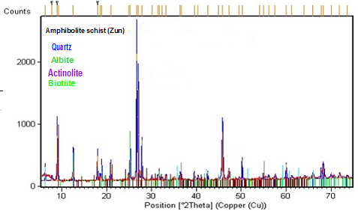

(c) (d)

 

(e) (f)

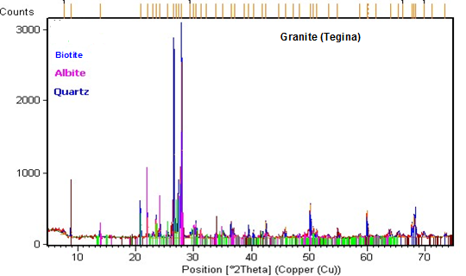

Appendix I: XRD Refractograms of rocks from the study area

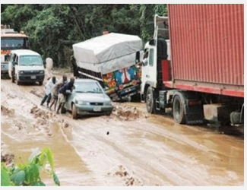 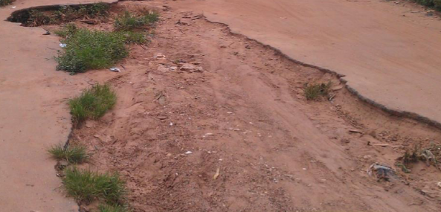

Appendix II: Failed road sections along Minna – Tegina and Tegina - Makera federal road