VICROADS INTER CONF. 10-12, DEC. 2015


AN OVERVIEW ON SELF COMPACTING CONCRETE (SCC)

1.Dept. of Building, F.U.T. Minna, Nigeria,

- INTRODUCTION

The concept of Self Compacting Concrete (SCC) was first developed in Japan in the mid to late 1980s and by the mid 1990s it spread around the world because of the major concerns poor compaction was having on the quality and durability performance of concrete structures. The reasons for compacting conventional concrete is to ensure that maximum density is achieved by fully expelling entrapped air entrained during mixing and placing, and to further ensure that the concrete is in full contact with both the steel reinforcement and the formwork.

The purpose of good compaction is to ensure satisfactory strength, sound impermeable concrete with satisfactory detail at corners, good bond with the steel reinforcement, good finish and appearance and impermeable protective cover to the steel reinforcement. SCC on the other hand does not require any mechanical effort such as the use of immersion vibrators or external formwork vibrators, to achieve full compaction.

A well designed and produced SCC has the capability to flow under its own weight through and around congested steel reinforcement fully encapsulating it, completely filling the space within the formwork, without any loss of strength, stability or homogeneity, while still achieving the same outcomes of good compaction. It is now well accepted that the fundamental research into producing SCC has now been completed and it was being used successfully in practice in many countries around the world for both precast concrete and in-situ applications (1, 2, 3, 4, 5, 6, 7 and 8).

- WHAT IS SELF COMPACTING CONCRETE?

SCC is defined as “Concrete that is able to flow and consolidate under its own weight, completely fill the formwork or bore hole even in the presence of dense reinforcement, whilst maintaining homogeneity and without the need for additional compaction, and which complies with the requirements of Table 610.181 (of the VicRoads Standard Specification Section 610 “Structural Concrete”)(9)”.

SCC is not a new building material but rather a further extension of existing concrete technology which has been found to offer the potential for improvements in various
Apeh, Abah Joseph¹, Fred Andrews²
2.Principal Engineer, concrete Tech, GeoPave

aspects of construction. In terms of structural and durability requirements, SCC is not different from conventional vibrated concrete and therefore existing design codes and standards are still valid.

The basic constituent materials used in SCC are essentially the same as those of conventional concrete, although additional admixtures or fine materials may be necessary to achieve the required rheological properties. However, the biggest difference between the two concretes is the actual proportioning of these materials. In order to achieve its defined purpose, SCC mixes contain lower coarse aggregate contents, higher amounts of sand, higher amounts of cementitious materials including Portland cement, lower water/cementitious material ratio, higher superplasticiser doses and sometimes viscosity modifying admixtures.

A comparison of materials in typical SCC and conventional concrete is shown in Table 1 (3). The reduction in the amount of coarse aggregate is done in order to reduce the friction between them and therefore enhance the overall concrete fluidity. The increase in paste contents (i.e. sand, cementitious materials, admixtures etc) is also intended to further increase fluidity as well as enhance its cohesiveness and resistance to segregation and viscosity. Control of the viscosity and cohesiveness of the paste ensures the flow of the SCC through obstacles such as steel reinforcement without any aggregate blockages.

Due to the lower water/cementitious material ratios used in SCC mixes and higher dosages of dispersive superplasticisers which are key to achieving the required rheological characteristics for flow and self-compaction, the properties of fresh SCC are more sensitive to variations in the quality and consistency of the mix constituents, particularly variations in water contents. As the fresh properties of SCC are fundamental to both its short and long term performance (i.e. they can not be compensated with further compaction) tighter controls on materials and production consistent with the requirements of Section 610 are therefore required, with particular emphasis on the actual determination of the moisture content of both the sand and the stone on a frequent basis. Ensuring that no residual water is left in the concrete truck mixers prior to batching is also of primary importance.

Page 1 of 4



Table 1 Comparison of materials in typical SCC and conventional concrete

Material, | Conventional Vi- | SCC
Material, | brated Concrete | (%)
by volume | brated Concrete | (%)
by volume | (%)
Admixtures | < 0.01 | 0.01
Water | 18 | 20
Coarse | 46 | 28
Aggregate | 46 | 28
Sand | 24 | 34
Fines, including | 12 | 18
Portland cement | 12 | 18

There are two commonly known methods of producing self compacting type concretes, namely, the powder and admixture methods. The powder method uses superplasticisers in conjunction with very high cementitious material contents (i.e. cement, fly ash, slag, etc) to form a paste which controls the homogeneity of the mix, improves its flowability and holds the mix constituents together and resists segregation. The admixture method is based on the use of the new generation of polycarboxylate superplasticisers which offer the capability of providing for improved flowability, viscosity and cohesion, as well as workability retention. Depending on the characteristics of constituent materials, a viscosity modifier may also be required.

It is important to emphasise that SCC should not be confused with high or very high slump (180mm to 250mm) “flowable” conventional concretes (which may also use the new generation of polycarboxylate superplasticisers)which are still subject to segregation problems and require vibration to achieve compaction.

- KEY PERFORMANCE REQUIREMENTS OF FRESH SELF COMPACTING CONCRETE

There are three distinct fresh properties which essentially define SCC and which are fundamental to its performance both in the plastic and hardened state. These properties are also interrelated and must be maintained for a required period of time after mixing. To achieve these properties, the material selection, proportioning and quality control including production control are critical. The three essential fresh properties required by SCC are:

- Filling Ability:- the concrete must have the ability to flow and completely fill all parts within the formwork under its own weight without leaving voids. As it is highly fluid it has the ability to flow considerable

distances both horizontally and upwards and fill vertical elements from the bottom.

- Passing Ability:- the concrete containing the required aggregate size must have the ability to flow through and around restricted spaces between steel reinforcing bars and other embedded objects under its own weight and without blocking or segregation.

- Segregation Resistance:- the concrete must be able to satisfy both the filling ability and passing ability requirements while it still remains homogeneous both during transport and placing and after placing.

Paste viscosity (measure of the speed of flow) is another important property, which although not essential in defining SCC, it can nevertheless influence the passing ability, segregation resistance and cohesiveness of SCC. Sufficient viscosity is required within an SCC concrete to ensure that aggregates are fully suspended within the paste and thus enhance the other important properties of SCC.

- BENEFITS OF SCC

The principal benefits of SCC are advantages derived from the properties of fresh mix itself, namely:

- Ability to completely fill complex formwork and encapsulate areas of congested steel reinforcement without any compaction and yet with reduced risks of voids and honeycombing.

- Ability to develop higher early and ultimate strengths and enhanced durability properties compared with conventional vibrated concretes.

- Potential for improved surface finishes with reduced making good costs related to poorly compacted surfaces.

Although the SCC as a material will cost slightly more than conventional concrete, significant costs savings can be realised through the whole concreting process including giving consideration to SCC at the detailed design stage of a project. Such benefits can be summarised as follows:

- Reduced construction time and labour costs.

- Reduced man power for placing and compacting.

- Lower equipment costs and less noise since vibrators are not required.
- Improved OH&S in the workplace environment through the elimination of vibrating equipment and associated health and safety risks. Reduced noise levels, reduced trip and fall hazards, less manual handling.

- PRECAUTIONARY MEASURES

The following practical considerations should be taken into account when working with SCC.

- Due to the high fines content and viscosity SCC concrete tends to dry faster than conventional concrete and therefore there is a potential of increased plastic

Page 2 of 4 June 2006



shrinkage cracking, as there is little or no bleed water at the surface. As such it is important that evaporative retarders are used between initial screeding and finishing and curing is implemented in a timely manner as per specification requirements. On the other hand the reduced bleeding reduces the risk of plastic settlement.

- SCC must be supplied on a continuous basis and sufficient manpower and equipment must be on site to avoid any delays which may result in the concrete being left too long without fresh concrete being applied thus creating the potential for a cold joint to be formed. Where concrete has been untouched for long periods it may be necessary to vibrate the new concrete into the old to prevent a cold joint from occurring.

- In order to minimise the risk of segregation of SCC the vertical free-fall should be limited to 3 m and the horizontal flow from point of discharge to 6 m.

- As SCC concretes are more susceptible to quality and material fluctuations than conventional vibrated concrete, a stricter quality control regime, production control, construction control and training regime must be put in place.

- In concreting applications other than under water and dry bores, consideration should be given to undertaking controlled field trials where all of the critical plastic and then hardened properties can be assessed.
- Ensure adequate and ongoing communication between the mix designer, the contractor, supervising personnel and the personnel responsible for placing SCC concrete.

- HARDENED PROPERTIES OF SCC

The main differences between conventional vibrated concrete and SCC concrete are related to the behaviour in the fresh state. In terms of the hardened properties, at similar water/cementitious material ratio, properly proportioned, produced and placed SCC is generally denser and less variable than the equivalent conventional vibrated concrete, thereby resulting in improved strength and durability performance. In addition, compared to conventional vibrated concrete, SCC at similar water/ cementitious material ratio is expected to have:

- The same structural performance.

- Equal or higher compressive and tensile strength.

- Equal to or lower shrinkage.

- Equal to or better bond to the steel reinforcement.

- Lower surface absorption and therefore better durability.

- SCC IN SECTION 610

SCC has now been introduced into the September 2005 version of the VicRoads standard specification Section 610 “Structural Concrete”. At this stage Clause 610.18(c) limits the use of SCC for underwater and dry bore (bored piles, etc) applications only. Clause 610.18(c) also specifies the minimum quality and testing requirements for SCC. Any

proposals for use of SCC for other structural applications are subject to the approval as per the requirements of Clause 610.07(k).

- SAMPLING AND TESTING FOR SCC

Several test methods have been developed and together with visual inspection are often utilised to verify the performance of fresh SCC. However, none of these methods are standardised as yet, either nationally or internationally. Some of these test methods include the Slump-flow test, the J- Ring test, the L -Box test, the Orimet test and the GTM Screen Stability Test. As part of the introduction of SCC into the VicRoads standard specification Section 610, three tests were also introduced, namely, the Slump-flow (to measure the filling ability/flowability), the Slump-flow T₅₀₀ time (to measure the paste viscosity/rate of flow) and the J-Ring test (to measure the passing ability). These tests were identified as the most practical and adaptable for both the laboratory and on-site for mix design and development and for acceptance and quality control.

The slump flow (Refer Fig.1), T₅₀₀ time (measure of viscosity) and passing ability of the SCC are required to be determined using the Slump Flow and J-Ring test method in accordance with VicRoads test methods as described in the VicRoads Code of Practice RC 500.16. The slump flow, T₅₀₀ time and passing ability of the SCC are required to comply with the requirements of Table 2 (9).

Table 2 Slump flow, T₅₀₀ time and passing ability requirements of SCC

Properties of |  |  | Measurement | Observations
 | SCC
 |  |  |  | The aggregate
 |  |  |  | shall be evenly
 |  |  |  | Distributed
Slump Flow |  |  |  | throughout the
 |  |  | 550 – 650 mm | concrete paste
(Filling ability/ |  |  | 550 – 650 mm | concrete paste
 |  |  | spread | within the spread
Flowability) |  |  | spread | within the spread
 |  |  |  | and shall not
 |  |  |  | exhibit signs of
 |  |  |  | Segregation
T |  | time | 3.5 ± 1 seconds | The final spread
T | 500 | time | 3.5 ± 1 seconds | shall not exceed
 | 500 |  | to achieve a
(measure of |  |  | to achieve a | 650 mm in diam-
 |  |  | spread of 500 | 650 mm in diam-
viscosity) |  |  | spread of 500 | Eter
 |  |  | mm | Eter
 |  |  |  | The concrete
Passing Ability |  |  |  | shall not exhibit
 |  |  | ≤ 10 mm | signs of
 |  |  |  | Segregation

Sampling and testing for the slump flow, T₅₀₀ (measure of viscosity) and passing ability of SCC should be undertaken at a minimum prescribed frequency (as indicated in Section

Page 3 of 4

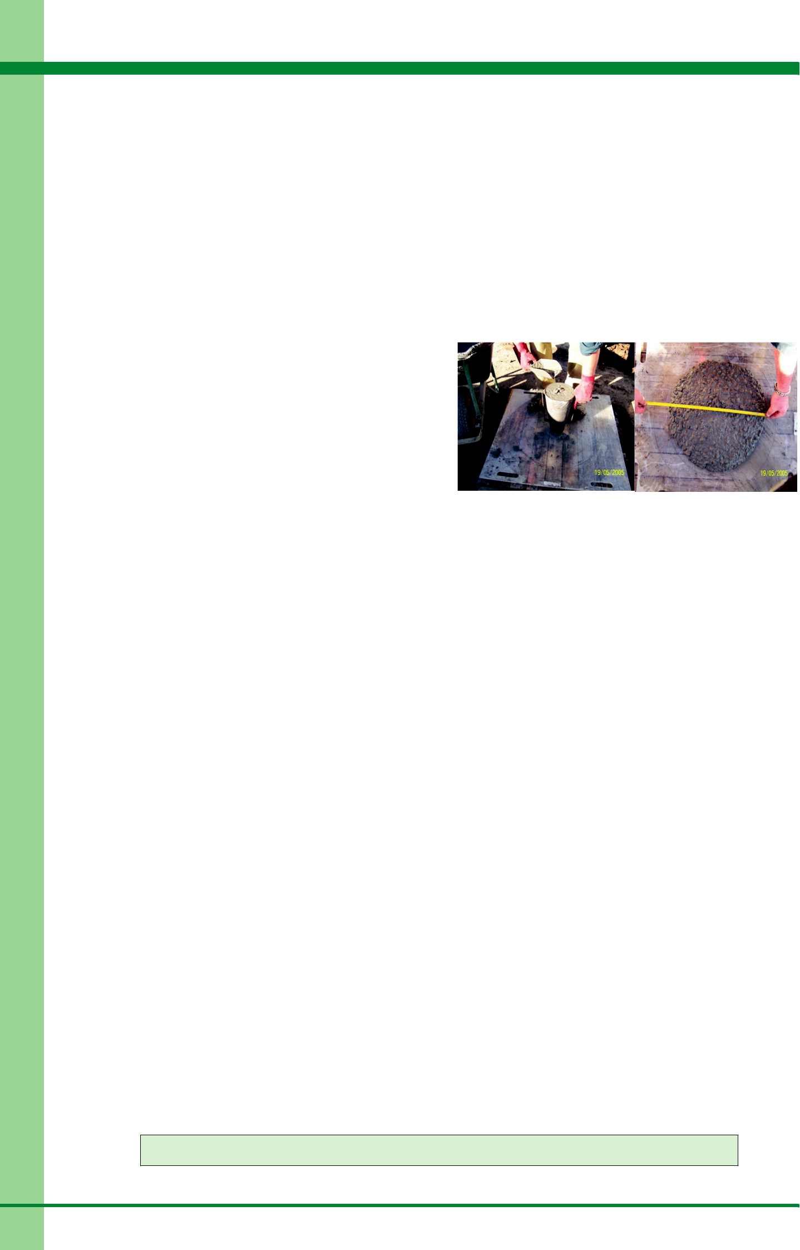

610). Section 610 also requires that when making test cylinders for SCC the test sample should be placed into the cylinder moulds from a height not exceeding 100 mm from the top of the mould and be placed in one continuous motion. Roding or vibration should not be applied to test cylinders made up of SCC.

- SUMMARY

SCC offers improved quality and durability compared to conventional vibrated concrete, provided it is considered as part of the whole construction process including the detailed design stage of a project. This technical note has identified a number of benefits that can be realised both in the fresh and hardened state. However, these benefits can only be achieved through the adoption of a stricter quality control regime, production control, construction control and training regime for personnel involved with SCC. To this regard more knowledge and control is required by the concrete suppliers and users. In terms of VicRoads works this means strict compliance with specification requirements including those of Section 610 “Structural Concrete”.

10. REFERENCES

- Holton I (2004), “Self-compacting concrete”, BRE.

- Hurd MK (2002), “Self Compacting Concrete”, Concrete Construction, Vol. 47, No. 1.
- Concrete Society (2003), Self-Compacting Concrete

– Part I. The Material and its Properties”, Current Practice Sheet No. 123.
- Concrete Society (2005), “Self-compacting concrete

– A review”, Technical Report No. 62.

- EFCA, EFNARC (2005), “The European Guidelines for Self Compacting Concrete”.
- Concrete Institute of Australia (2005), “Super-Workable Concrete”, Recommended Practice.
- Vachon M (2002), “Self-Consolidating Concrete”, ASTM Standardization News.
- Precast/Prestressed Concrete Institute (2003), “Interim Guidelines for the Use of SCC in Member Plants”, TR-6-03.

- VicRoads Standard Specification Section 610 (2005), “Structural Concrete”.

11. CONTACT

Fred Andrews-Phaedonos, Principal Engineer- Concrete Technology, GeoPave.

Tel: (03) 98818939,

Mob: 0419 597 277,

Fax: (03) 9881 8900.

Figure 1 – Slump Flow Test. A technician lifts the slump cone and measures the diameter of the SCC Spread with reference to the requirements of Table 2.

