Application of Machine Learning Algorithm for Classification of Fake COVID-19 Tweets

Oluwatobi Sunday Malomo¹, Andrew Anogie Uduimoh² and John Kolo Alhassan³,
¹Department of Computer Science, Federal University of Technology, Minna, Nigeria
²Department of Cyber Security Science, Federal University of Technology, Minna, Nigeria
³Department of Computer Science, Federal University of Technology, Minna, Nigeria
¹malomo.m1605450@st.futminna.edu.ng
¹a.uduimoh@futminna.edu.ng
³jkalhassan@futminna.edu.ng

Abstract— The intentional dissemination of false information, known as fake news, aims to manipulate readers into accepting biased or untrue beliefs by altering their interpretation and response to real news. However, identifying fake news is a tedious task, especially on platforms like Twitter where information is rapidly disseminated. Therefore, Machine Learning classifiers can be leveraged to detect fake news with a higher accuracy. The novelty of Corona Virus Disease 2019 has made it hard to identify a widely accepted dataset for fake news detection. Recently, a more robust and up-to-date dataset called FND Dataset was created by scraping tweets from health organizations' Twitter accounts using Twitter API and socialscrapr. The dataset was processed using Python libraries and Microsoft Excel before being split into training, validation, and testing datasets. SVM, LR, and DT baseline Machine Learning algorithms were utilized, with the SVM classifier achieving the best performance for accuracy and F1-Score metrics as 93.17%.

Keywords— Supervised Learning, Classification, Text Classifier, Detection, Corona Virus Disease 2019

INTRODUCTION
The emergence of the World Wide Web (WWW) has hastened the spread of information, particularly with the rise of Social Networking Sites (SNSs) and numerous websites that circulate news whose authenticity is uncertain. SNSs function as virtual communities where individuals can share and access various forms of content. These platforms have witnessed a consistent increase in usage, as evidenced by a report Clement (2020), indicating that over 3.6 billion individuals were active on social media in 2020. This number is projected to rise to over 4.41 billion users by 2025, which will represent more than half of the world's projected population.The advent of these platforms has led to a decrease in the limitations of sharing information in physical spaces (Wani etal, 2021). Nevertheless, propagating false information has become just as effortless for malicious individuals with ill intentions.
While fake news has been around for a long time, the rise of social media has exacerbated the problem. With more people participating and sharing news through various social media platforms, fake news has become a growing concern. Anyone can share their beliefs and opinions through a simple act of liking, sharing, tweeting or favoriting, leading to an overwhelming amount of unregulated information. As a result, self-proclaimed authors are spreading fake news on social media, leading to a rapid dissemination of misinformation that can mislead people. (Zhou & Zafarani, 2020).
Year 2020 was uniques, been marked with the emergence of Corona Virus Disease 2019 (COVID-19) as a severe public health emergency and a worldwide ordeal that impacted individuals across the globe. This disease was arguably the most significant problem faced by humanity since World War II (Jalali, 2020). Alongside the health crisis, people had to confront a huge ‘infodemic’ that posed an equal, if not greater, threat to humanity than the deadly virus (Jalali, 2020).
The issue of fake news is still a challenge, not only for social media users, but also for researchers, as it poses a threat to society (Patwa etal, 2021). When it comes to COVID-19, fake news is an even bigger problem as it can persuade people to take drastic actions based on false information. For example, in Karimi & Gambrell, (2020) the claim that "Alcohol is a cure for COVID-19" resulted in many hospitalizations and deaths in Iran during the height of the pandemic in 2020.
The statement that “Alcohol is a cure for COVID-19”, highlights the impact of fake news during difficult times and emphasizes the importance of addressing it to avoid severe consequences. As stated by Patwa etal, (2021), detecting false information is the initial step in combating it. This research study concentrates on tweets gathered from various sources such as the official Twitter accounts and websites of prominent organizations, including Centre for Disease Control and Prevention (CDC), World Health Organization (WHO), National Primary Health Care Development Agency (NPHCDA) and Nigeria Centre for Disease Control (NCDC).

Web scraping is the process of autonomously mining data or extracting relevant information from the internet. The scope of web scraping ranges from manual methods that require user intervention to fully automated systems that convert entire websites into structured data, albeit with certain limitations. The exchange of information between computer programs through requesting and transmitting is made possible by Application Programming Interfaces (APIs). APIs allow software applications to access endpoints, which correspond to specific types of data, such as phone numbers.

II LITERATURE REVIEW
It is estimated that unstructured data constitutes roughly 80% of all data, with text being among the most prevalent types (Bucur, 2019). Analyzing, organizing, sorting, and comprehending a particular dataset of textual nature is a time-consuming and tedious task due to the noisy nature of the text. Consequently, this significantly diminishes the value that companies can extract from such data.
Text classification using Machine Learning can be a valuable tool for businesses as it enables them to efficiently organize various forms of relevant content, including structured, unstructured, and semi-structured data. This approach is not only cost-effective, but also allows for quick analysis of datasets and automation of processes, leading to data-driven decision-making and time savings for the company.
In Ahmed etal, (2017) study, several Machine Learning models such as Support Vector Machine (SVM), K-Nearest Neighbour (KNN), Logistic Regression (LR), Linear Support Vector Machine (LSVM), Decision Tree (DT), and Stochastic Gradient Descent (SGD), after extracting linguistic features, primarily n-grams, from textual articles. They focused on identifying text patterns that can effectively distinguish between genuine news and fabricated articles. Their models were supplied with a feature set extracted using the Linguistic Inquiry and Word Count (LIWC) tool.
The highest accuracy score among all the machine learning models trained was obtained by both SVM and LR, which were both able to achieve 92% accuracy. The researchers observed that increasing the number of calculated n-grams for a given article reduces the accuracy of the model, a phenomenon that has been noted in other models used for text classification tasks. To combat the spread of fake news, the researchers emphasized the need to identify key elements in the rapid dissemination of news articles. They suggested the use of both Machine Learning techniques and Graph Theory approaches for this purpose.
In Shrivastava etal, (2022), a classification task of feature selection was conducted using two different datasets. The research employed feature selection techniques, namely the bag of words model and TF-IDF vectorization model, along with different classifiers like Logistic Regression, Random Forest, Naive Bayes, and Passive-Aggressive. The outcomes revealed that the Bag of Words model, when used with Logistic Regression, scored an F1 average of 92.16%, while the TF-IDF vectorization model resulted in an F1 average of 93.47%. Furthermore, the study discovered that the combination of the Passive-Aggressive classifier with the TF-IDF vectorization model resulted in the most significant increase in F1 Score, particularly with large datasets.
Utilizing the potential of Blockchain Technology (BT) and its versatility in various domains, Wang, (2017) was motivated to integrate BT and ML to detect fake news. This approach not only widens the range of news categorization but also generates a resilient predictive system. In Rao etal, (2012), a technique known as Bidirectional Encoder Representations from Transformers (BERT) was suggested, which pre-trains words using left and right contexts to create bidirectional representations from unlabelled words. The BERT performance surpassed both KNN and Logistic Regression. It also decreases computation time and simplifies categorization. The proposed system effectively identified false information that was disseminated on numerous websites, thereby improving the consumption of authentic and verified news while disregarding fake news.
In Vijjali etal, (2020) a two-stage automated pipeline was created to detect fake COVID-19 news using fact-checking techniques and natural language processing (NLP). In the initial phase, a novel fact-checking model is utilized to gather the most relevant facts pertaining to users' assertions regarding COVID-19. Subsequently, the veracity of these claims is examined in the second stage through an analysis of the textual entailments found in the claims, in addition to the facts that have been meticulously curated in the COVID-19 dataset.
Around 5000 unique fictitious claims and proven statement about Crona Virus (COVID-19) were collected from publicly useable knowledge bases to create the dataset. A subset of this dataset was internally noted and cross-verified to develop and test the algorithms used in the study. The study then evaluated various models, including those based 6on conventional text features and contextual transformer models. The best results were obtained by utilizing BERT and ALBERT in the two respective stages of the model pipeline
According to Roy etal, (2018), the prevalence of fake news is rising as a result of the abundance of information available from various sources, including social media, online newspapers, and blogs. To address this challenge of identifying fake news, researchers developed several Deep Learning models that classify news into specific categories. The models employed were Convolutional Neural Network (CNN) architectures and Bi-directional Long Short Term Memory (Bi-LSTM) networks. After obtaining representations from these models, they were fed into a Multi-Layer Perceptron Model (MLP) to carry out the final classification. Testing on a benchmark dataset resulted in an overall accuracy of 44.87%, demonstrating an advancement over prior models.
To address the problem of detecting fake news, Paka etal, (2021), created a large COVID-19 Twitter dataset called CTF and proposed a neural attention model called Cross-SEAN. The model is semi-supervised and utilizes external knowledge to generalize to new fake news. To evaluate its performance, the Cross-SEAN model was compared to seven other methods; Multitask Learning (MTL), Hierrachial attention based networks(1HAN), 3-level ), Hierrachial attention based networks (3HAN), ), Hierrachial structure at word and sentence level (16HLT-HAN), Capture Score and Intergrate (CSI), word -level sentence level encoding along with a moduel for sentence-comment co-attention (dFEND), interpolation of hidden text in space with large training samples (MixText). Their model outperformed the best baseline by 9% with a 95% F1 score. Additionally, the researchers developed a Google Chrome extension called Chrome-SEAN that allows for real-time detection of fake tweets.
In Kolluri & Murthy, (2021), a web-based application called CoVerifi was developed to assess the credibility of news by combining the capabilities of Machine Learning models with human feedback obtained through voting on news content. CoVerifi also provides open-source labelled data, which can encourage future research into preventing the spread of false COVID-19-related news.
Additionally, the app includes a functionality that employs a Machine Learning algorithm to build and train a designated dataset focusing on COVID-19 false information called CoAID (Cui & Lee, 2020). A Bidirectional LSTM model was built using 1257 news instances from a dataset for training. To validate the model, 419 instances were manually checked, and a 75% train and 25% test split was used. The labels were assessed for precision, recall, F1-score, and accuracy, and the weighted average score for each metric was 93%.
Lastly, a dataset was created and made available for detecting fake COVID-19 news. The dataset consists of 10,700 articles related to COVID-19, with both real and fake articles included. The dataset was obtained from Twitter accounts belonging to health organizations like The COVID India Seva, and The Indian Council of Medical Research CDC and WHO. Each post was manually verified for accuracy. To evaluate the dataset, four baseline machine learning classifiers - Support Vector Machine (SVM), Gradient Boost (GDBT) with Logistic Regression (LR), and Linear Kernel, Decision Tree (DT), - were utilized. The best performance was achieved by the SVM-based classifier with an F1-score metric of 83.46%.
The problem of infodemic (information pandemic) has been worsened by the ongoing pandemic, particularly on Social Networking Sites. This is because it has spread in an atmosphere of fear and uncertainty (Patwa etal, 2021). However, previous research has not taken into account the sources of COVID-19 news available in Nigeria, meaning that the COVID-19 news that can be found in the country has been completely disregarded. Furthermore, the data sets employed in numerous of these investigations are inadequate in terms of being both up-to-date and exhaustive, particularly when COVID-19 has become a crucial research domain in the past year, with governmental and healthcare agencies constantly disseminating information to the general public about the disease.
The aim of this study is to compile a new collection of data comprising 11,180 tweets sourced from the Twitter accounts of verified Nigerian government and health organizations, such as Centre for Disease Control and Prevention (CDC), World Health Organization (WHO), National Primary Health Care Development Agency (NPHCDA) and Nigeria Centre for Disease Control (NCDC). This study will categorize COVID-19 news posted by Nigerians on Twitter, making it easier to sift through irrelevant and potentially false information that could contribute to an infodemic in the country. Moreover, the dataset being compiled will be more up-to-date and all-encompassing, including the latest updates shared by these organizations.

METHODOLOGY
Figure 1 presents the methodology of this study. Initially, Twitter was scraped to gather COVID-19 related news. Next, the collected tweets underwent preprocessing to eliminate extraneous characters such as stopwords, extra spaces, and outliers. Tokenization was performed on the tweets to uncover concealed patterns and insights in the dataset, as part of the exploratory analysis.
Using the Pareto Principle, commonly referred to as the 80/20 Rule, the curated dataset was divided such that 80% of the data processed was designated to individually train each of the 3 classifiers. The next phase involved validating the trained classifiers, where 10% of the preprocessed dataset was used, while the remaining 10% was utilized for testing the trained model. Finally the performance of the models was assessed by employing a range of metrics.
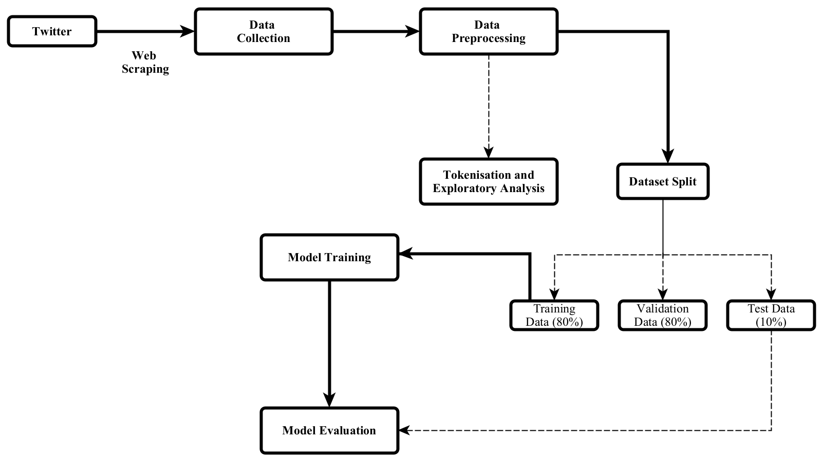

Figure 1: Classification Processfor Distinguishing Between Genuine and Fabricated COVID-19 News
- Collection of Data
A new dataset of inaccurate COVID-19 news was compiled, consisting of two categories:
- Genuine news: Only tweets that originate from websites that have been verified and Twitter accounts that offer reliable information to the public about COVID-19 was included.
- False news: These are include threads or tweets that speculate or make claimed that are unverified about COVID-19 or the pandemic, and are therefore not trustworthy.
To gather data, the following method was used:
- Tweets had to pertain to COVID-19.
- Only tweets in English were included.
In this study Twitter handles that are verified, belonging to various health organizations were used as the primary source of data. The dataset has been generated by utilizing Twitter API and socialscrapr to extract COVID-19 associated tweets and threads Extracted from the Twitter accounts of CDC, WHO, NPHDA, and NCDA that have been verified by Twitter. In this study, meaningful information related to COVID-19 such as The information pertaining to the count of cases, important dates, updates on vaccine development, details on lockdown measures, and governmental directives is identified by reviewing the scraped tweets which are stored in a csv file. It is important to note that only tweets from the aforementioned specific Twitter handles were considered reliable, while tweets from any other handles were deemed to be fake news.
- Data Cleaning
In order to conduct exploratory analysis, the curated dataset requires preprocessing, which includes the removal of stopwords, converting all letters to lowercase, and tokenization. This preprocessing step is beneficial in reducing the size of the dataset by eliminating outliers and redundant tweets. To accomplish this task, the Python libraries NumPy, Seaborn and Pandas, are utilized for cleaning the data, which gets the dataset ready for modeling.
- Removal of Stop Words
Stopwords are appear in a language but are not useful for text classification as they add noise to the context. These words are often used to connect thoughts and enhance sentence structure. Examples of stopwords include conjunctions, pronouns, prepositions, and some articles like "a," "as," "of," "at," "from," "how," "in," "is," "be," "by," "for," "on," "or," "these," "that," "the," "who," "this," "too," "was," "what," "when," "where," and "will." Before proceeding to the next phase of text classification, the dataset undergoes a process of removing these words in order to enhance its accuracy.
- Feature Engineering
Text classification presents a significant challenge in handling high-dimensional data. Given that documents consist of numerous keywords, words, and phrases, the computational demands of the learning process can be substantial. Additionally, the presence of redundant and irrelevant features can negatively impact the accuracy and performance of classifiers. Therefore, to mitigate the problem of high feature space dimensions, it is advisable to use feature extraction techniques
- Count Vector represents every document in the corpus as a row, and each phrase from the corpus as a column.The cell in each row and column signifies the count of the specific term present in that specific document.
- The vector for TF-IDF (Term Frequency-Inverse Document Frequency): measures the importance of a term by considering the number of times it appears in a document, its prevalence in the corpus. The more often a term appears in a document, the higher its TF-IDF score. However, if the term appears frequently in many documents, its TF-IDF score will decrease. The score is calculated using two components: TF, The term frequency in a document and the inverse document frequency (IDF) can be defined as the logarithm of the ratio of the total number of documents in the corpus to the number of documents containing the term. This score provides a relative measure of the significance of the term in both the document and the corpus.
Given a term e:
(1)
IDF (e) = (2)
- Overiew of Dataset
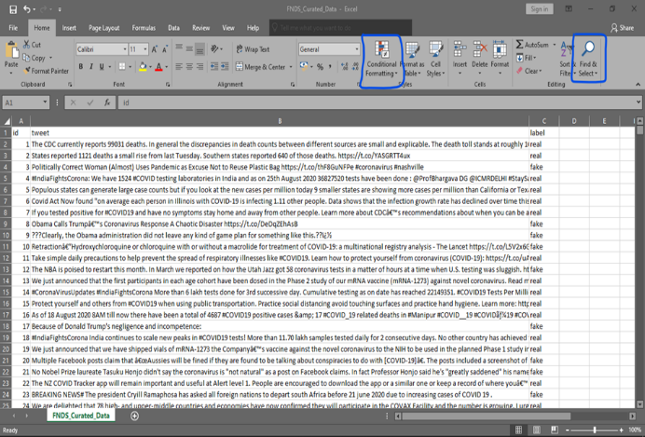
Figure 2: Curated Dataset Provided by FND.
The figure 2 shows the resulting dataset which was compiled by scraping the official Twitter accounts of health organizations such as CDC (@CDCgov), WHO (@WHO), NPCHDA (@NPCHDA), and NCDC (@NCDCgov). Furthermore, false news was obtained from PolitiFact, a well-known news site for fact-checking, and subsequently, all the tweets were recorded in a CSV (comma-separated values) file.
The operations showcased in figure 2 of Microsoft Excel, such as 'find and replace' and 'conditional formatting', were utilized to eliminate non-space characters and duplicate rows. Once the dataset was cleaned, it was imported into a Pandas DataFrame for further processing.
According to the Table 1, the average word and character count of fake tweets (772,235) is lower than that of real tweets (1,262,973). The curated dataset comprises a vocabulary size of 38,669 unique words, of which 5,602 words are common to both the real and fake tweet categorie.
Table 1 Numeric Features of Dataset
Attributes | Fake | Real | Both
Unique Words | 20561 | 23810 | 38769
Average Words per Post | 144.99 | 215.74 | 182
Average Chars per Post | 22.03 | 31.87 | 27.18

The dataset in the Table 2 was divided into classes, revealing a well-balanced distribution where real tweets accounted for a slightly higher percentage (52.36%) than fake tweets (47.64%). Throughout the division of datasets into training, validation, and testing sets, this balance was consistently sustained.
Table 2 Split Information of Dataset
Split | Real | Fake | Both
Train | 3522 | 3204 | 6726
Valid | 1161 | 1066 | 2227
Test | 1171 | 1056 | 2227
Table 2 outlines the division of the dataset into genuine and counterfeit tweets for training, validation, and testing of the models. A thorough token-level examination of the dataset was conducted after removing stop words, which revealed the most commonly used words for each tweet category. The frequency of occurrence of each token in the dataset was visualized using the Python WordCloud library. The word cloud shown in . 3 depicts all the tokens in the refined dataset, with the highest commonly occurring tokens including coronavirus, covid19, , tests, cases, new, will, people, covid, number, and deaths.
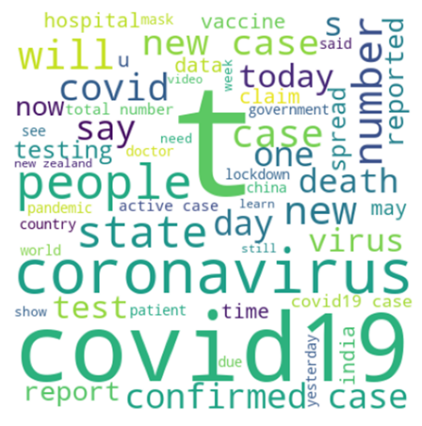

Figure 3: Word Cloud for Both Categories of Token

- Performance Metrics
- Confusion Matrix
One simple method for assessing the effectiveness of a classification task that includes multiple output categories is to employ a two-dimensional table with columns labeled "Actual" and "Predicted." Confusion matrix is a technique that has been used my many authors to evaluate performance analysis of algorithm (Liang, 2022).
The table contains four distinct categories of results, namely True Positive (TP), True Negative (TN), False Positive (FP), and False Negative (FN). These categories are defined as follows:
- A True Positive (TP) happens whenever a given data point is classified as 1 by both the actual class and the predicted class.
- A True Negative (TN) happens whenever a given data point is classified as 0 by both the actual class and the predicted class.
- A False Positive (FP) happens whenever a given data point is classified as 1 by the predicted class, but as 0 by the actual class.
- Whenever a predicted class classifies a data point as 0, it is considered a False Negative (FN). The baseline classifiers were trained using the preprocessed FNDS dataset, where the 'tweet' attribute was used as the input feature and the 'label' attribute was used as the target variable. Several metrics such as Precision, Recall, F1 Score, and Support were used to evaluate the performance of the classifiers during training.
- Precision is a measure of the accuracy of a Machine Learning classifier, which calculates the number of correct predictions made. It can be computed using the following formula::
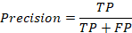 (3)
- Recall, also known as sensitivity, refers to the number of true positives identified by a machine learning classifier.
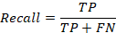 (4)

- The F1 score is calculated as the harmonic mean of precision and recall, which is a weighted average of these two metrics.
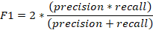 (5)
- Accuracy is the predominant metric used to assess classifiers, which gauges the ratio of accurate predictions made by the classifier among all the predictions it produced. Yes, that is correct. Classification accuracy is a common metric used to evaluate the performance of a classification model. It measures the proportion of correct predictions made by the model over all predictions made.
To calculate the classification accuracy; count the number of correct predictions made by the model and divide it by the total number of predictions made. For example, if a model made 100 predictions and got 80 of them correct, the classification accuracy would be:.
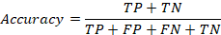 (6)

Classification Results and Discussion
The task of classifying text was accomplished using three Machine Learning classifiers - SVM, DT and LR, - which were implemented in Python's sklearn package. The runtime of the task was approximately 1 minute on the system employed.
Each of the baseline classifiers was given the preprocessed FNDS dataset as input, with the 'tweet' attribute used as the input feature and the 'label' attribute used as the target variable during the training phase. Prior to the application of the algorithms, the input texts were initially transformed into a word count representation using the CountVectorizer library.
- Validation Model
The tables 3 and 4 display the assessment of the baseline classifiers' performance on validation and test datasets using performance metrics such as precision, recall, F1 score, and accuracy. The findings suggest that there is only a slight difference in the accuracy and F1 score of the baseline classifiers.
Table 3 Validation Data Model Performance
Classifier | Accuracy | Precision | Recall | F1 Score
SVM | 90.88% | 90.91% | 90.88% | 90.88%
LR | 90.12% | 90.24% | 90.12% | 90.11%
DT | 83.29% | 83.29% | 83.29% | 83.29%
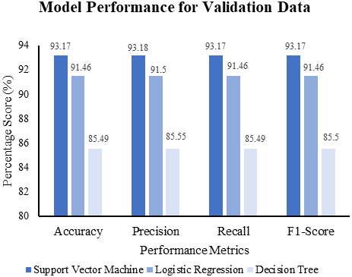
The table 3 displays a comparison of algorithm performance based on given metrics, indicating that the Support Vector Machine classifier achieved better classification results than the Logistic Regression and Decision Tree classifiers in the validation dataset, with an F1 score of 90.88%, 90.11%, and 83.29%, respectively. A graphical representation of the validation results is presented in figure 4.

Figure 4: Model Performance Chart for Validation Data

- Evaluation of the Model
- The study involved an evaluation process for a model, which entailed assessing the classifier's ability to predict new and unseen data sets. To achieve this, 10% of the preprocessed dataset was reserved for testing purposes. The baseline classifiers were then assessed to gauge their accuracy in accurately classifying instances and performing the classification task.

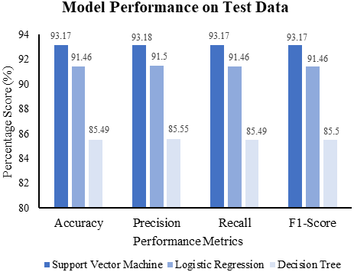

Figure 5: Model Performance Chart for Test Data
Table 4 Model Performance on Test Data
Classifier | Accuracy | Precision | Recall | F1-Score
SVM | 93.17% | 93.18% | 93.17% | 93.17%
LR | 91.46% | 91.50% | 91.46% | 91.46%
DT | 85.49% | 85.55% | 85.49% | 85.50%
The table 4 illustrates how the baseline algorithms performed on the test dataset. The Support Vector Machine classifier had the highest accuracy, recording 93.17%. The Logistic Regression algorithm closely followed with an accuracy of 91.46%, while the Decision Tree algorithm had the lowest accuracy at 85.49%. A visual comparison of these results is provided in . 5.

The curated FND Dataset underwent statistical analysis, which provided valuable insights that can assist in the classification process. One notable finding was that the tokenisation of the dataset showed there are overlapping tokens between the real and fake categories, such as "covid19," "new," and "people," which were among the 10 most commonly used tokens in both categories. Additionally, the analysis showed that, on average, fake news tweets are shorter than real news tweets as seen in the average number of words per tweet.
The figures 4 and 5 illustrate the performance of the Machine Learning classifiers used in this study on the validation and test datasets, using accuracy, recall, F1-score, and precision performance metrics. The results indicate that the SVM classifier performs better than the Logistic Regression and Decision Tree classifiers on both datasets. The high performance of the SVM classifier is evident from both visualizations.
Finally the results revealed that the SVM classifier outperformed other classifiers based on the chosen performance metrics. This could be explained partly by the linear kernel, which guarantees that the tweet classes are linearly separable across a hyperplane.

- Error Analysis Classification
To evaluate the performance of the three classifiers employed in this study, a manual review was conducted on a group of tweets that may have been classified incorrectly. To provide background information, it was observed that the SVM classifier misclassified tweets into two categories of errors:
- Type I Errors: The term "False Positive Error" refers to the acceptance of a hypothesis that is actually untrue. In the context of manually annotated sentences, this can occur when an algorithm classifies a sentence as "FAKE" despite being labeled as "REAL" due to a lack of necessary world knowledge needed to comprehend the sentence's meaning. s an example, instance 132 of the misclassified dataset, which is the tweet "U.S. nears 2.7 million total COVID-19 cases 130000 deaths https://t.co/qfRhC9joES ", was mistakenly labeled as FAKE even though it was manually classified as REAL.
- Type II Errors: False Negative Error occurs when a hypothesis that is true is mistakenly rejected. When classifying tweets, if a SVM classifier identifies tweets that have been labeled as FAKE by a manual process as REAL, it could be due to shared word usage (tokens) between real and fake tweets. For instance, a tweet may contain certain words that are commonly found in both real and fake tweets, leading to misclassification. “The SVM classifier incorrectly categorized "The total number of deaths in Brazil decreased instead of increased when comparing 2019 to 2020" as a REAL statement.

CONCLUSIONS
By collecting tweets from verified health organizations in Nigeria, a new and more reliable dataset for COVID-19 news was created in this study. According to the study, machine learning classifiers such as SVM, LR, and DT can be used to classify COVID-19 news in a practical manner. The study's findings show that the SVM classifier was the most effective, achieving the highest accuracy and F1-score of 93.17%, while Logistic Regression had a 91.46% accuracy and Decision Tree had an 85.50% accuracy, as shown in Figures 4.10 and 4.11.

RECOMMENDATIONS
Researchers and news outlets are recommended to use the curated fake COVID-19 news detection dataset FND for identifying fake COVID-19 news. The dataset is recent and comprehensive, making it suitable for classification tasks related to COVID-19 using other Machine Learning algorithms. Additionally, news outlets can utilize the dataset to distinguish real news from fake ones and create trustworthy content for the public.

FURTHER WORK
The following areas could be of interest for future research:
- It is possible to implement the COVID-19 fake tweet detection model into a web-based application.
- The application of Deep Learning, which has demonstrated superior performance compared to conventional Machine Learning algorithms, can be utilized in constructing the model.
- The development of a model that categorizes news in Nigerian indigenous languages could assist in reducing the spread of misinformation in the country.
- Future researchers may consider analyzing misclassified tweets as it was not within the scope of this study.

REFERENCES
Ahmed, H., Traore, I., & Saad, S. (2017). Detection of online fake news using n-gram analysis and machine learning techniques. In Intelligent, Secure, and Dependable Systems in Distributed and Cloud Environments: First International Conference, ISDDC 2017, Vancouver, BC, Canada, October 26-28, 2017, Proceedings 1 (pp. 127-138). Springer International Publishing.
Bucur, C. (2019). Using Machine Learning Techniques to Gain Insights from Enterprise Unstructured Data.
Clement, J. (2020). Number of Global Social Media Users 2017–2025. Stat. Website.
Cui, L., & Lee, D. (2006). CoAID: COVID-19 Healthcare Misinformation Dataset.(2020). arXiv preprint arXiv:2006.00885.
Jalali, M., & Jalali, M. (2020). A bibiliometric analysis of the Journal of Computers in Human Behavior: 1985–2019. Library Philosophy and Practice, 3847
Karimi, N., & Gambrell, J. (2020). Hundreds die of poisoning in Iran as fake news suggests methanol cure for virus. Times of Israel.
Kolluri, N. L., & Murthy, D. (2021). CoVerifi: A COVID-19 news verification system. Online Social Networks and Media, 22, 100123.
Liang, J. (2022). Confusion Matrix: Machine Learning. POGIL Activity Clearinghouse, 3(4).
Paka, W. S., Bansal, R., Kaushik, A., Sengupta, S., & Chakraborty, T. (2021). Cross-SEAN: A cross-stitch semi-supervised neural attention model for COVID-19 fake news detection. Applied Soft Computing, 107, 107393.
Patwa, P., Sharma, S., Pykl, S., Guptha, V., Kumari, G., Akhtar, M. S., ... & Chakraborty, T. (2021). Fighting an infodemic: Covid-19 fake news dataset. In Combating Online Hostile Posts in Regional Languages during Emergency Situation: First International Workshop, CONSTRAINT 2021, Collocated with AAAI 2021, Virtual Event, February 8, 2021, Revised Selected Papers 1 (pp. 21-29). Springer International Publishing. Rao, D. S., Rajasekhar, N., Sowmya, D., Archana, D., Hareesha, T., & Sravya, S. Fake News Detection Using Machine Learning Technique.
Roy, A., Basak, K., Ekbal, A., & Bhattacharyya, P. (2018). A deep ensemble framework for fake news detection and classification. arXiv preprint arXiv:1811.04670.
Shrivastava, S., Singh, R., Jain, C., & Kaushal, S. (2022). A research on fake news detection using machine learning algorithm. In Smart Systems: Innovations in Computing: Proceedings of SSIC 2021 (pp. 273-287). Springer Singapore.
Vijjali, R., Potluri, P., Kumar, S., & Teki, S. (2020). Two stage transformer model for COVID-19 fake news detection and fact checking. arXiv preprint arXiv:2011.13253.
Wang, W. Y. (2017). " liar, liar pants on fire": A new benchmark dataset for fake news detection. arXiv preprint arXiv:1705.00648.
Wani, A., Joshi, I., Khandve, S., Wagh, V., & Joshi, R. (2021). Evaluating deep learning approaches for covid19 fake news detection. In Combating Online Hostile Posts in Regional Languages during Emergency Situation: First International Workshop, CONSTRAINT 2021, Collocated with AAAI 2021, Virtual Event, February 8, 2021, Revised Selected Papers 1 (pp. 153-163). Springer International Publishing.
Zhou, X., & Zafarani, R. (2020). A survey of fake news: Fundamental theories, detection methods, and opportunities. ACM Computing Surveys (CSUR), 53(5), 1-40.
.

