

**RESPONSE SURFACE METHODOLOGY BASED MODEL FOR PREDICTING COMPRESSIVE STRENGTH OF KUTA GRAVEL CONCRETE**

**Abubakar, J. 1*, Abdullahi, M. 2, Aguwa, J.I.3 and Abbas, B.A.4**

**1,2,3,4** Department of Civil Engineering, Federal University of Technology, Minna, NIGERIA.

**Abstract**

Compressive strength is undoubtably the most important property of concrete and measures the performance of a concrete mix. Hence, concrete constituent materials are mostly proportioned in terms of compressive strength. Several Design of Experiment tools have been developed that can be used to improve accuracy, optimize and model concrete properties. In this study, a model to predict compressive strength of Kuta gravel concrete was developed. Central Composite Design in Minitab was used to generate 20 mixes with varied water to cement, coarse aggregate to total aggregate, and total aggregate to cement ratios as design variables. Concrete cubes were tested for compressive strength at 28 days of curing. The model was developed and analyzed using response surface methodology. Results obtained showed that a maximum compressive strength of 27.47N/mm2 can be achieved with mix proportion of water to cement (W/C) ratio of 0.4, Coarse aggregate to total aggregate (CA/TA) ratio of 0.55 and total aggregate to cement (TA/C) ratio of 3. The model has overall P-value of 0.001, R2 value of 90.2% and Adjusted R2 value of 81.38%. It was concluded among others, that Kuta gravel can be used in producing C15, C20 and C25 grades of structural concrete, and that the developed model is adequate in predicting 28-day compressive strength of Kuta gravel concrete.

**Keywords:** Compressive strength, Concrete, Kuta gravel, predictive model, Response surface methodology

**OPEN ACCESS**



***Corresponding author’s e***[***-mail: jibo008@yahoo.com***](mailto:jibo008@yahoo.com) ***website:*** [***www.academyjsekad.edu.ng***](http://www.academyjsekad.edu.ng)

**This work is licensed under a Creative Commons Attribution 4.0 International License (CC BY)**

**1.0 INTRODUCTION**

Concrete is a versatile construction material that is used world-wide. It is adaptable to a wide range of applications including roads, dams, ports, bridges, tunnels, residential and agricultural uses. The production and use of concrete is substantially more than any other synthetic material in the world (Damme,

2018). It is regarded as the most popular material used for building and infrastructural development (Fapohunda *et al*., 2020; Obolewicz and Wadolowska, 2020; Smarzewski and Stolarski, 2022). In view of its importance therefore, our daily activities would not be possible or easy without these basic infrastructures. It is adequate to state therefore, that concrete is a major part of our existence and the world cannot do without it.

In structural engineering, concrete serves as the major material used in resisting compressive stresses. Hence, studying and improving the compressive strength of concrete has become imperative. Compressive strength is undoubtably, the most useful property of structural concrete (Ajagbe *et al.,* 2018). Compressive strength is used in assessing the performance of a particular concrete mix (Akorli *et al.,* 2021). For these reasons, most concrete ingredient proportioning is generally done in terms of compressive strength.

Methods that are based on trial and error have been used traditionally in the past for concrete mix proportioning. These methods are mostly time consuming, far from perfection and error ridden. As a result, the methods do not provide optimum proportioning of concrete constituents to meet performance criteria (Kharazi *et al.,*

2013). Devising other means of mix proportioning that will result in the best (optimal) proportioning to bring about concrete with the most desirable

characteristics have hence, become imperative. In recent years, numerous software’s and computer programs have been invented and used in optimizing concrete mix composition. With these tools, time and effort expended in designing concrete mixes have been drastically reduced, errors associated with manual designs are avoided, and accuracy in the values of concrete mix have been enhanced (Patil and Rajakumara,

2018).

Response Surface Methodology (RSM) is a mathematical/statistical technique that combines fundamentals of statistical experimental design, regression modelling and optimization (Carley *et al*., 2004). As the name implies, RSM identifies and fit an appropriate response surface model to data obtained from experiments. The method helps in minimizing construction cost by ensuring efficient use of concrete constituent materials (Haque *et al.,* 2021).

A natural deposit of aggregate (Kuta gravel) sourced from Kuta in Niger state has been used locally in producing concrete within and around the deposit region. The use of this aggregate has become popular even though there is limited study on the properties of this aggregate and there is no data on properties of concrete produced from this aggregate.

This study seeks to optimize the mix composition of concrete containing Kuta gravel and also, develop a predictive model for determining the compressive strength of concrete made from Kuta gravel using RSM.

**2.0 REVIEW OF EXISTING LITERATURE**

Haque *et al.* (2021) used Central Composite Design (CCD) in RSM to develop models useful in predicting fresh and hardened concrete properties. This was done by

replacing cement partially with rice husk ash (RHA) and incorporating glass fibre (GF) as additional element for reinforcement. Volumes of the RHA and GF were adopted as independent variables to develop the models for slump, compressive strength, density and splitting tensile strength. High values of coefficient of determination between 0.9359 and 0.9975 were obtained for the developed models. It was concluded among others that the models developed using RSM are capable of predicting the fresh and hardened concrete properties, and that the responses were optimised with mixture of

16.05% RHA and 0.08% GF based on the

RSM results.

In a related study, Hamada *et al.* (2022) optimised the strength properties of lightweight concrete. This was achieved by incorporating nano palm oil fuel ash and palm oil clinker as light weight aggregates in producing concrete. Investigation was primarily on the ultrasonic pulse velocity (UPV), compressive strength and flexural strength of concrete. Central composite design within RSM was adopted for optimizing mix design parameters. It was concluded that mix design of lightweight aggregate concrete can be accurately enhanced using RSM.

The evincing strength of RSM in developing accurate models for predicting responses is further confirmed by the study carried out by Ahmed *et al.* (2022). The researchers investigated the effect of replacing river sand with glass waste (at 10%, 20% and 30%) while incorporating condensed milk can (0.5%, 1% and 1.5%) to serve as fibre material for reinforcement. The analysis of variance (ANOVA) results obtained from the models developed using RSM showed that the models are accurate and valid, yielding

predicted values with high level of desirability.

**3.0 MATERIALS AND METHODS**

**3.1 MATERIALS**

The materials used for the study are:

**3.1.1 Portland Limestone Cement (PLC)**

42.5N grade of Portland Limestone Cement obtained from a retail outlet in Minna was used for the investigation.

**3.1.2 Fine Aggregates (Sand)**

River sand obtained from Gidan Mangoro in Minna, Niger state was used as fine aggregate in this study. The sand is sharp and organic matter free. This sand conforms with the requirements of BS EN 12620 (2008) specifications for natural aggregates used for concrete production. The physical properties of the sand are as shown in Table 1.

**3.1.3 Coarse Aggregates (Kuta Gravel)** Kuta gravel obtained from Kuta, Niger state, was used as coarse aggregate in this study. The aggregate conforms to requirements of BS EN 12620 (2008). Physical and mechanical properties of the aggregate are presented in Table 1.

**3.1.4 Water**

Potable water was used as mixing water for this study. It was sourced from Federal University of Technology, Minna. The water is clean and free from particles, salts and impurities. Its nature is such that it requires no further testing before use as mixing water according to BS EN 1008 (2002).

**Table 1**: **Properties of constituent materials**

**Material Properties**

**River sand** Specific gravity:2.64

Water absorption: 0.79%

Loose bulk density: 1588.83kg/m3

Loose bulk density: 1697.56kg/m3

Fineness Modulus: 2.2

Grading: falls within limit of graded fine aggregates

**Kuta gravel** Specific gravity:2.67

Water absorption:0.6%

Loose bulk density: 1523.47kg/m3

Compacted bulk density: 1640.52 kg/m3

Aggregate Impact Value (AIV): 16.45% Flakiness Index: 26%

Elongation Index: 29%

Grading: falls within limit of graded coarse aggregates

**3.2 METHODS**

**3.2.1 Factor Setting**

The Central Composite Design (CCD) in Minitab 21 was used in generating mix combinations in this study. This fractional factorial design is the most commonly used in RSM. This method is suitable in finding functional relationships between the design variables and the response (Haque *et al.*,

2021) . By this means, the designer is able to understand the effect of different design factors on the response (Olaoye, 2020).

The following values were assigned to the proportions of the constituent materials and considered independent variables.

Table 2 shows the coded and uncoded values of the variables as generated in

Minitab 21. An 𝛼 value of 1.4142 was used

in generating the coded points.

|  |  |
| --- | --- |
| W/C (x1) = 0.4, 0.5, 0.6 | (1) |
| CA/TA (x2) = 0.55, 0.6, 0.65 | (2) |
| TA/C (x3) = 3, 4.5, 6 | (3) |

Where: W/C= Water to Cement ratio, CA/TA=Coarse Aggregate to Total Aggregate ratio, TA/C= Total Aggregate to Cement Ratio and TA= Total Aggregate = FA+CA

**Table 2: Coded and uncoded values of variables**

**Coded Variables Uncoded Variables**

|  |  |  |  |  |  |  |  |
| --- | --- | --- | --- | --- | --- | --- | --- |
| **RunOrder** | **StdOrder** | **W/C** | **CA/TA** | **TA/C** | **W/C** | **CA/TA** | **TA/C** |
| 1 | 18 | 0 | 0 | 0 | 0.5 | 0.6 | 4.5 |
| 2 | 2 | 1 | -1 | -1 | 0.6 | 0.55 | 3 |
| 3 | 4 | 1 | 1 | -1 | 0.6 | 0.65 | 3 |
| 4 | 9 | -1.4142 | 0 | 0 | 0.35858 | 0.6 | 4.5 |
| 5 | 12 | 0 | 1.4142 | 0 | 0.5 | 0.67071 | 4.5 |
| 6 | 11 | 0 | -1.4142 | 0 | 0.5 | 0.52929 | 4.5 |
| 7 | 13 | 0 | 0 | -1.4142 | 0.5 | 0.6 | 2.3787 |
| 8 | 8 | 1 | 1 | 1 | 0.6 | 0.65 | 6 |
| 9 | 1 | -1 | -1 | -1 | 0.4 | 0.55 | 3 |
| 10 | 7 | -1 | 1 | 1 | 0.4 | 0.65 | 6 |
| 11 | 17 | 0 | 0 | 0 | 0.5 | 0.6 | 4.5 |
| 12 | 14 | 0 | 0 | 1.4142 | 0.5 | 0.6 | 6.6213 |
| 13 | 19 | 0 | 0 | 0 | 0.5 | 0.6 | 4.5 |
| 14 | 3 | -1 | 1 | -1 | 0.4 | 0.65 | 3 |
| 15 | 10 | 1.4142 | 0 | 0 | 0.64142 | 0.6 | 4.5 |
| 16 | 5 | -1 | -1 | 1 | 0.4 | 0.55 | 6 |
| 17 | 16 | 0 | 0 | 0 | 0.5 | 0.6 | 4.5 |
| 18 | 20 | 0 | 0 | 0 | 0.5 | 0.6 | 4.5 |
| 19 | 6 | 1 | -1 | 1 | 0.6 | 0.55 | 6 |

20 15 0 0 0 0.5 0.6 4.5

**3.2.2 Design of Concrete Mixes**

To prepare the concrete mix composition, the absolute volume method was used. The absolute volume equation is given as

*W W W W*

*W* +  *c* +  *FA* +  *CA* + *AV* = 1

(4)

1000

Where:

1000*SGC*

1000*SGFA*

1000*SGCA*

aggregates expressed in terms of the CA/TA

WW=Weight of water, WC=Weight of

and TA/C ratios.

𝑊𝑤

cement, WFA=Weight of fine aggregate,

WCA=Weight of coarse aggregate,

�𝑤 = �𝑐 × (

𝑊 𝑇𝐴

𝑊

𝑊𝑐

) (5)

𝑊 𝐶𝐴

SGC=Specific gravity of cement,

SGFA=specific gravity of fine aggregate,

�𝐹�� = (

𝑐

𝑊

��𝑇𝐴

) × (1 −

𝑊

��𝐶𝐴

𝑇𝐴

) × �𝑐 (6)

SGCA=Specific gravity of coarse aggregate

�𝐶𝐴 = (

𝑐

) (

��𝑇𝐴

) �𝑐 (7)

and AV=air void=2%=0.02

To incorporate the variables of the design, weight of water was expressed in terms of W/C ratio and the weights of fine and coarse

The weight of cement, Wc for a unit volume

of concrete can be derived from equation (4) and substituting equation (5), (6) and (7) into (4)

�𝑐 =

( �𝑤 )

1 − 𝐴�

(1 − �𝐶𝐴 ) ( �𝑇𝐴 )

( �𝑇𝐴 ) ( �𝐶𝐴 )

(8)

�𝑐 + 1 + �𝑇𝐴 �𝑐 + �𝑐 �𝑇𝐴

1000

1000𝑆��𝑐

1000𝑆��𝐹𝐴

1000𝑆��𝐶𝐴

These mixes were combined to produce concrete for 20 points that were selected by Minitab. Three (3) cube samples were produced for each sample point per age of concrete.

The uncoded design variables in Table 2 were inserted in equation (8) to obtain the quantities of constituent materials presented in Table 3.

**Table 3: Proportions of concrete constituents required per cubic meter of concrete mix**

|  |  |  |  |  |  |  |  |  |
| --- | --- | --- | --- | --- | --- | --- | --- | --- |
| **Run**  **Order** | **W/C(x1)** | **CA/TA(x2)** | **TA/C(x3)** | **Water**  **(kg/m3)** | **Cement**  **(kg/m3)** | **Fine**  **Aggregates** | | **Coarse**  **Aggregates** |
| **(kg/m3) (kg/m3)** | | | | | | | | |
| 1 | 0.5 | 0.6 | 4.5 | 195.18 | 390.36 | 702.64 |  | 1053.97 |
| 2 | 0.6 | 0.55 | 3 | 287.28 | 478.80 | 646.37 |  | 790.01 |
| 3 | 0.6 | 0.65 | 3 | 287.46 | 479.09 | 503.05 |  | 934.23 |
| 4 | 0.35858 | 0.6 | 4.5 | 148.33 | 413.66 | 744.59 |  | 1116.88 |
| 5 | 0.5 | 0.67071 | 4.5 | 195.28 | 390.57 | 578.75 |  | 1178.81 |
| 6 | 0.5 | 0.52929 | 4.5 | 195.07 | 390.15 | 826.41 |  | 929.26 |
| 7 | 0.5 | 0.6 | 2.3787 | 286.15 | 572.29 | 544.53 |  | 816.79 |
| 8 | 0.6 | 0.65 | 6 | 185.28 | 308.80 | 648.48 |  | 1204.31 |
| 9 | 0.4 | 0.55 | 3 | 212.26 | 530.65 | 716.37 |  | 875.57 |
| 10 | 0.4 | 0.65 | 6 | 131.83 | 329.57 | 692.09 |  | 1285.32 |
| 11 | 0.5 | 0.6 | 4.5 | 195.18 | 390.36 | 702.64 |  | 1053.97 |
| 12 | 0.5 | 0.6 | 6.6213 | 148.10 | 296.20 | 784.48 |  | 1176.72 |
| 13 | 0.5 | 0.6 | 4.5 | 195.18 | 390.36 | 702.64 |  | 1053.97 |
| 14 | 0.4 | 0.65 | 3 | 212.41 | 531.01 | 557.57 |  | 1035.48 |
| 15 | 0.64142 | 0.6 | 4.5 | 237.03 | 369.54 | 665.17 |  | 997.76 |
| 16 | 0.4 | 0.55 | 6 | 131.71 | 329.29 | 889.07 |  | 1086.64 |
| 17 | 0.5 | 0.6 | 4.5 | 195.18 | 390.36 | 702.64 |  | 1053.97 |
| 18 | 0.5 | 0.6 | 4.5 | 195.18 | 390.36 | 702.64 |  | 1053.97 |
| 19 | 0.6 | 0.55 | 6 | 185.13 | 308.55 | 833.09 |  | 1018.22 |

20 0.5 0.6 4.5 195.18 390.36 702.64 1053.97

**3.2.3 Workability Test**

On the fresh concrete, slump test was carried out to determine its workability. The procedure was in accordance to method prescribed in BS EN 12350-2 (2009).

**3.2.4 Curing**

After casting the cube specimens, they were cured for 28 days by total immersion in a curing tank in accordance with BS EN

12390-2 (2000).

**3.2.5 Compressive Strength Test**

Three (3) cube samples of 150 × 150 ×

150mm were cast per sample point and tested

to determine compressive strength at 28 days

of curing in accordance to BS EN 12390-3 (2002).

**4.0 RESULTS AND DISCUSSIONS**

**4.1 slump**

The result for slump is presented in Table 4. There are significant variations in the workability of concrete mixes due to the proportions of the constituent materials. Slump ranges between very low to high slumps.

Slump of 250, 230, 270 and 220mm were recorded for concrete mix 2, 3, 7 and 15 respectively. These slump values fall within the range of slump values for very high degree of workability concrete (Shetty,

2005). These high slump values are as a result of lower TA/C ratio, since the volume of water in comparison to the total aggregate surface is increased. Generally, for a constant W/C ratio, workability tends to increase with decreasing aggregate to cement ratio (Neville and Brooks, 2010; Li, 2011).

Slump values of 120 and 160mm were recorded for mixes 8 and 19 respectively.

These slump values falls within the range for high workability concrete (Shetty, 2005). These high slump values are obviously as a result of the high W/C ratio.

Slump between 10 to 60mm was recorded for mixes 1, 4, 5, 6, 9, 11, 12, 13, 14, 17, 18 and

20. This is classified as low slump for concrete with maximum aggregate size of 20 or 40mm (Shetty, 2005).

Zero (0mm) slump was recorded for mixes 10 and 16. This is as a result of high TA/C ratio and a comparatively low W/C ratio. The obvious reason for this is that the workability decreases as TA/C ratio increases even when the W/C ratio is kept constant (Neville and Brooks, 2010).

|  |  |  |  |  |
| --- | --- | --- | --- | --- |
| **Table 4: Slump** |  | | | |
| **Mix No.** | **W/C(x1)** | **CA/TA(x2)** | **TA/C(x3)** | **Slump (mm)** |
| 1 | 0.5 | 0.6 | 4.5 | 50 |
| 2 | 0.6 | 0.55 | 3 | 250 |
| 3 | 0.6 | 0.65 | 3 | 230 |
| 4 | 0.35858 | 0.6 | 4.5 | 10 |
| 5 | 0.5 | 0.67071 | 4.5 | 40 |
| 6 | 0.5 | 0.52929 | 4.5 | 60 |
| 7 | 0.5 | 0.6 | 2.3787 | 270 |
| 8 | 0.6 | 0.65 | 6 | 120 |
| 9 | 0.4 | 0.55 | 3 | 40 |
| 10 | 0.4 | 0.65 | 6 | 0 |
| 11 | 0.5 | 0.6 | 4.5 | 40 |
| 12 | 0.5 | 0.6 | 6.6213 | 10 |
| 13 | 0.5 | 0.6 | 4.5 | 40 |
| 14 | 0.4 | 0.65 | 3 | 30 |
| 15 | 0.64142 | 0.6 | 4.5 | 220 |
| 16 | 0.4 | 0.55 | 6 | 0 |
| 17 | 0.5 | 0.6 | 4.5 | 50 |
| 18 | 0.5 | 0.6 | 4.5 | 40 |
| 19 | 0.6 | 0.55 | 6 | 160 |
| 20 | 0.5 | 0.6 | 4.5 | 50 |

**4.2 Compressive Strength**

The compressive strengths at 28 days of curing for different concrete mix proportions are presented in Table 5. Lowest compressive strength (13.48N/mm2) was obtained with a mix combination of W/C=0.6, CA/TA=0.65 and TA/C=6 while the highest compressive strength (27.47N/mm2) was obtained with a mix combination of W/C=0.4 CA/TA=0.55 and TA/C=3.

Mixes 8 and 15 yielded compressive strengths lower than 15N/mm2. The low strengths are obviously as a result of high W/C ratio. High water content brings about interconnected pore structures within the hydrates, resulting in concrete with low strength and durability (Apebo *et al*., 2013). Generally, the lower the water to cement ratio, the higher the compressive strength (Simnani, 2017; Salain, 2021). Apart from

the high-water content in the two mixes, the high value of TA/C ratio implies a further reduction in the cement content, consequently, reducing the compressive strength of the resulting concrete. Strength decreases with increase in the total aggregate to cement (TA/C) ratio (Soudki *et al*., 2001; Shariq *et al.,* 2021).

The highest compressive strength (27.47N/mm2) was obtained with TA/C=3. The low TA/C ratio results in higher cement content thereby enhancing the strength of the resulting concrete. The compressive strength of concrete is inversely proportional to the total aggregate to cement ratio (Saloma *et al*.,

2020). This assertion is however, limited to a particular value of TA/C. Below a particular threshold value, the compressive strength begins to decrease. In this study for instance, compressive strength is seen to decrease slightly in Mix 7 as compared to Mix 1

despite having a lower TA/C with constant

W/C and CA/TA ratios in both mixes.

Apart from mix 8 and 15, other concrete mixes yielded compressive strength above

15N/mm2 and are suitable for use as structural concrete in different structural elements depending on strength requirement.

**Table 5: Compressive strength at 28 days of curing**

**Mix No. W/C(x1) CA/TA(x2) TA/C(x3) Compressive Strength (N/mm2)**

|  |  |  |  |  |  |  |  |
| --- | --- | --- | --- | --- | --- | --- | --- |
| 1 | 0.5 |  | 0.6 |  | 4.5 |  | 21.72 |
| 2 | 0.6 |  | 0.55 |  | 3 |  | 20.59 |
| 3 | 0.6 |  | 0.65 |  | 3 |  | 18.70 |
| 4 | 0.35858 |  | 0.6 |  | 4.5 |  | 20.34 |
| 5 | 0.5 |  | 0.67071 |  | 4.5 |  | 19.29 |
| 6 | 0.5 |  | 0.52929 |  | 4.5 |  | 22.31 |
| 7 | 0.5 |  | 0.6 |  | 2.3787 |  | 20.09 |
| 8 | 0.6 |  | 0.65 |  | 6 |  | 13.48 |
| 9 | 0.4 |  | 0.55 |  | 3 |  | 27.47 |
| 10 | 0.4 |  | 0.65 |  | 6 |  | 17.39 |
| 11 | 0.5 |  | 0.6 |  | 4.5 |  | 21.87 |
| 12 | 0.5 |  | 0.6 |  | 6.6213 |  | 16.77 |
| 13 | 0.5 |  | 0.6 |  | 4.5 |  | 21.99 |
| 14 | 0.4 |  | 0.65 |  | 3 |  | 24.36 |
| 15 | 0.64142 |  | 0.6 |  | 4.5 |  | 13.82 |
| 16 | 0.4 |  | 0.55 |  | 6 |  | 20.62 |
| 17 | 0.5 |  | 0.6 |  | 4.5 |  | 21.42 |
| 18 | 0.5 |  | 0.6 |  | 4.5 |  | 22.04 |
| 19 | 0.6 |  | 0.55 |  | 6 |  | 15.82 |
| 20 | 0.5 |  | 0.6 |  | 4.5 |  | 21.51 |

**4.3 Model Development**

Multiple regression analysis was carried out on the experimental data in Table 5 using response surface methodology in MINITAB

21 at 95% confidence level. The full quadratic model for prediction of compressive strength of concrete using Kuta gravel is presented as Equation (9).

Compressive Strength, ��28 = 72.5 +

1

84.7��1 − 190��2 + 0.94��3 − 156.1��2 +

Figures 1 and 2 respectively. Each plot displays the effect of interaction of two variables on the compressive strength while holding the mid-value of the third variable.

2 2

119��2 − 0.394��3 + 53��1��2 + 3.19��1��3 −

0.95��2��3 (9)

The effects of the interaction of the variables

in the model on the response are shown using contour and surface plots presented in

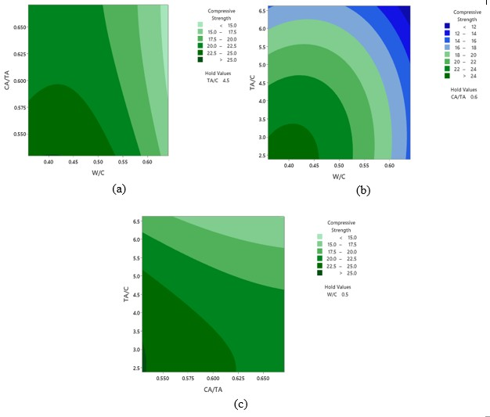

**Figure 1**: **Contour plots of compressive strength vs variables**

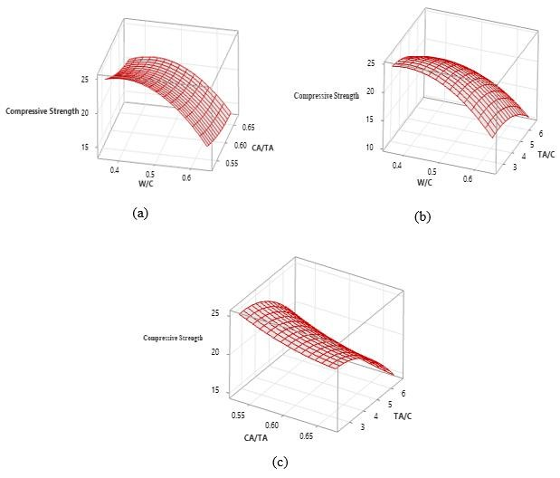

**Figure 2: Surface plots of compressive strength vs variables**

**4.4 Model Validation**

**4.4.1 Analysis of Variance**

The result for analysis of variance

(ANOVA) is presented in Table 6.

P-value measures the significance of a regression model. The developed model has an overall P-value of 0.001, indicating the developed model is highly significant. A regression equation with an overall p-value very close to zero (0) implies that the model has a good overall significance and can be used for prediction (Triola, 2018). It can also be seen that all of the linear terms and one of the quadratic terms are statistically

significant (𝑝 ≤ 0.05) while some of the

quadratic terms and all of the interaction

terms are statistically insignificant (𝑝 ≥

0.05). The standardized effects of the

individual terms on the regression equation

are shown in Figure 3.

The coefficient of determination (R2) for the regression equation is 90.2%. This value is reasonably high and implies that 90.2% of the variation in compressive strength can be explained by the design variables. A high R2 value is considered to mean that the model is well fitted. However, a regression model with R2 value of 100 or close to 100% may not

actually reflect a true relationship (Sapra,

2014; Keer *et al*., 2023). It is best therefore, to use the adjusted coefficient of determination (R2 Adj). It is defined as the particular value of R2 that is expected when the regression equation is applied on a new

sample from the same population (Kirk,

1999). The adjusted R2 for the regression equation developed is 81.38%. This is an acceptable adjustment.

**Table 6**: **Analysis of variance**

|  |  |  |  |  |  |
| --- | --- | --- | --- | --- | --- |
| **Source** | **DF** | **Adj SS** | **Adj MS** | **F-Value** | **P-Value** |
| **Model** | 9 | 196.065 | 21.7850 | 10.23 | 0.001 |
| **Linear** | 3 | 163.439 | 54.4796 | 25.58 | 0.000 |
| W/C | 1 | 77.372 | 77.3719 | 36.33 | 0.000 |
| CA/TA | 1 | 18.354 | 18.3544 | 8.62 | 0.015 |
| TA/C | 1 | 67.712 | 67.7124 | 31.79 | 0.000 |
| **Square** | 3 | 30.195 | 10.0651 | 4.73 | 0.027 |
| W/C*W/C | 1 | 21.127 | 21.1272 | 9.92 | 0.010 |
| CA/TA*CA/TA | 1 | 0.773 | 0.7731 | 0.36 | 0.560 |
| TA/C*TA/C | 1 | 6.808 | 6.8084 | 3.20 | 0.104 |
| **2-Way Interaction** | 3 | 2.431 | 0.8102 | 0.38 | 0.769 |
| W/C*CA/TA | 1 | 0.557 | 0.5565 | 0.26 | 0.620 |
| W/C*TA/C | 1 | 1.834 | 1.8336 | 0.86 | 0.375 |
| CA/TA*TA/C | 1 | 0.041 | 0.0406 | 0.02 | 0.893 |
| Error | 10 | 21.298 | 2.1298 |  |  |
| Pure Error | 5 | 0.323 | 0.0646 |  |  |
| Total | 19 | 217.363 |  |  |  |
| **R-sq** |  |  | 90.2% |  |  |
| **R-sq(adj)** |  |  | 81.38% |  |  |
| **R-sq(pred)** |  |  | 32.33% |  |  |

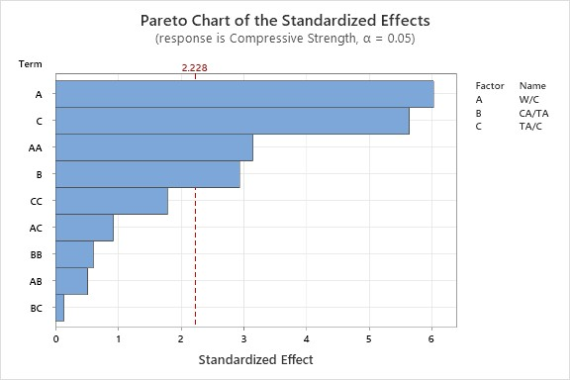

**Figure 3**: **Pareto chart of standardized effects of the polynomial term**

**4.4.2 Residual Plots**

Residual plots are plots that show the deviation of the expected values from the observed values or experimental values (Keer *et al*., 2023)

Figure 4 shows the normal plot of residuals. The plot of the residual versus the normal percent of probability is seen to approximately follow the straight line,

implying that the developed model can be used in navigating the design space. The model is hence, valid.

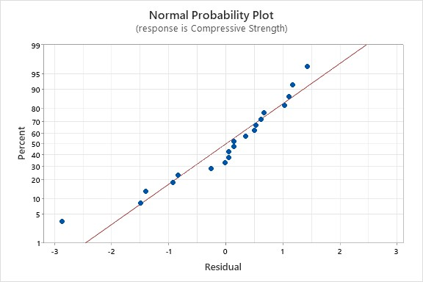

**Figure 4 Normal probability plot**

Figure 5 shows the plot of residuals against fitted values. The model is observed to be well fitted and adequate since the plot shows no regular pattern. Good residual plots shouldn’t appear to look thinner or wider when observed from left to right and should not assume a definite pattern (Triola,

2018).

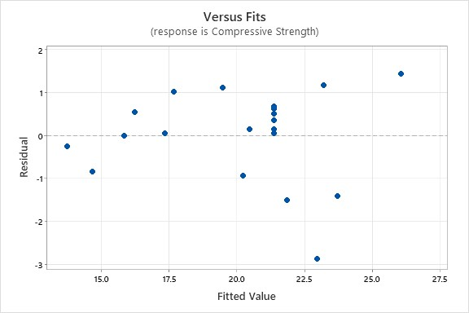

**Figure 5: Residual versus fits plot**

**4.4.3 Observed Response Versus**

**Predicted Response**

Table 7 shows a comparison between the experimental values and predicted values (from the developed model). The predicted compressive strength values are seen to compare closely to the experimental values.

Most of the predicted values are different from the experimental value in the range

±2.77%. Overall, 95% of the predicted

values are different from the experimental

values within the range of ±9.1%.

**Table 7**: **Observed response versus predicted response**

|  |  |  |  |  |  |  |  |  |
| --- | --- | --- | --- | --- | --- | --- | --- | --- |
| **Mix**  **No.** | **W/C(x1)** | **CA/TA(x2)** | **TA/C(x3)** | **Compressive**  **Strength** | | **Compressive**  **Strength** | | **Difference**  **(%)** |
|  |  |  |  | **(N/mm2)** | | **(N/mm2)** | |  |
| **(Observed) (Predicted)** | | | | | | | | |
| 1 | 0.5 | 0.6 | 4.5 | 21.72 |  | 21.429 |  | +1.34 |
| 2 | 0.6 | 0.55 | 3 | 20.59 |  | 19.56 |  | -5.00 |
| 3 | 0.6 | 0.65 | 3 | 18.70 |  | 17.735 |  | +5.16 |
| 4 | 0.35858 | 0.6 | 4.5 | 20.34 |  | 21.87721 |  | -7.56 |
| 5 | 0.5 | 0.67071 | 4.5 | 19.29 |  | 20.25801 |  | -5.02 |
| 6 | 0.5 | 0.52929 | 4.5 | 22.31 |  | 23.78997 |  | -6.63 |
| 7 | 0.5 | 0.6 | 2.3787 | 20.09 |  | 23.00981 |  | -14.53 |
| 8 | 0.6 | 0.65 | 6 | 13.48 |  | 13.8065 |  | -2.42 |
| 9 | 0.4 | 0.55 | 3 | 27.47 |  | 26.096 |  | +9.10 |
| 10 | 0.4 | 0.65 | 6 | 17.39 |  | 17.3685 |  | +0.12 |
| 11 | 0.5 | 0.6 | 4.5 | 21.87 |  | 21.429 |  | +2.02 |
| 12 | 0.5 | 0.6 | 6.6213 | 16.77 |  | 16.30226 |  | +2.79 |
| 13 | 0.5 | 0.6 | 4.5 | 21.99 |  | 21.429 |  | +2.55 |
| 14 | 0.4 | 0.65 | 3 | 24.36 |  | 23.211 |  | +4.72 |
| 15 | 0.64142 | 0.6 | 4.5 | 13.82 |  | 14.73691 |  | -6.63 |
| 16 | 0.4 | 0.55 | 6 | 20.62 |  | 20.5385 |  | +0.40 |
| 17 | 0.5 | 0.6 | 4.5 | 21.42 |  | 21.429 |  | -0.04 |
| 18 | 0.5 | 0.6 | 4.5 | 22.04 |  | 21.429 |  | +2.77 |
| 19 | 0.6 | 0.55 | 6 | 15.82 |  | 15.9165 |  | -0.61 |
| 20 | 0.5 | 0.6 | 4.5 | 21.51 |  | 21.429 |  | +0.38 |

**5.0: CONCLUSION**

The following conclusions can be drawn from this investigation

1. Slump of the concrete is directly proportional to W/C ratio and inversely proportional to TA/C ratio.

2. Kuta gravel can be used for producing C15, C20 and C25 grades of structural concrete.

3. The highest compressive strength (27.47N/mm2) was obtained with a mix proportion of W/C of 0.4, CA/TA of 0.55 and TA/C of 3.

4. The regression model developed here in is found to be well fitted, significant and adequate in predicting

28-day compressive strength.

**REFERENCES**

Ahmed, T., Ray, S., Haque, M., Nahin, T.F. and Mita, A.F. (2022). Optimization of properties of concrete prepared with waste glass aggregate and condensed milk can fibre using response surface methodology. *Cleaner Engineering and Technology,* 8, art. no. 100478.

Ajagbe, W.O., Tijjani, M.A., Arohunfegbe, I.S. and Akinleye, M.T. (2018). Assessment of fine aggregates from different sources in Ibadan and nvirons for concrete production. *International Journal of Technological Development*, 15(1),

7-13.

Akorli, K.S., Danso, K., Ayarkwa, J. and Acheampong, A. (2021). Investigating the compressive strength properties of concrete using some common Ghanian ordinary Portland cements. *International Journal of Technology and Management Research*, 6(1), 154-

166.

Apebo, S.N., Shiwua, A.J., Agbo, A.P., Ezeokokwo, J.C. and Adeke, P.T. (2013). Effect of water-cement ratio on the compressive strength of gravel crushed over burnt bricks concrete. *Civil and Environmental Research*,

3(4), 74-81.

BS EN 1008 (2002). Mixing water for concrete: specification for sampling, testing and assessing the suitability of water, including water recovered from concrete industry as mixing water for concrete. London, British Standard Institution.

BS EN 12350-2 (2009). Testing fresh concrete. Slump-test. British Standard Institution, London.

BS EN 12390-2 (2000). Testing hardened concrete. Making and curing specimens for strength tests. British Standard Institution, London.

BS EN 12390-3 (2002). Testing hardened concrete. Compressive strength of test specimens. British Standard Institution, London.

BS EN 12620 (2008). Specification for aggregates from natural sources for concrete. London, British Standard Institution.

Carley, K.M., Kamneva, N.Y. and Reminga, J. (2004). Response surface methodology.CASOS Technical Report, School of Computer Science, Carnegie Mellon University.

Damme, H.V. (2018). Concrete material science: past, present, and future innovations. *Cement and Concrete Research*, 112, 5-24.

Fapohunda, C.A., Famodimu, B.I., Adigo,

B.C. and Jeje, A.S. (2020). Effect of changing cement grade on the properties of structural concrete. *Nigerian Journal of Technological Development*, 17(3), 197-204.

Hamada, M.H., Al-Attar, A.A., Tayeh, B. and Yahaya, F.B.M (2022). Optimizing the concrete strength of lightweight concrete containing nano palm oil fuel ash and palm oil clinker using response surface methodology. *Case Studies in Construction Materials,* 16, art. no. e01061

Haque, M., Ray, S., Mita, A.F., Bhattacharjee, S. and Shams, J.B. (2021). Prediction and optimization of the fresh and hardened properties of concrete containing rice husk ash and glass fiber usinf response surface

methodology. *Case Study in*

*Construction Materials*, 14, 1-14. Keer, M., Lohiya, H. and Chouhan, S.

(2023). Goodness of fit for linear

regression using R squared and adjusted R squared. *International Journal of Research Publication and Reviews,* 4(3), 2421-2439.

Kharazi, M., Leonard, M.Y. and Hussein, A. (2013). Designing and optimizing concrete mix proportion using statistical mixture design methodology. CSCE General Conference, Montreal Quebec.May

29 to June 1, 2013.

Kirk, R.E. (1999). *Statistics. An Introduction.*

Orlando: Harcourt Brace College

Publishers.

Li, Z. (2011). *Advanced concrete technology*.

New Jersey: John Wiley & Sons Inc. Neville, A.M. and Brooks, J.J. (2010).

*Concrete technology*. Harlow, England: Pearson.

Obolewicz, J. and Wadolowska, E. (2020).

Concrete as a safe building material.

*Modern Engineering*, 3, 107-112. Olaoye, B. (2020). A comprehensive handout

on central composite design

(CCD).ObafemiAwolowo

University.

Patil, R. and Rajakumara, H.N. (2018). An overview on optimization of concrete mix design. *International Journal of Pure and Applied Mathematics*, 120 (6), 6647-6663.

Salain, I.M.A.K. (2021). Effect of water/cement and aggregate/cement ratios on consistency and compressive strength of concrete using volcanic stone waste as aggregates. *Civil Engineering and Architecture*, 9(6), 1900-1908.

Saloma, H., Ferdinand, N., Muliawan, S. and Rachman, M.F. (2020). The effect of A/C variation on compressive strength, permeability and porosity

of pervious concrete. *International Journal of Scientific and Technology Research*, 9(8), 866-871.

Sapra, R.L. (2014). Using R2 with caution.

*Current Medicine Research and*

*Practice,* 4(3), 130-134.

Shariq, M., Prasad, J. and Ahuja, A.K. (2012). Optimization of concrete mix proportioning. *International Journal of Engineering Technology and Advanced Engineering*, 2 (7), 22-28.

Shetty, M.S. (2005). *Concrete technology theory and practice*. Ram Nagar, Delhi: S.Chand & Company Limited.

Simnani, I.S. (2017). Effect of water-cement ratio on compressive strength of concrete. *Journal of Emerging Technologies and Innovative Research,* 4(10), 486-488.

Smarzewski, P. and Stolarski, A. (2022).

Properties and performance of concrete materials and structures. *Crystals*, 12, 1193. [https://doi.org/10.3390/cryst1209119](https://doi.org/10.3390/cryst12091193)

[3.](https://doi.org/10.3390/cryst12091193)

Soudki, K.A., El-Salakawy, E.F. and Elkum, N.B. (2001). Full factorial optimization of concrete mix design for hot climates. *Journal of Materials in Civil Engineering,* 13(6): 427-433.

Triola, M.F. (2018). *Essentials of statistics*.

13th edition, Boston: Pearson.