NIGERIA JOURNAL OF ENGINEERING AND APPLIED SCIENCES (NJEAS)

**EXTRACTION OF ADHESIVE FROM GUILL AND PERR (*CISSUS POPULNEA*) FOR PARTICLEBOARD PRODUCTION USING RICE HUSK**

**\*Aboje, A. A.1; Akor, I. H. 1; Uthman, H. 1; & Bala, A.2**

1Chemical Engineering Department, Federal University of Technology, Minna, Nigeria

2Civil Engineering Department, Federal University of Technology, Minna, Nigeria email: [alen248@futminna.edu.ng](mailto:alen248@futminna.edu.ng)

**Abstract**

*Preliminary analysis of the constituent materials of a particleboard shows that by replacement of its major constituent (urea formaldehyde and saw dust) with locally sourced material that has a pozzolanic effect can enable it to become more durable. Rice husk was found to possess some of these composite properties (cellulose, lignin and silica) which can therefore stand as better substitute if properly worked on. The study focuses on the extraction of organic adhesives from the Guill and Perr plant (Cissus populnea) for particleboard production using rice husk. The adhesive was extracted using a soxhlet apparatus at different operating conditions (temperature, extraction time and sample dosage) with an optimum temperature of 75 °C, and 40 g sample dosage at 90 minutes for fresh sample using Ethyl acetate as the extraction solvent. Proximate/elemental analysis of the extract*

*shows a viscosity of 0.29* . *, density of 1.25* / *, 42.8 w/w % of carbon, ash content of 3.12*

*w/w %, protein of 5.56 w/w %, Fat content of 0.68 w/w %, fiber content 1.12 w/w % while an FTIR*

*analysis of the extract shows the presence of carboxylic group at wave number of 1680.64 . In this study, the method reported by Azumah (2014) from Shanghai Jinnan Import and Export Co. Ltd in line with the manufacturing process of particleboard was viewed under the following stages: Pre- treatment/Chip preparation stage, Drying and sizing stage, Adhesive regulating and applying stage. Others are: simulation and fabrication of Mould Stage, Forming and hot-pressing stage, Cooling and sizing stage and finally Characterisation stage. From the various particleboards produced, the result from the sample tagged J with 1:3 adhesive to rice husk ratio (wt. %) at 70ºC within a pressing time of 10 minutes shows the best Modulus of Elasticity (410 N/mm2), Modulus of Rupture (19.04*

*N/mm2) with an average density of 1013kg/m3 and Scanning Electron Microscopy (SEM) showing the surface morphology and the level of compactedness between the adhesive and the aggregate proportion of rice husk used. This was compared with the conventional boards and it shows similar mechanical properties and met the LD-1 requirement of ANSI A208.1Standards.*

**Keywords:** Adhesive, *Cissus Populnea*, Delignification, Particleboard, Rice husk

**INTRODUCTION**

The desire of mankind to have shelter and furniture requires construction materials; these construction materials can exist in various resources; ranging from stones to timber (Acharya *et al*., 2011). To satisfy this craving of humanity, the quest for those resources sets in; this led to the use of substances that has the potential of being transformed into shelter and other furniture materials (Topbaşlı, 2013). Due to this change in trend of life patterning furniture

process, the demand for wood became high and led to deforestation (Indah *et al*., 2018). In the last few decades, successful development and improvement of wood based composites panels (with the economic benefit of producing low cost wooden materials) has been a major alternative to solid wood usage (Mohanty *et al.*, 2015). The demand for composite wood products of various varieties like particleboard, plywood, hardboard, oriented standard board, medium density fiberboard and veneer board has equally increased

significantly throughout the world (Chen *et al*., 2006, Awopetu *el al.*, 2019). In Modern industrial processes, particleboards are made mainly from selected particles bonded together with a thermosetting resin. Mostly used resins are formaldehyde based, that are usually produced from petrochemical raw materials (Yang *et al*., 2007). The concept of substituting the fast depleting petrochemical raw material (formaldehyde) which are known to emit carcinogenic gases with other environmental friendly adhesive is always desired (Mohanty *et al.,* 2015). The binding agent in particleboard processing cannot be neglected, as it plays a vital role in its longevity and water permeability. The use of synthetic glue and other chemical bond pose a high cost of production on its processing (Jamaludin *et al*., 2001, Owofadeju *et. al*.,

2016). In this study, the extraction of adhesive from *Cissus populnea* (Okoho Plant) for particleboard production can be attributed to its high availability, low cost of extraction, binding ability, resistance to weathering and eco-friendly makes it a good substitute for phenol-formaldehyde resin and other conventional adhesives used. Cissus Populnea adhesive also called Guill and Perr, is a tropical climbing plant usually found in West Africa, particularly in Nigeria (Olutayo *et al*., 2019). It belongs to the family of Amplidaceae (Vitaceae). Adhesive, also known as glue, is any compound that adheres or binds particles together when applied to one surface or both surfaces, of two separate items and then resists their separation (Pike, 2013).

**MATERIALS AND METHODS**

The *Cissus populnea* used in this study were obtained from Inele Ugoh, Olamaboro local government of Kogi State. The rice husks were sourced from Gidan Kwano Village of

Niger State. More so, major reagents used include; Sodium hydroxide (NaOH) pellet - Burgoyne and Co, Hydrochloric acid (HCl) which were both bought from Ochala chemical store in Ankpa Kogi state, Nigeria. Ethyl acetate and distilled water chemistry department faculty of physical sciences Kogi State University Nigeria. All the reagents used are of analytical grade/standard.

*A. Methods: Extraction of Adhesive*

After getting all the required materials and equipment needed for the extraction of the adhesive, the barks of the fresh *Cissus populnea* stems obtained were scrapped off and chopped into smaller sizes (4-8 cm long) with an average weight of 0.2kg. The chopped sample was delignified by treating with 0.1M NaOH in a 10L plastic bowl at room temperature for 48 hours, after which samples were washed repeatedly with distilled water to neutralize the sample. After the delignification process, the sample was divided into two groups. The first group was oven dried and then pulverized into powdery form and a mesh sieve was use to obtain a particle size of 150 µm. The second group was blended using a laboratory blender to obtain a paste. After each group of the samples had undergone size reduction, the fresh samples were weighed out ranging from 30 g to 50 g respectively and then enclosed in a Muslin cloth. Likewise, the dried samples were also weighed out ranging from 30g to 50g respectively and enclosed with a Muslin cloth. Each of the enclosed

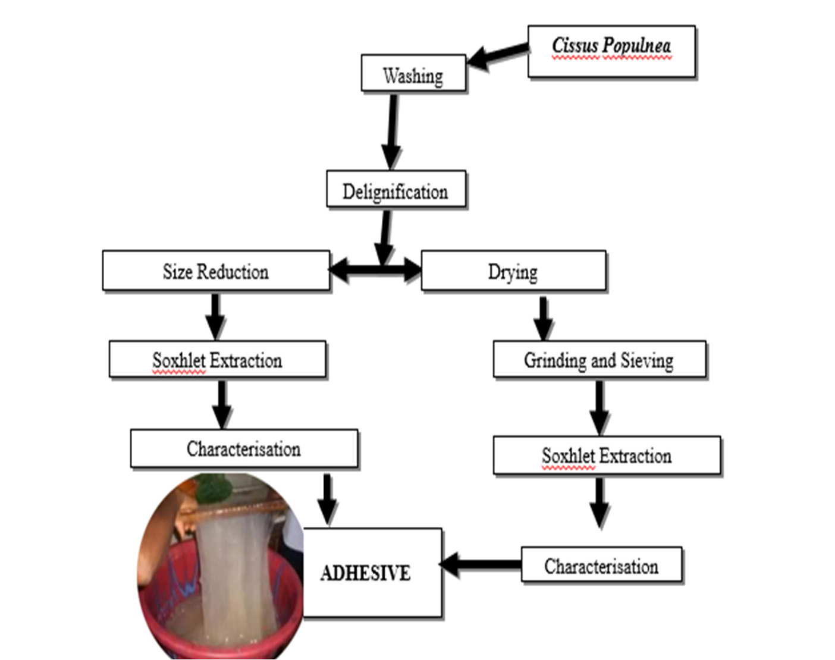

**Fig. 1:** Extraction process of Adhesive from *Cissus populnea*

samples was placed in the thimble of the soxhlet extractor and the operating conditions were varied, having a temperature range of 65oC to 85oC. More so, the operating time was varied from 30 minutes to 90 minutes respectively. Fig. 1 shows the process and Table 1 shows the variance of variable for response surface model used in

the extraction process, comprising of the

lower, middle and upper limit for the extraction. A multiple regression analysis was done using Design Expert software 7.0 to obtain the model to this experimental data in order to get the fitted quadratic response model. A model equation in terms of actual factors including the non – significant terms for percentage yield, Y is given by the

truncated second order polynomial equation:

= 81.88 + 0.6630 + 1.63 + 0.8670 – 0.2512 − 0.3162

+ 1.42 – 2.10 + 0.4767 – 7.05 (1)

where the extraction temperature is with coded value (A), the extraction time with

coded value (B), and the sample dosage with coded value (C)

**Table 1:** Variance of variable for response surface model the extraction

|  |  |  |  |
| --- | --- | --- | --- |
| **Factor** | **Lower** | **Middle** | **Upper** |
| Temperature (0C) | 65 | 75 | 85 |
| Extraction time (Min) | 30 | 60 | 90 |
| Amount (wt %) | 30 | 40 | 50 |

*B. Production of Particleboard*

In this study, the method reported by Azumah, (2014) from Shanghai Jinnan Import and Export Co. Ltd in line with the manufacturing process of particleboard was viewed under the following stages (Fig. 2): Pre-treatment/Chip preparation stage, Drying and sizing stage, adhesive regulating and applying stage, Simulation and fabrication of Mould Stage, Forming and hot- pressing stage, Cooling and sizing stage, Analysis/Characterization (quality check). Upon obtaining adequate amount of the rice husk, stones and other materials were handpicked from the samples. Distilled water was used to wash and remove remnants of impurities from the samples.

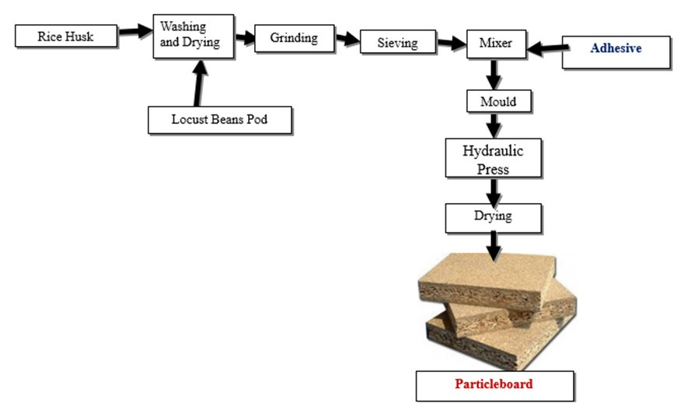

After a series of washing, the rice husk was dried. This was carried out using an electrical oven, at 80oC for 8 hours. After the drying comes the sizing stage; when the desirable size was obtained after the crushing, a particle size of 150µm was obtained by sieving, Loh *et al*., (2010) reported similar particle size of rice husk in particleboard production. The American National Standard for Particleboard (ANSI,

2009), classifies particleboard by physical, mechanical and dimensional characteristics as well as adhesive/binder levels. In particleboard production, the ratio of adhesive to feed stock used plays a very important role in meeting up to the regulatory standard. In this research, the ratio for adhesive to feed stock was optimized to know the optimum condition where the best yield will be produced. This was obtained through Response Surface Methodology using the design expert software. Table 2 show the variance of variable for response surface model used in

the particle board production.

**Fig. 2:** Particleboard production process

**Table 2:** Variance of variable for response surface model for particleboard

|  |  |  |  |
| --- | --- | --- | --- |
| **Factor** | **lower** | **centre** | **Upper** |
| Temperature (0C) | 60 | 70 | 80 |
| Pressing time (Min)  Adhesive to Feed stock Ratio (wt %) | 5  1:3 | 10  1:6 | 15  1:9 |

From the prepared mixture of feed stock and adhesive after completion of mould, aggregate proportion of the mixture were properly poured into the mould as relative heat was applied. This was done in accordance with the result obtained from the Response Surface Methodology via composite design expert. This comprises of

Rice Husk to Adhesive ratio, taking into consideration the temperature of the pressing and time spent during the pressing respectively. In place of the electric hot- pressing machine, the electrical hot plate was used varying the temperature from 60oC to 80oC, applying pressure from both ends of the mould using bolts and Nuts. The cooling

was done after the forming and hot-pressing stage, to allow the particle board cools off as it dried out. This was done to reduce the heat content of the particleboard. After the cooling process came the sizing of the particle board. This was done by trimming out the extruded edges and area of improper

2010). Modulus of rupture (MOR) is a measure of the ability of a sample to resist a transverse (bending) force perpendicular to its longitudinal axis. The bending strength of each test piece was calculated from the formula show below.

3 f L

alignment as a result of the

compression/pressure applied during the

MOR =

(2)

2bt

hot-press process. An emery paper was used to remove such areas of default.

*C Analysis on Adhesive*

In this research several characteristic tests (ash content, moisture content, protein content, lipid content, crude fibre, carbohydrate content, Viscosity, pH) were performed on the adhesive extracted in accordance with Association of Official Analytical Chemistry method (AOAC,

1990) on the performance of an adhesive. More so, instrumental analysis like Fourier transforms infrared (FTIR) was carried out to know the presences of functional groups in the samples at respective wave number using the Infrared Spectrophotometer.

*D Analysis on Particleboard*

In this research, several characteristic tests were performed on the particleboard produced in accordance with the German

Institute for Standardization of particleboard

where: is the maximum load, is the distance between the centers of the supports, in millimeters, is the width of the test piece in millimeters, and is the thickness of the test piece in millimeters. In accordance with DIN EN 312, Internal Bond Strength of a sample is the ability of the material to withstand internal stress within the sample in relation to its adhesive bond. Internal Bond Strength of a sample generally correlates with the density in the panel core. This was investigated by using Instron machine to compress the sample to determine the IB strength. The MOE of a material show the extent to which a material can be stretched before yielding or breaking. In accordance with DIN EN 312, this was done using the Instron machine. The modules of elasticity of each test piece were calculated from the formula below:

f L .

(DIN EN 312, 2010), which requires three

MOE =

(3)

4bdt

main standard tests. These standard tests

carried out on the produced particleboards are: Modulus of Elasticity (MOE), Modulus of Rupture (MOR) and the swelling in thickness test. These tests were necessary to ascertain if the panels satisfy the minimum required values of MOR, and swelling in thickness due to moisture absorption. The DIN EN 312 particleboard requirement is equivalent to the American National Standard A208.12009 (CPA, 2009) for wood particleboard classes M-2 and M-3 (Li *et al*.,

where is the deformation occurring against the load. The water absorption test was conducted to determine the rate of water penetration into the sample which will in turn result in physical change in samples dimension. In accordance with the DIN EN

312, the weight of each sample were carefully measured out after which, they were submerged in the distilled water after taking their measurements at room temperature for 12 hours to determine long term water resistance properties,

respectively. The samples were taken out and surfaces were dried using a clean dry cloth after going through an immersion process. They were weighed again for every

4 hours until a constant weight was obtained. Water absorption at time (t) was calculated as follows:

**RESULTS AND DISCUSSION**

*A. Analysis on the Feed Stock*

The proximate compositions of the feed stock (rice husk) is presented in Table 3. The Ash contents and Moisture contents of the sample were 26.18 and 4.55 % w/w respectively. These values compare favorably with those reported by Cuthbert (2014), although it is slightly less than the range, 26.20 % as reported by Cuthbert (2014). It is also slightly greater than the

18.5 % reported by Anbu et al. (2009)

(W (t) − W )

where: . ( ) is the water absorption (%)

at time , is the initial weight, W (t) is

the weight of the samples at a given

immersion time, . The surface morphology of the samples was observed using SEM machine, this was carried out to check the surface morphology of the samples. Moderate resolution scanning electron microscope (SEM) of JEOL JSM – 630 models was used to study the morphology of the samples. More so, other physical and mechanical tests were carried out including: Moisture content test, Particleboard density, Water absorption test. This was done in accordance to ANSI A208.1-2009, an American Standard of Testing and Methods (ASTM) which were compared with the minimum required for particleboard production by the norm of these Standards Institute. Particle board Morphology Characterization using SEM was also carried out on the sample to analyze the sample surface morphology and compatibility.

.

W. A (t) =

× 100 (4) W

**Table 3:** Proximate Analysis of rice husk

**Composition Experimental**

**Anbu *et al.* (2009)**

**Cuthbert, (2014)**

**% Composition % Composition % Composition**

|  |  |  |  |  |  |
| --- | --- | --- | --- | --- | --- |
| Ash | 26.18 |  | 18.15 |  | 26.20 |
| Moisture | 4.55 |  | 10.40 |  | 8.80 |
| Volatile Matter | 52.38 |  | 54.10 |  | 59.20 |
| Fixed Carbon | 8.04 |  | 10.35 |  | 14.60 |

*B. Extraction Yield of Adhesive*

After the delignification and the extraction of Adhesive from *Cissus populnea* plant, the percentage yield from both the dried and the fresh samples was calculated as shown in Table 4 using ethyl acetate as the extraction solvent. The Model F-value of 13.59 as seen in Table 5 implies the model is significant. There is only a 0.52% chance that an F-value

this large could occur due to noise. P-values less than 0.0500 indicate model terms are significant. In this case B, BC, C² are significant model terms. Values greater than

0.1000 indicate the model terms are not significant. If there are many insignificant model terms (not counting those required to support hierarchy), model reduction may

improve the model. From Table 5, the optimum yield from the fresh sample was obtained at the sample dosage of 40g

(highest point) and 50g (lowest point).

Likewise, the optimum yield from the dried sample were obtained at the sample dosage of 40g (highest point) and 50g (lowest point)

respectively.

**Table 4:** Extraction Response using Ethyl Acetate

|  |  |  |  |  |  |  |
| --- | --- | --- | --- | --- | --- | --- |
| **Std** | **Run** | **Temperature**  **0**  **( C)** | **Time (Minutes)** | **Amount (g)** | **Fresh Sample**  **(Wt. %)** | **Dried Sample**  **(Wt. %)** |
| 6 | 1 | 85.00 | 30.00 | 50.00 | 70.80 | 60.00 |
| 5 | 2 | 65.00 | 30.00 | 50.00 | 70.40 | 65.20 |
| 13 | 3 | 75.00 | 60.00 | 30.00 | 72.00 | 71.33 |
| 4 | 4 | 85.00 | 90.00 | 30.00 | 73.33 | 70.00 |
| 12 | 5 | 75.00 | 90.00 | 40.00 | 84.15 | 72.00 |
| 7 | 6 | 65.00 | 90.00 | 50.00 | 76.40 | 66.80 |
| 2 | 7 | 85.00 | 30.00 | 30.00 | 74.00 | 70.00 |
| 3 | 8 | 65.00 | 90.00 | 30.00 | 72.67 | 66.67 |
| 8 | 9 | 85.00 | 90.00 | 50.00 | 76.80 | 68.40 |
| 11 | 10 | 75.00 | 30.00 | 40.00 | 80.50 | 67.50 |
| 15 | 11 | 75.00 | 60.00 | 40.00 | 82.00 | 68.50 |
| 9 | 12 | 65.00 | 60.00 | 40.00 | 78.50 | 66.50 |
| 1 | 13 | 65.00 | 30.00 | 30.00 | 71.33 | 67.33 |
| 14 | 14 | 75.00 | 60.00 | 50.00 | 77.60 | 67.20 |
| 10 | 15 | 85.00 | 60.00 | 40.00 | 81.00 | 65.00 |

These results obtained can be attributed to the effects of the process variables, such as; Temperature and extraction time. Fig. 3 shows the effect of process variables on the extraction yield using Response surface methodology. From the result, it can be seen that the maximum yield of 84% was obtained at 75°C with 40g sample dosage at

90mins for fresh sample using Ethyl acetate

as the extraction solvent. While the minimum yield of 60% was obtained at 85°C with 50g sample dosage at 30mins from dried sample using Ethyl acetate as extraction solvent. This shows that fresh samples give higher yield of extract than the dried samples and shows a good extraction process variable to use in the extraction technique.

**Table 5:** Analysis of Variance for the Response Surface Model

**Source Sum of**

**Df Mean**

**f-Value p-Value**

**Squares Square**

|  |  |  |  |  |  |  |  |  |  |
| --- | --- | --- | --- | --- | --- | --- | --- | --- | --- |
| Model | 264.74 |  | 9 |  | 29.42 |  | 13.59 |  | 0.0052 |
| A-Temperature | 4.40 |  | 1 |  | 4.40 |  | 2.03 |  | 0.2134 |
| B-Time | 26.63 |  | 1 |  | 26.63 |  | 12.31 |  | 0.0171 |
| C-Amount | 7.52 |  | 1 |  | 7.52 |  | 3.47 |  | 0.1214 |
| AB | 0.5050 |  | 1 |  | 0.5050 |  | 0.2333 |  | 0.6495 |
| AC | 0.8001 |  | 1 |  | 0.8001 |  | 0.3697 |  | 0.5697 |
| BC | 16.05 |  | 1 |  | 16.05 |  | 7.41 |  | 0.0416 |
| A² | 11.32 |  | 1 |  | 11.32 |  | 5.23 |  | 0.0709 |
| B² | 0.5843 |  | 1 |  | 0.5843 |  | 0.2700 |  | 0.6255 |
| C² | 127.75 |  | 1 |  | 127.75 |  | 59.02 |  | 0.0006 |
| Residual | 10.82 |  | 5 |  | 2.16 |  |  |  |  |
| Cor Total | 275.56 |  | 14 |  |  |  |  |  |  |

significant

= 0.47 = 0.997 = 0.9800 = 0.892

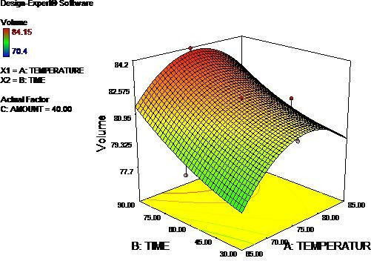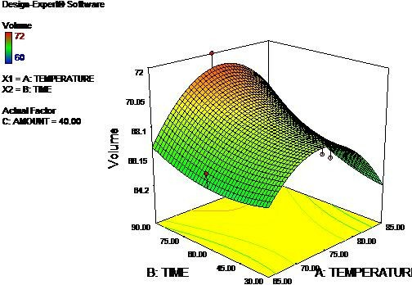

**Fig. 3:** Response using Ethyl acetate for dried and fresh sample

*C. Analysis on Adhesive*

Proximate analysis on the Adhesive shows how effective the extraction process was. This can be seen in Table 6. From the result obtained, the Ash, Moisture, Protein, Fat, Fibre and carbohydrate content of the adhesive were: 3.12 %, 12.74 %, 5.56%,

0.68 %, 1.12% and 76.78 % w/w respectively. Hanninen *et al*. (2020) have shown that the bonding strength decreases when the moisture content is increased above 20%. The carbohydrate content of the adhesive is slightly less than the values reported by Olutayo *et al*. (2019) and Oyedemi (2012), ranging from 82.31-

87.81% w/w. The ash content of the adhesive was slightly higher than that of Oyedemi, (2012) but lower than the value reported by Olutayo et al., (2019). The FTIR spectrum of the extract is shown in Fig. 4. The finger print region of the spectrum consists of characteristic peaks between 800 and 3400 per cm; these peaks are attributed to the C-N stretching, the C-O bond stretching, the OH stretching, N-H bond stretching and C-H bond stretching respectively, as reported by Azeez and Onukwuli (2019) in their study. The pH values of the adhesive as recorded Table 7, is 6.5. This pH values as compared with the other adhesive that have been reported in literature is within the range. Iwe *et al*.

**Table 6:** Proximate Analysis of Adhesive

**Composition Experimental**

(2004) reported Cissus extracted with the aid of edible starch has a pH value of 6.49 while the pH of the polyamine – adhesives formulated with mucuna and African yam bean were 6.3 and 5.5 respectively Owofadeju and Alawode (2016). pH is critical for determining the product shelf life from the view point of microbiological degradation of sensitive ingredients. Preservation of Cissus extract could be by acidification and mild heating (Iwe *et al*.,

2004). The differences in the pH could be due to solute hydration, physicochemical environment and thermodynamic properties of the system.

**Achikanu and Ani (2020)**

**% Composition % Composition**

|  |  |  |  |
| --- | --- | --- | --- |
| Ash | 3.12 |  | 4.61 |
| Moisture | 12.74 |  | 2.67 |
| Protein | 5.56 |  | 1.49 |
| Fat content | 0.68 |  | 13.07 |
| Fiber Content | 1.12 |  | 22.13 |
| Carbohydrate content | 76.78 |  | 56.04 |

**Table 7:** Physiochemical Analysis of Adhesive

|  |  |  |  |  |
| --- | --- | --- | --- | --- |
| **Composition** | **Unit** | **Experimental**  **Value** | **Iwe *et al.***  **(2004)** | **Oyedemi,**  **(2012)** |
| pH | - | 6.5 | 6.4 | 6.8 |
| Specific Gravity | - | 1.25 | 1.25 | - |
| Viscosity | Pa.s | 0.294 | 0.24 | 0.26 |
| Density | g/cm3 | 1.25 | 1.25 | - |

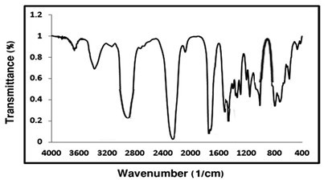

**Fig. 4:** FT-IR Spectrum of *Cissus Populnea* Adhesive

*D. Analysis on Particleboard*

From the particleboard produced, it was observed that some of the products were found to be inappropriate (twisted, Cracked and bent) while others appeared appropriate. This is as a result of the different mixing ratio, temperature applied and pressing time applied. From the result (Table 8), product with high dosage of Locust Beans Pod tends to twist more at high temperature compared to others. More so, the highest number of cracked products was observed from the 50-

50% mixing at low adhesive ratio.

Appropriate and moderate products were obtained at high adhesive ratio, low temperature, high rice husk to locust beans Pod dosage and moderate pressing time. From the result, it can be seen that the adhesive ratio plays a very important role in the resistance to stress property of the particleboard. Compared with literature, Azumah (2014) recorded its highest bending mean stress at a high adhesive ratio. More so, the effect of the pressing temperature can also be seen as higher temperature weakens the adhesive bonding capacity thus reducing its bending stress. The water content of each

**Table 8:** Produced particleboard with varying process parameters.

|  |  |  |  |  |  |  |  |  |  |
| --- | --- | --- | --- | --- | --- | --- | --- | --- | --- |
| **Rice Husk**  **(wt. %)** | **Locust**  **Beans Pod** | | **Gum to Feed stock Ratio** | | **Pressing**  **Temperature** | | **Pressing**  **Time** | | **Product**  **Tag** |
| **(wt. %) (wt. %) (0C) (Min.)** | | | | | | | | | |
| 25 | 75 |  | 6 |  | 70 |  | 10 |  | A |
| 50 | 50 |  | 9 |  | 60 |  | 15 |  | B |
| 75 | 25 |  | 3 |  | 80 |  | 5 |  | C |
| 100 | 0 |  | 6 |  | 70 |  | 10 |  | D |
| 50 | 50 |  | 6 |  | 70 |  | 10 |  | E |
| 75 | 25 |  | 9 |  | 60 |  | 5 |  | F |
| 100 | 0 |  | 3 |  | 80 |  | 15 |  | G |
| 100 | 0 |  | 9 |  | 60 |  | 10 |  | H |
| 50 | 50 |  | 9 |  | 80 |  | 5 |  | I |
| 75 | 25 |  | 3 |  | 70 |  | 10 |  | J |
| 50 | 50 |  | 6 |  | 60 |  | 15 |  | K |
| 75 | 25 |  | 9 |  | 80 |  | 5 |  | L |
| 50 | 50 |  | 3 |  | 70 |  | 5 |  | M |
| 75 | 25 |  | 6 |  | 60 |  | 15 |  | N |
| 100 | 0 |  | 9 |  | 80 |  | 5 |  | O |
| 75 | 25 |  | 3 |  | 60 |  | 10 |  | P |
| 25 | 75 |  | 9 |  | 70 |  | 5 |  | Q |
| 50 | 50 |  | 3 |  | 60 |  | 15 |  | R |
| 75 | 25 |  | 6 |  | 80 |  | 5 |  | S |
| 100 | 0 |  | 9 |  | 70 |  | 10 |  | T |

of the samples was determined using the equation reported by Huang & Li (2016). Tests were carried out to determine the moisture content, Modulus of Elasticity (MOE), water absorption, swelling in thickness, Modulus of rupture (MOR) and density of the particle board produced. The results of the test are presented in Table 9. The results for the moisture content, swelling in thickness, MOR and MOE are also presented in the form of histograms in Figs. 5 - 8 for better comparison. It was

observed that the Particleboard with the highest amount of Moisture content was obtained from the particleboard containing high quantity of rice husk to adhesive ratio at low temperature and pressing time. While the lowest Moisture content was obtained from particleboards that contain higher amount of Adhesive to rice husk ratio at high temperature and pressing time. Hence, this shows that production temperature affects the moisture content of a sample. The higher

**Table 9:** Mechanical and Physical Properties of Produced Particleboard

|  |  |  |  |  |  |  |
| --- | --- | --- | --- | --- | --- | --- |
| **Product**  **Tag** | **Moisture content** | **MOE (N/mm2)** | **Water**  **Absorption** | **Swelling in thickness** | **MOR (N/mm2)** | **Density**  **(Kg/m3)** |
|  | **(wt. %)** |  | **(%)** | **(%)** |  |  |
| A | 2.38 | 230 | 4.65 | 3.33 | 10.67 | 1147 |
| B | 5.26 | 191 | 10.00 | 6.67 | 8.86 | 1067 |
| C | 8.33 | 333 | 12.82 | 13.33 | 15.47 | 1040 |
| D | 11.76 | 272 | 13.16 | 16.67 | 12.62 | 1013 |
| E | 5.41 | 210 | 10.26 | 10.00 | 9.73 | 1040 |
| F | 8.57 | 320 | 10.53 | 6.67 | 14.83 | 1013 |
| G | 8.82 | 233 | 13.51 | 13.20 | 10.79 | 987 |
| H | 12.50 | 360 | 13.89 | 17.27 | 16.71 | 960 |
| I | 8.11 | 250 | 7.50 | 7.33 | 11.62 | 1067 |
| J | 8.57 | 410 | 10.53 | 12.93 | 19.04 | 1013 |
| K | 5.26 | 206 | 7.50 | 5.73 | 9.55 | 1067 |
| L | 8.82 | 344 | 13.51 | 12.20 | 15.95 | 987 |
| M | 5.41 | 176 | 10.26 | 7.27 | 8.16 | 1040 |
| N | 5.56 | 409 | 10.53 | 12.00 | 18.99 | 1013 |
| O | 8.82 | 304 | 16.22 | 19.67 | 14.09 | 987 |
| P | 8.33 | 360 | 7.69 | 12.67 | 16.68 | 1040 |
| Q | 2.38 | 230 | 7.14 | 4.00 | 10.67 | 1120 |
| R | 5.26 | 191 | 7.50 | 6.67 | 8.86 | 1067 |
| S | 8.33 | 333 | 10.53 | 10.40 | 15.47 | 1013 |
| T | 11.76 | 272 | 13.89 | 17.33 | 12.62 | 960 |

the temperature the lower the moisture content of the sample, while the lower the temperature the higher the moisture content recorded. More so, it shows that rice husk is more hydrophilic than the adhesive. This is attributed to the fact that the absorption capacity of water is higher than that of the adhesive owing to the fact that carbon- hydrogen ratio is dominant (starch). This is result is similar to that reported by Azumah (2014). From the standard equation for calculating the density (ρ) of a material as a ratio of its mass to the volume occupied, the

density was evaluated from its uniform volume (75cm3) and varying masses ranging from 72-86g respectively. It was observed that sample Q had the highest density at 1120

Kg/m3, which was obtained from the

particleboard containing highest quantity of rice husk to adhesive ratio. The Modulus of elasticity (MOE) is an evaluation of the flexibility characteristics of a sample. In this paper, the optimum MOE was achieved with sample J, which also recorded the highest MOR. This shows that modulus of rupture (MOR) and MOE are somehow linked with

respect to the mechanical property of the material. Also, the result of the Termite resistivity test (TRT) showed that the best result was obtained with samples that have high adhesive dosage and it decreased with reduction of the adhesive. Fig. 9 shows samples of the produced particle board. The surface morphology of the sample was observed using SEM machine. From Fig. 10

we can deduce the binding interaction

between the adhesive and the feed stock. The binding capacity of an adhesive used in particleboard production contributes to mechanical properties and also water permeability of the product. From the result, an average distribution of the adhesive is seen and region around the right corner of the result shows lower distribution of adhesive as compared to other region.

14

12

10

8

6

**%**

4



2

0

A B C D E F G H I J K L MN O P Q R S T

**Product Tag**

25

20

15

**%**

10

5

0

A B C D E F G H I J K L MN O P Q R S T

**Product Tag**



**Fig. 5:** Moisture content (wt.%) **Fig. 6:** Swelling in thickness (%)

20

15

10

5



0

**N/mm2**

A B C D E F G H I J K L M N O P Q R S T

**Product Tag**

500

400

300

**N/mm2**

200

100

0

A B C D E F G H I J K L M N O P Q R S T

**Product Tag**



**Fig. 7:** MOR (N/mm2) **Fig. 8:** MOE (N/mm2

)

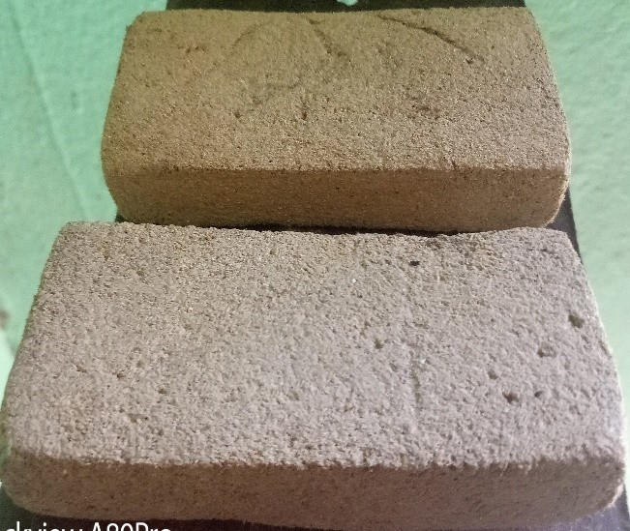

**Fig. 9:** Samples of produced Particleboard

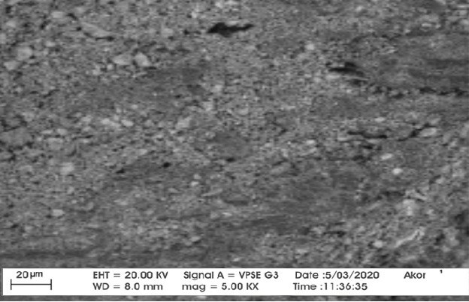

**Fig. 10:** SEM morphology of Particleboard

**CONCLUSION**

In the study, the following conclusions were drawn: The Adhesive was successfully extracted from *Cissus populnea* plant studying the effect of process parameters via RSM and the optimum yield (84%) was obtained at 75°C with 40g sample dosage at

90mins for fresh sample, while the lowest yield (60%) was obtained at 85°C with 50g

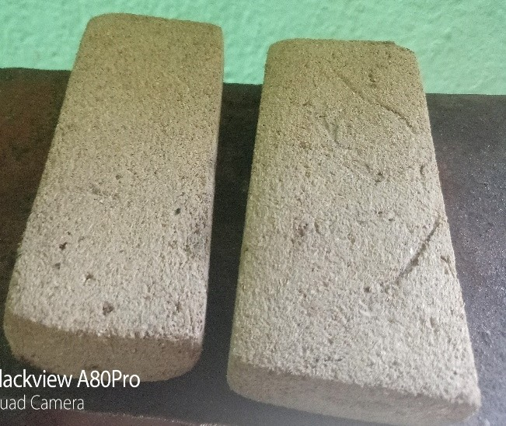

sample dosage at 30mins from dried sample using Ethyl acetate as extraction solvent respectively. Comparative study on the yield of the Adhesive obtained from different Samples (fresh and dried) shows higher percentage of adhesive in fresh sample to dried sample*.* The analysis of the sample using Fourier Transform Infrared Spectroscopy (FT-IR) shows the presence of carboxylic group in the substance at similar

stretching with literature. The result of the analysis of the particleboard indicated that sample J has the best MOE of 410 N/mm2, MOR of 19.04 N/mm2, with an average density of 1013kg/m3 respectively. Hence, the particleboard produced shows similar mechanical and physiochemical properties with the conventional boards and its mechanical properties met the LD-1 requirement of ANSI A208.1Standards.

**ACKNOWLEDGEMENT**

The authors would like to acknowledge support from Mr. Bulus B. Musa of Water Resources, Aquaculture and Fisheries Technology Department Federal University of technology Minna for his Laboratory guidance and Mr. Clement O. of Shestco chemical Advance laboratory Sheda Abuja, for the technical assistance they rendered during the analysis. The authors also express their sincere gratitude to the Department of Chemical Engineering, Federal University of technology Minna for the technological know-how and to Mr. Ochala A. of Chemistry Department Kogi State University Nigeria, for the technical support and laboratory assistance rendered.

**REFERENCES**

Achikanu, C.and Ani, O. N. (2020).

Nutritional and Phytochemical Content of Cissus populnea (Okoho) Stem Bark. Biology. DOI:10.9734/ajrb/2020/v7i330139Cor pus ID: 225292804.

Awopetu, O. O. and Hassan, B. B. (2019).

Production and Characterization of Particleboards from Common Agrowastes in Nigeria. International Journal of Innovative Science and Research Technology, 4(1).

Azeez, T.O.; Onukwuli, O. D. and Chukwudi, M. M. (2018). Mechanical properties of lignocellulosic fibers (saw dust, rice husk and okpa seed husk) reinforced waste and virgin polyethylene. Pakistan Journal of Scientific and Industrial Research

61A(1):28 - 33.

Acharya, S. K.; Mishra, P., & Mehar, S. K. (2011). Effect of surface treatment on the mechanical properties of bagasse fiber reinforced polymer composite. BioResources, 6(3), 3155–3165.

Anbu, C. J.; Dato, Y. B. & Nordin, B. Y. (2009). Particleboards from Rice Husk. A Brief Introduction to Renewable Materials of Construction.

ANSI. (2009). American National Standards Institute, A208.1-2009, Composite Panel Association, 19465 Deerfield Avenue, Suite 306, Leesburg, VA

20176, USA.

AOAC. (1990). Association of Official Analytical Chemistry. Official Methods of AOAC International, 14th Edition, Gaithersberg, MD, USA.

Azumah, O. K. (2014). Production of Particleboard Using Sawdust and Plastic Waste. Kwame Nkrumah University of Science and Technology College of Agriculture and Natural Resources Faculty of Renewable Natural Resources, Department of Wood Science and Technology.

Chen, H. C.; Chen, T. Y. & Hsu, C. H. (2006). Effects of wood particle size and mixing ratios of HDPE on the properties of the composites. Holz Roh Werkst, 64, 172–177.

Cuthbert, M. F. (2014). Analysis of energy characteristics of rice and coffee husks

blends. International Scholarly

Research Notices.

DIN EN 312. (2010). German Institute for Standardization. Particleboards and fibreboards Specifications.

Hanninen, T.; Rautkari, L.; Hautamaki, L.,

& Altgen, M. (2020). The effect of diammonium phosphate and sodium silicate on the adhesion and fire properties of birch veneer. Holzforschung, 74(4), 372–381.

Huang, J., & Li, K. (2016). Development and characterization of a formaldehyde- free adhesive from lupine flour, glycerol, and a novel curing agent for particleboard (PB) production. Holzforschung, 70(10), 927–935.

Indah, R.; Nurfika, R.; Karim, A. & Musrizal, M. (2018). Modifying Of Particle Boards From Rice Husk and Pinus Merkusii Sawdust And Using Soybean Waste Waters Based Adhesive. 2nd International Conference on Science (ICOS), Makassar, Indonesia, 279.

Iwe, M. O.; Obaje, P. O., & Akpapunam, M.

A. (2004). Physicochemical Properties of Cissus Gum Powder extracted with the aid of Edible Starches. Plant Foods for Human Nutrition, 59, 161–168.

Jamaludin, K.; Jalil, H. A.; Jalaludin, H.; Zaidon, A. A.; Latif, M. M., & Nor, M. Y. (2001). Properties of Particleboard Manufactured from Commonly Utilized Malaysian Bamboo. Pertanika J. Trop. Agric. Sci, 24(2), 151–157.

Li, X.; Cai, Z.; Winandy, J. E., & Basta, A.

H. (2010). Selected properties of particleboard panels manufactured from rice straws of different geometries.

Bioresource Technology, 101(12),

4662–4666.

Loh, Y. W.; H`ng, P. S.; Lee, S. H.; Lum, W.

C. & Tan, C. K. (2010). Properties of Particleboard Produced from Admixture of Rubberwood and Mahang Species. Asian Journal of Applied Sciences, 3, 310–316.

Mohanty, B. N.; Sujatha, D. & Uday, D. N. (2015). Bamboo Composite material: Game - changer for developing economies. 10th World Bamboo Congress, Korea 2015.

Olutayo, A. A.; Mbang, N. F.; Michael, A.

O., & Tolulope, O. A. (2019). Evaluation of Cissus populnea gum as a directly compressible matrix system for tramadol hydrochloride extended- release tablet. Department of Pharmaceutics and Pharmaceutical Technology, Olabisi Onabanjo University, Ago Iwoye, Nigeria.

Owofadeju, F. K. & Alawode, A. O. (2016).

Evaluation of Vetiver (Vetiveria nigritana) plant extract as eco-friendly wood preservative. Arid Zone Journal of Engineering, Technology and Environment, 12, 49–57.

Oyedemi, T. I. (2012). Characterization of Fuel Briquettes from Gmelina Arborea (Roxb) Sawdust and Maize Cob Particles Using Cissus Populnea Gum as Binder. Department of Agricultural and Environmental Engineering, University of Ibadan, Nigeria.

Pike, R. (2013). Adhesive. Encyclopædia Britannica Online. Encyclopædia Britannica Inc. Retrieved 9 April, 2021.

Topbaşlı, B. (2013). The examination of mechanical and physical properties of particleboard produced from waste

banana peel. Institute of Science, Süleyman Demirel University, Isparta, Turkey.

Yang, T. H.; Lin, C. J.; wang, S. Y. & Tsai, M. J. (2007). Characteristics of

particleboard made from recycled wood-waste chips impregnated with phenol formaldehyde resin. Building and Environment, 42(1), 189–195.