**Pt-MWCNT as Counter Electrode for Dye Sensitised Solar Cell**

Fati Mohammed Abdullahi1, Mohammed Isah Kimpa1, Ibrahim O. Sharifat1, Ahmad Alhaji Abubakar1, Haruna Isah1,2 , Adamu Salawu Gene1,3, and Kasim Uthman Isah1

1 Department of Physics, School of Physical Sciences, Federal University of Technology Minna.

2Department of Physical Sciences, School of Natural and Applied Sciences, Niger State Polytechnic Zungeru.

3Department of Physics, Faculty of Natural Sciences, Ibrahim Badamasi Babangida University, Lapai

**Corresponding Authors:** [fabdul0001@gmail.com](mailto:fabdul0001@gmail.com) **(+234-81-69362792)**

ABSTRACT

The study presents the synthesis and functionalization of multi-walled carbon nanotubes (MWCNT) decorated with platinum nanoparticles (Pt-Np) and their potential application as a counter electrode (CE) in dye-sensitized solar cells (DSSCs). The catalytic chemical vapour deposition (CVD) method was employed for MWCNT synthesis using Fe-Co/CaCO3 as the catalyst. Subsequent functionalization and purification were achieved through treatment with sulfuric acid solution, and the MWCNTs were then decorated with Pt-Np using a wet impregnation method. Characterization techniques including UV-Vis spectrophotometry, Scanning Electron Microscopy (SEM), Transmission electron Microscopy (TEM), Energy Dispersive X-ray (EDX), XRD, and TGA were employed to analyse the Pt-MWCNTs. The UV-Vis analysis confirmed the concentration of deposited Pt on the MWCNTs based on absorbance. The morphological analysis revealed entangled tubular nanostructures with different average diameters. The elemental analysis by EDX confirmed the presence of carbon and Platinum, while XRD analysis indicated the successful formation of Pt-MWCNT with high degree of crystallinity. Additionally, TGA analysis showed a high degradation temperature, indicating potential suitability for solar cell applications. Despite the promising aspects of Pt-MWCNTs as a low-cost and high catalytic counter electrode for DSSCs, the study noted the poor photovoltaic performance of the developed DSSCs, attributing it to the choice of sintering temperature. However, the observation of room for improvement in the fill factor (FF) value suggests opportunities for enhancing the efficiency of DSSCs with Pt-MWCNTs. In conclusion, the findings suggest that MWCNTs decorated with Pt-Np hold potential as an alternative to pure Pt in the development of efficient and cost-effective CEs for DSSCs, with further research recommended to optimize the photovoltaic performance of Pt-MWCNT-based DSSCs.

**Key words: Counter electrode, Dye sensitised solar cell(DSSC), Efficiency**

**1.0 Introduction**

The global population growth and increased industrialization have escalated the demand for fossil energy, leading to adverse environmental impacts. Consequently, there is an urgent need for sustainable and renewable energy sources. This has prompted extensive research into technologies such as solar cells, fuel cells, and biofuels as alternatives to fossil energy(Zhang *et al.,* 2009; Kimpa *et al.,* 2018).. Notably, dye-sensitized solar cells (DSSCs) have emerged as a promising third-generation solar cell technology due to their high energy conversion efficiency and eco-friendly fabrication processes (Ning *et al.,* 2010; Yum *et al.,* 2010).However, the traditional platinum (Pt) counter electrode in DSSCs presents challenges such as high cost, scarcity (Anbarasan *et al*., 2019), and potential performance degradation over time due to it tendency of decomposing in to PtI4 and also forming H2PtI6 with I-/I3- redox couple in the electrolyte(Chou *et al*., 2010; Xiao *et al*., 2013). To address these limitations, researchers have explored Pt nanocomposites, particularly Pt and Pt alloy supported on carbon-based materials like carbon nanotubes (CNTs) (Sharon *et al.,* 2017). CNTs, known for their crystallinity, stability, uniformity, and high conductivity, have garnered significant attention for their potential to enhance the catalytic activity and stability of Pt catalysts (Gupta *et al.,* 2016).Addressing the need for a cost-effective and stable alternative to Pt-based counter electrodes in DSSCs, the present work focuses on Pt-CNTs nanocomposites. Notably, Ibrahim *et al*. (2020) synthesized multi-walled carbon nanotubes (MWCNTs) with Fe-Co catalyst supported on CaCO3 for the first time using the catalytic chemical vapour deposition method. The Pt-MWCNT composite exhibited considerable electrical conductivity, positioning it as a potential candidate for a counter electrode in solar cells.

**2.0 Experiment**

Carbon nanotubes were synthesized using the catalytic chemical vapour deposition (CVD) technique with a bimetallic (Fe–Co/CaCO3) catalyst prepared from Fe and Co metal salts supported on CaCO3. The synthesis involved preparing a Fe-Co precursor, forming a catalyst gel, drying, and heating the mixture in the presence acetylene (as source of carbon) flow into the CVD reactor to produce CNTs. The CNTs were purified using an acid treatment to remove impurities. In the preparation of the Pt MWCNT electrode, purified MWCNTs were mixed with polyethylene glycol, then stirred with K2PtCl4 solution for 300min, filtered, dried, and analysed the process was repeated for two different stirring time .

DSSC fabrication: The conducting side of the FTO glass (Solaronix) was identified, cut into 1.5 cm2, cleaned thoroughly, and 0.5 cm2 was covered with scotch tape. TiO2 Photo-Anodes Fabrication: TiO2 paste (Solaronix) was doctor bladed onto the exposed area of the FTO glass, sintered, and soaked in N719 dye solution. A dye solution was prepared by dissolving N719 (Solaronix) dye in ethanol and stirring to dissolve the dye for 30 min. Pt-MWCNT paste was form with 0.5 g of Pt-MWCNT into 0.5 ml of Texanol and 0.5 ml of Acrylic resins and doctor bladed onto FTO glass and then sintered at 350⁰ C. The electrodes were assembled, and the electrolyte (IonLic DMPII Solaronix) containing was injected between the glass plates with a syringe. The performance of the DSSC was assessed using an Automated Ossila solar simulator testing kit.

**3.0 Result**

**3.1 UV-Vis**

The percentage of Pt deposited on the CNTs over time is shown in Table 1. It was observed that as the deposition time increased, the absorbance and concentration of the filtrate decreased, while the Pt concentration increased. The sample with 480-minute deposition time as the highest Pt concentration, indicating a linear relationship between deposition time and concentration.

Table 1: UV–VIS analysis showing percentage concentration of Pt on the CNTs

|  |  |  |  |  |  |
| --- | --- | --- | --- | --- | --- |
| Sample | Dispersion time (mins) | Absorbance  of Filtrate (a.u) | Filtrate Concentration | Concentration of Pt on CNTs | % Concentration of Pt on CNTs |
| C300 | 300 | 0.854 | 3.37 | 0.79 | 19.05 |
| C30 | 360 | 0.751 | 2.92 | 1.25 | 30.03 |
| C480 | 480 | 0.665 | 2.53 | 1.63 | 39.20 |

**3.2 SEM/EDX**

Figure 1 depict the Pt-MWCNTs (Platinum-Functionalized Multi-Walled Carbon Nanotubes) at varying deposition times. These images reveal an intertwined tubular structure with a whitish rough surface, indicative of the Pt deposition on the CNT. Notably, the roughness of the Pt-MWCNT surface is found to increase with longer deposition times, as evidenced by the greater roughness observed at 480 minutes compared to 360 minutes. Additionally, it was observed that the brightness of the tubes intensifies with extended deposition time, attributed to the homogeneous deposition of Platinum nanoparticles. This trend aligns with similar observations made by Padmavathi *et al.* (2013) and Ibrahim *et al*. (2020), further corroborating the findings.



Figure 1: SEM micrograph of Pt-MWCNT

Table 2. shows the composition of element in wt%, while carbonaceous material are predominant, the presence of other elements like Fe, Co and Ca detected comes from catalyst and catalyst support use in synthesising MWCNT. Elements such as O and S emanate from H2SO4 use in purifying the MWCNT. The Pt peaks observed in C480 was due to deposition of Pt and longer deposition time.

Table 2: EDX analysis: elemental composition normalised to 100% of Pt-MWCNTs

|  |  |  |  |  |  |  |  |  |  |
| --- | --- | --- | --- | --- | --- | --- | --- | --- | --- |
| Elemental Composition (wt %) | | | | | | | | | |
| Elements | C | O | Ca | S | Fe | Co | Pt | Cu | TOTAL |
| C300 | 98.08 | 1.09 | 0.14 | 0.15 | 0.31 | 0.21 | - | 0.02 | 100 |
| C360 | 95.95 | 1.65 | - | - | 1.24 | 1.14 | - | 0.02 | 100 |
| C480 | 95.50 | 1.09 | - | - | 0.34 | 0.17 | 2.44 | 0.02 | 100 |

**3.3 TEM**

The TEM micrograph in Figure 2 shows well-dispersed platinum nanoparticles on the MWCNT surface, facilitated by carbonyl and hydroxyl groups during purification. The hydrophobic nature of CNTs caused random Pt distribution. Dark spots indicate entrapped catalyst material, supported by Padmavathi *et al*. (2013) and Ibrahim *et al.* (2020).



Figure 2: TEM micrographs of Pt-MWCNT

**3.4 XRD**

Figure 3 shows the XRD profile of Pt-MWCNT nano composites. The first peak at 2 theta: 25.9° is attributed as the characteristic peak of MWCNTs.The presence of sharp peaks pattern suggests a low content of amorphous carbon, impurities, and high degree of crystallinity. The peaks observed at 2theta values of 39.65°, 67.70° and 82.44° correspond to the (111), (220) and (311) plane of Pt NP. The crystal planes verified a face cantered cubic (fcc) structure of the Pt Np on the surface of MWCNTs. Gutpta *et al*. (2016); Ibrahim *et al*. (2020); and Biswas *et al.* (2021) observed a similar learning.

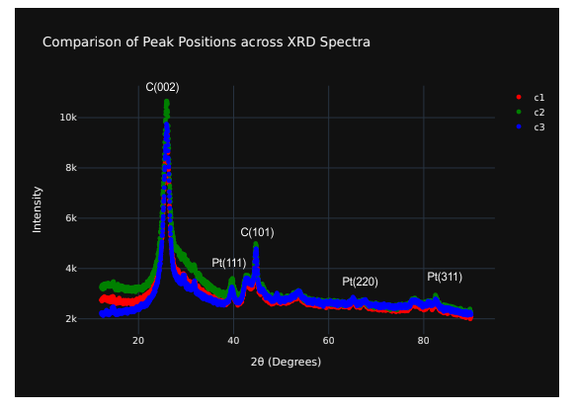

Figure 3:XRD profile of Pt-MWCNT nano-composite

**3.5 TGA**

The typical degradation temperature for CNT observed to be 622.910 – 861.670 C (Gupta *et al.,* 2016). From Figure 5 the peak temperature of 527.700 was obtained for nanocomposites. The decrease in the thermal stability of the nanocomposites in comparison to that of CNT is due the presence of Pt- nanoparticle which act as a defect and a catalyst to the oxidation process.

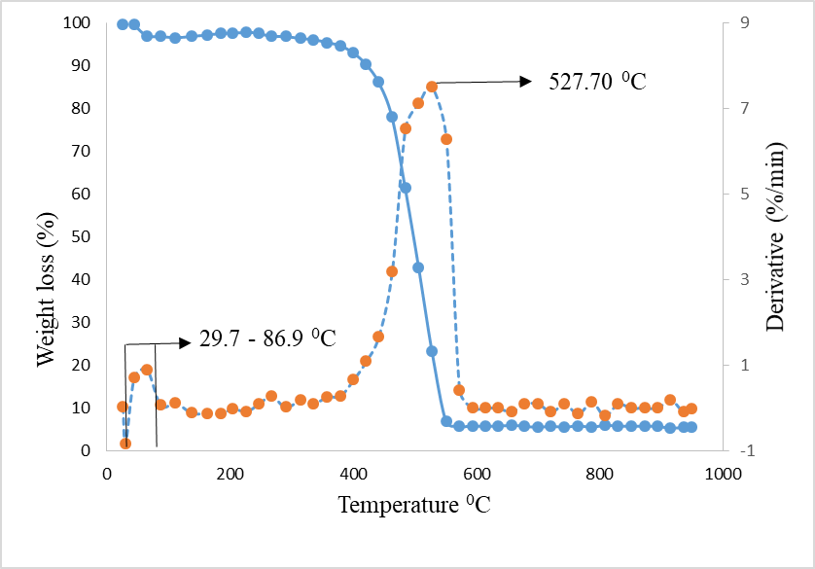

Figure 4: TGA profiles of Pt-MWCNT

**4.0 Current-Voltage characteristic**

Table 3 shows the performance matrix of the samples which was accessed using Ossila automated solar testing kit under A.M 1.5 solar simulator (100 mW/cm 2). PCE recorded for the Pt-MWCNT DSSC was low compared to the standard Pt use in Grȁtzel cell. This might be as a result of sintering temperature (350°C) used Rahman *et al*., (2022). This could have resulted in low crystallinity and grain growth of the TiO2, Inadequate dye loading, reduced electrical conductivity and diminished light harvesting.The low PCE from the cell could also be influenced by the acrylic resin in making Pt-MWCNT paste and the sintering temperature (350) which might not be enough to burn out the resin. The resin might have introduced additional resistance to cell as they are design to offer electrical insulation and chemical resistance.

Table 3: Photovoltaic performance matrix

|  |  |  |  |  |  |
| --- | --- | --- | --- | --- | --- |
| SAMPLE | PCE (10-6 %) | Jsc (10-5 A.cm^-2) | Voc (V) | Pmax (10-8W) | FF (%) |
| C300 | 2.75 | 168.45 | -0.2124 | 34.56 | 49.41 |
| C360 | 0.92 | -8.25 | 0.00068 | 9.32 | 43.57 |
| C480 | 6.38 | -20.46 | 0.00145 | 6.38 | 21.55 |

**5.0 Conclusion**

Catalytic CVD method used to synthesize MWCNT with Fe-Co/CaCO3 as catalyst. Functionalization and purification of MWCNT carried out using sulfuric acid solution Pt-N decorated MWCNT through wet impregnation method, Pt concentration assessed via UV-Vis. Morphological analysis (SEM, TEM) shows entangled tubular nanostructures with a whitish rough surface. EDX confirms presence of carbon and Platinum, XRD reveals sharp characteristic peaks of MWCNT and face centred cubic structure of Platinum. The study highlights the potential of Pt-MWCNTs as cost-effective counter electrodes for DSSCs but notes poor performance linked to sintering temperature choice.However, the observation of room for improvement in the fill factor (FF) value suggests opportunities for enhancing the efficiency of DSSCs with Pt-MWCNTs.

**Reference**

Anbarasan, P. M., Priyadharsini, C. I., Sathiyapriya, R., Hariharan, V., Parabakaran, K., & Aroulmoji, V. (2019). Development of TiO2 Nanomaterials and Dyes Selection (using DFT) for DSSC Applications–A Stepwise Review. *International journal of advanced Science and Engineering*, *6*(02), 1326-1350.

Biswas, R. K., Nemala, S. S., & Mallick, S. (2019). Platinum and transparent conducting oxide free graphene-CNT composite based counter-electrodes for dye-sensitised solar cells. *Surface Engineering and Applied Electrochemistry*, *55*, 472-480.

Chou, C. S., Hsiung, C. M., Wang, C. P., Yang, R. Y., & Guo, M. G. (2010). Preparation of a counter electrode with P-type NiO and its applications in dye-sensitised solar cell. *International Journal of Photoenergy*, *2010*.

Ibrahim, S. O., Isah, K. U., Abdulkareem, A. S., Ahmadu, U., Tijani, J. O., & Roos, W. D. (2020). Synthesis and characterization of platinum multi-walled carbon nanotubes nanocomposite film electrode. *Journal of Materials Science: Materials in Electronics*, *32*, 12800-12811.

Kimpa, M. I., Yabagi, J. A., Isah, H., Sulaiman, T., Isiyaku, A. K., Iya, S. G. D., & Imam, A. M. (2018). Photoelectrode nanostructure dye-sensitised solar cell. *Science World Journal*, *13*(1), 32-34.

Ning, Z., Fu, Y., & Tian, H. (2010). Improvement of dye-sensitised solar cells: what we know and what we need to know. *Energy & Environmental Science*, *3*(9), 1170-1181.

Padmavathi, R., & Sangeetha, D. (2013). Synthesis and characterization of electrospun carbon nanofiber supported Pt catalyst for fuel cells. *Electrochimica Acta*, *112*, 1-13.

Xiao,Y., Wu, J., Lin, J., Yue, G., Lin, J., Huang, M., & Fan, L. (2013). A high performance Pt-free counter electrode of nickel sulfide/multi-wall carbon nanotube/titanium used in dye-sensitised solar cells. *Journal of Materials Chemistry A*, *1*(44), 13885-13889.

Yum, J. H., Humphry-Baker, R., Zakeeruddin, S. M., Nazeeruddin, M. K., & Grätzel, M. (2010). Effect of heat and light on the performance of dye-sensitized solar cells based on organic sensitizers and nanostructured TiO2. *Nano Today*, *5*(2), 91-98.

Zhang, Q., Dandeneau, C. S., Zhou, X., & Cao, G. (2009). ZnO nanostructures for dye‐sensitised solar cells. *Advanced materials*, *21*(41), 4087-4108.