ICT ARCHITECTURE FOR NATIONAL SECURITY
Alabi, I. O.¹, Ojeniyi, J. A², Ismail, A. A.³, Ahmad, S.⁴, Abdulazeez, H. T.⁵
¹Department of Information Technology, School of Information & Communication Technology, Federal University of Technology, Minna.
³ Department of Computer Engineering, Faculty of Engineering, University of Maiduguri, Maiduguri.
^{2,4,5} Department of Cyber Security Science, School of Information & Communication Technology, Federal University of Technology, Minna.
Corresponding Author: isiaq.alabi@futminna.edu.ng, +(234) 802 313 0292.

ABSTRACT

As information and communication technology (ICT) permits the use of information computing devices adaptable for electronic communication. National security threats does not only include conventional nation-state warfare but it includes non-state actors such as illicit drugs cartels, multinational corporations, non-governmental organisations and ICT infrastructure supply chains. Therefore, ICT facilities can be configured to structure national security to manage, monitor and report security breaches. Since information systems impacts economy, knowledge, and society, national security could be at risk. This paper highlights the synergy between ICT and national (state) security. Issues that constitute state security risks were outlined and it proposed an ICT architectural design to realise national security.

Keywords: Criminal tracking system, Security policy, National security, ICT Framework, NCTS, ICT for national security.
- Introduction
The information communication technology (ICT) with myriad of electronic devices and sophistry had lately become ubiquitous while ICT is rapidly pervading all strata of human endeavours devoid of regions and locations. ICT devices are readily available in portable forms and often times conveniently accessible. Modern ICT sources and infrastructures have led to cyber-security threats which can be construed as a critical national security issue whereby individual, corporate and/or nation’s classified information are evaded by unauthorised invaders.
ICT was introduced by academic researchers in the 1980s as the convergence of audio-visual and telecommunication networks over computer networks (Melody et al., 1986). Information computing devices, (software, hardware, telecommunication devices and high technical skills) to enable users to access, store, transmit, and manipulate information (Srinivas et al., 2018). Information communication had lately extended into the all-pervading web and internet applications, multimedia, mobile phones, private and global networks, broadband connectivity, etc. all of which have improved or optimized the effectiveness and value of people (Soldani et al., 2018). Meanwhile, the adverse security challenges of information systems is threatening, thus, adequate security measures and structures need to be provisioned. ICT is a national security concern, impacting economy, knowledge, and society.

National security is the aspiration of every independent nation-state to preserve and sustain its prowess over a range of banal concerns or interests such as energy, food, economic, political, etc. within its territory in order to guaranty its territorial integrity (Garba and Ahmadu, 2015). Indeed, in order to promote national security, a nation must possess a stable structure, encompassing energy, food, economic, political securities, etc. When any of these interests is jeopardized, then the national security of a nation is threatened. Buzan (2007) stated that national security includes the management of threats and can be perceived as freedom from threats.
Cyber espionage (the art of prying on information about the plans and activities of others) resulting in hi-tech cyber warfare has degenerated to a level where every nation must define what constitute a cyber-attack. In this wise, a country might view a cyber-attack as a compromise of its IT apparatus security, conﬁdentiality, integrity and availability (Hathaway & Kimburg, 2012), while others apply both military defense and domestic strategies to counter the attack.

Accordingly, security threats not only include conventional nation-state warfare or foe assault but also non-state actors such as illicit drugs cartels, multinational corporations, non-governmental organisations and natural disasters. Therefore, in order to sustain national security, a nation must strengthen its economic security, energy security, environmental security, etc. against disruptions.

Due to the complexity and sophistry of modern societies, especially with diverse information and communication technologies in its arsenal, it is becoming apparent that national security is a shared responsibility between the state and its citizens. However, Governments have the uppermost responsibility of using its endowed resources (people, institutions, technology, economy, diplomacy and political manoeuvres) to sustain its national security. The onerous task of national security is mitigated with the use of ICT facilities to manage, monitor and report security breaches (Soldani, 2019).

Discerning national security from information security or data security, this study proposes some architectural frameworks for using the available information and communication technologies to further the development of a society and solving some identified national security issues (see Table 1). According to (Romm, 1993), socio-political stability, territorial integrity, economic solidarity and strength, ecological balance, cultural cohesiveness, and external peace were identified as the fundamental elements of national security.
The security of lives and properties of citizens in every society determines to a large extent on the development of that society. Infrastructural and economic development can only flourish in a secured atmosphere. Therefore the role of national security in the development of a nation is enormous.
  - Sources of Threats

There are increasingly several issues threatening national security of virtually all global nations, these threats are majorly internal and/or external conflicts such as intra-state agitations, ethnic/tribal xenophobic, heighten extremism (terrorism), violent crime (arson, kidnapping and assassination), arms proliferation, etc. (see Table 1). Aside from foreign invasion and natural disasters cyber attack is an emerging potent warfare to which all nations are vulnerable, whereby enemies infiltrate into a nation’s classified national data, secrets, plans and strategy.

Table1: Internal and external threats to national security.
NATIONAL SECURITY THREATS
INTERNAL | Agitation, Ethnic dispute, Arms proliferation, Xenophobia, Organised Crime (Terrorism, Violence, Kidnapping), Drug & human trafficking, Economic sabotage, Money laundering, Social unrest (Protests, Strikes, Unemployment, Acute food scarcity, Poor Shelter, Environmental Pollution), Poor governance
EXTERNAL | Aggression/invasion, Cyber attacks Multinational corporation, Economic blockade, Cross-border conflict, Natural disaster, Climate change, Nuclear arms, Global trends, Communication, Transportation.

1.2 ICT Network Security
Network Security has to do with the design, implementation, and operation of networks for information security in an organization or for a state. The preservation of conﬁdentiality, integrity and availability of information in the Cyberspace is crucial (Hathaway & Kimburg, 2012). As ICT is used for surveillance of streets, estates, seaports, airports, and desirable places with a hierarchical security monitoring operating centres, as in Figure 1, that can provide remote browser access to stored data, high-definition (HD) video, audio, and wide-view display with date-and-time-specific playback for criminal investigation purposes (Ekuwem, 2012).
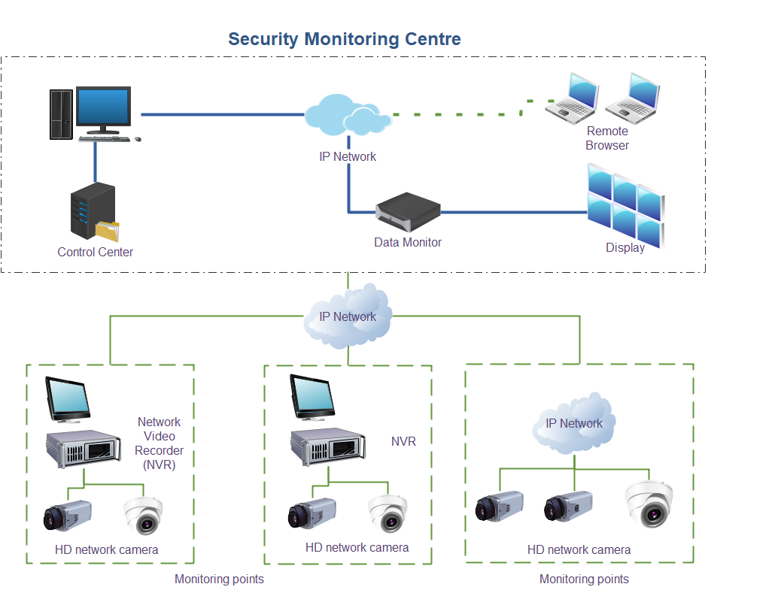
Figure 1: Security monitoring centres (hubs)

According to Ekwem (2012), technology has enabled non-intrusion scanning of six inches thick steel containers and cargoes to prevent illicit importation, trafficking of illicit drugs, firearms and ammunitions. Non-intrusive inspection (scan) is carried out on all imported cargoes and containers (goods-in-transit), to ascertain their content at the ports of entry (air, land and sea) into the country.

As vital as maritime activities is in modern economy, it could pose a challenge to national security; the threats posed in this regard are in form of, piracy, smuggling and other illicit offshore dealings and/or illicit bunkering transactions (McGee et al., 2004). These malicious activities have caused states a substantial loss of revenue thereby making ports unattractive to foreign shipping lines. Also, maritime environment could be used as cannon fodder by enemies to launch attack. Every nation has about 200 nautical miles off its coastline, as integral part of its territory to effectively police against external aggressors or any possible untoward deals.

From ICT point of view, Table 2 highlights the ICT infrastructure and their respective threats.

Table2: Examples of ICT infrastructure and threats
Infrastructure | Threats
User Equipment (UE)  (Enhanced Mobile Broadband [eMBB], Ultra-Reliable Low Latency Communication [URLLC],  Massive Machine Type Communications  [MMTC]) | Malware, cloning, bot hijacking, rough Base transceiver station (BTS), protocol downgrade, Firmware, Software and Hardware (supply chain) poisoning, International Mobile Subscriber Identity (IMSI) catching
Wireless interface  (eMBB, URLLC, mMTC) | Eavesdropping, impersonation, data tampering, jamming, rough BTS, SON attack
Links and Connectivity  (gNode B, a  new 5G Radio, Centralized and Distributed Unit [CU/DU] Split, enhanced Common Public Radio) Interface [eCPRI]) | Tampered software/hardware, unauthorized access, data leakage, Radio access network Distributed Denial-of-service [ RAN DDoS] from User Equipment)
Transport  (Optical, microwave, Software-defined network [SDN]) | Tampering, eavesdropping, protocol modification, protocol downgrade, SDN threats
Multi-Access Edge Computing (MEC)  (Network function visualization [NFV], Commercial off-the-shelf software [COTS], User plane function [UPF]) | Untrusted 3rd APP, DDoS UPF, malware, virtualization attacks, App layer attacks, API Attacks
Data  (User data, Operating system [OS] software,  O&M data) | NFV-based attacks, roaming (fraud, abuse), roaming protocol attacks, (SS7-like attacks), malicious AF/VNF, unauthorized access, data tempering, eavesdropping, DDOS, Operations support system (OSS/5g Core) attacks
Operations and Maintenance (O&M)  Hardware, Operations support system (OSS) integration & components management system software | Unauthorized access, data leakage, malware, API attacks, OSS services integration

The user equipment (UE) such as the hand-held smartphones, laptops and other enhanced Mobile Broadband (eMBB) devices that are used for faster and more reliable downloads. These devices are prone to threats such as malware, cloning, rough base transceiver station (BTS) and devices (hardware, software and/or firmware) poisoning during supply chain by vendors or spoofing of subscribers’ identity, more so as most of the telecom providers are not government owned.

Table 2 and Figure 2 is an overview of ICT infrastructure (User equipment, wireless interface, Links and connectivity (base stations, or BTS), transport, Multi-Access Edge Computing (MEC), data and Operations and maintenance (O&M)) and possible threats. These critical infrastructure including hardware, firmware, software, communication devices, the link interfaces as well as the data flow are all vulnerable to attack threat, provided human agents interact with the system and its operations through O&M.

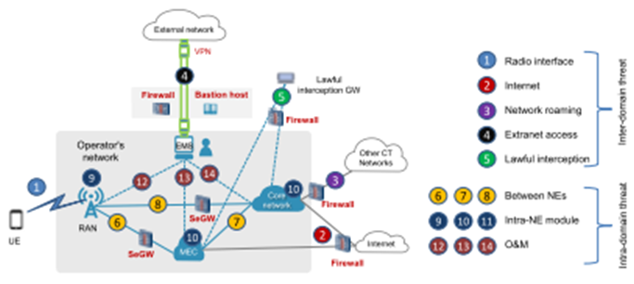
Figure 2: ICT infrastructure for security (Source: Soldani et al., 2018)

1.2.1 Enhancing National Security

Romm (1993) identified the fundamental elements of national security such as socio-political Stability, territorial integrity, economic solidarity and strength, ecological balance, cultural cohesiveness, and external peace which can be enhanced by the following measures:
- Effectively using diplomacy to rally allies and isolate threats;
- Marshalling economic power to facilitate or compel cooperation;
- Maintaining effective armed forces and security agencies;
- Implementing civil defence and emergency outfits (to counter terrorism and ameliorate natural disasters) ;
- Having resilient and redundant structures, adequate for critical infrastructures;
- Gathering intelligence to monitor and counter threats as well as espionage;
- Devising measures to protect classified data and/or information (secrets)
- Using counter-intelligence services or secret police to protect the nation from internal threats.
1.3 Misuse of ICT facilities
Presently, ICT is a major driving force for national security, for instance, internet od things (IoT), advances in mobile smart-phones’ capabilities have made ICT devices ubiquitous and indispensible in modern times. Though national security can be compromised by these smart devices if not effectively harnessed and controlled. Not too long ago, social networking platforms, Short Message Service (SMS), and e-mails messaging have been leveraged to circulate messages to incite spontaneous reactions or protests across the globe in Seoul (South Korea), Lebanon, Syria and Egypt, campaign of calumny, slander against private or public figures, de-marketing of products or services by competitors, etc.

Security threat is heightened by the fact that the infrastructure of major telecommunication firms are not owned by governments, which are prone to security breach, abuse or compromise, if not effectively monitored and controlled by government’s regulatory body. Invariably, ICT stakeholders must develop frameworks that, independently or co-responsibly, permit reduction of exposure to national security threats. All of the highlighted cases have brought in ICT technologies to support their efforts in achieving their national security goals.
- Related Works
Dhir and Sarraf (2016) proposed Crime and criminal tracking networks and systems (CCTNS) for Indian government. CCTNS is an integrated system for security surveillance and criminal records aggregation by connecting some 14,000 police stations. Bhattacherjee and Somashekhar (2017) designed an intelligent device with an image processor actuator linked to a geographic positioning system/ global system for mobile communication (GPS/GSM) technology to monitor some events and then sends signals to the nearest traffic controller or a security agent about a crime occurrence, its location and the direction, the criminals were heading.
Keatley, et al. (2019) provided a framework for a spatio-temporal analyses of crime and criminals. Fyfe (2017) argues against hate speech and inchoate crimes as incitement to genocide by integrating international law with speech act theory and moral philosophy using the Rwanda genocide as a case study.
Jiji and Anantharadha (2012) Proposed the use of data mining techniques like back propagation neural network-classifier and data association algorithms in tracking criminals through stored information and analysis.
Tundis, Kaleem, and Muhlhauser (2019) proposed that criminal Events could be tracked through internet of things (IoT) devices and an edge computing approach. Dupont and Reckmeyer (2012) argued for a system of systems approach for national security challenges rather than treating security issues as independent, compartmentalized issues by developing functional analytical tools for evaluating national security risks.
Dam and Lin (1996) were commissioned by the US government to develop cryptographic technologies to protect sensitive information to act as a countermeasure for national security.
In summary, national security concerns have motivated a lot of actions by researchers to counter threats to national security such as development of cryptographic technologies, deployment of ICT devices and enactment of countermeasures to protect critical ICT infrastructure and other sensitive information apparatus for national security. The method proposed in this study enhances the methods in the reviewed literatures.

3 Methodology
This study proposes a National Crimie Tracking System (NCTS), with ICT as the foundation comprising the following:

- Information extraction
- Data and text mining
- Multimedia processing
- Data integration

3.1 Data and information extraction
The national crime tracking system (NCTS) extracts a variety of data (text, graphics and multimedia) from different sources integrated to a national identity management database which keeps track of citizens and transactions such as social, academic, economic, skill set, integrity and patriotism. The data is accessed (or extracted), processed with data and text mining exploration technologies for security appraisals by analysts. This indicates that there is no hiding place for criminals, since everyone can be profiled through their records which are readily available and harnessed from diverse sources and contacts such as hospitals, customs, immigration points, sea/air-ports, courts, banks, hotels and so on, as shown in Figure 3.

Figure 3: National crime tracking system (NCTS) architecture

3.2 Security Architecture

The security design consideration for NCTS is a fail-safe strategy segmented into three components ― people, processes and technology. The key success factor here is the synergy of people, processes and technology creating a seamless security architecture, which is optimally functional and has the capability to fortify a nation’s security. Ability to lawfully intercept other networks, electronic mails, messages, voice calls, online chats, etc.

The people aspect comprises of user awareness, guidance, administration and effective monitoring of the system. The processes part comprises of policies, standards, guidelines and audit capabilities to ensure that information is not manipulated, corrupted, or destroyed. The technology part is the deployment of appropriate technology, which includes alarm system, firewall, broadband transmisisons and network integration as shown in Figure 3.
Overall, NCTS is a platform for detection, remediation and ascription of attacks, whereby agencies of government and non-government agencies such as police, immigration, customs and intelligence agencies are authorized to verify the profiles of individuals.
3.3 Shared Database
The NCTS architecture in Figure 3 presumed that the databases use the same schema across various tracking hubs or collaborating agencies interacting with NCTS for the following reasons:

- Availability and maintenance of a dynamic data repository for all citizens;
- Share and update databases at tracking centres or hubs of collaborating agencies;
- Data transfers using Wi-Fi, Point-to-Point broadband, Wireless or Fibre Optics (FO) cables;
- Local monitoring and archiving at each hub and upload to the NCTS headquarters using, WiMax or dedicated radio base stations. Difficult terrain can be monitored by deploying UAM (Unarmed Aerial Vehicles) to transmit data to the hubs;
- Mounted cameras at various locations, especially at identified hotspots in the cities and entry ports. Hotspots are places that are prone to frivolous activities;
- GPS-based coordination of law enforcement agents (to know the location of each patrol team, how many man/woman in each patrol team and the inventory of their ammunition, time spent on patrol and seamless duty exchange;
- Authorize Query, retrieval and analysis of archived data;
- Ports of entry and inland checkpoints are fitted with Gamma and X-ray based Scanners to check the content of trucks and cars conveying humans and goods-in-transit;
- Promulgation of legal frameworks to strengthen cyber security laws, national information infrastructure laws and national security surveillance act;
- Develop strong Intelligence/information sharing framework that duly sanction offenders;
- Geographic information system (GIS), Geographic Positioning System (GPS), DNA, Fingerprint, Biometric, photograph and bank, health, etc data to be integrated into tracking hubs;
- Establishment of common schema and/or data format standards across all the hubs.

Other elements of NCTS framework are:

NCTS administration performs integrated functions to:
- Authenticate users and administer applications in a distributed way;
- Selectively grant and revoke access rights to users of the distributed system;
- Encrypt data in an effective and yet efficient way both when data are
transmitted and when data are stored;
- Preserve databases from various forms of cyber-attacks that exploit the presence of inter-networked databases and systems.

3.4 Seamless Integration
The NCTS architecture is seamless whereby new agencies can be integrated into the NCTS once the following could be established at the hub station:

Data centre: The establishment of a comprehensive database to capture relevant new data, monitoring and update of the central NCTS database.

Awareness and sensitization: Adequate publicity to both citizens and aliens about security consciousness, identification and on the need to obtain statutory document that identifies everyone resident in the country.

Capacity building: Capacity building of collaborating agents with training in modern technologies to align with NCTS framework.
With these in place, the security network apparatus of various hubs or participating agencies would operate seamlessly with one another in order to share and exchange information as in Figures 3 and 4.
Figure 4: Hubs or tracking centres of the National Criminal Tracking System (NCTS) Architecture

- Recommendation

The adoption of network traffic snoop with modern interception strategy and the implementation of National ICT policy would strengthen a nation’s security and reduce crimes to barest minimum. National security can be greatly assured if through proactive measures of intelligence gathering, data control and surveillance activities, which are fast-driven by technology is adopted and incorporated into national security systems design.

Further, supply chains must be trusted and reliable to protect networks from unauthorized access or interference. Security agencies should keep tabs on the communication traffic that traverses the ICT infrastructures, in order to compliment the numerical strength of security personnel to intercept and burst crimes. Awareness campaign and capacity building of participating agencies should be augmented. The telecom regulatory agency of government should be alive to its responsibility, by applying sanctions where and when necessary as most telecom operators are non-governmental. Likewise, judiciary should not relent to invoke and apply appropriate sanctions to saboteurs and criminals.

- Conclusion
Obviously, a nation with many fractures is better off if concerted efforts are devoted to formidably confront her common challenges. In seeking the common security solution, one of the sectors that benefited immensely was the Information and Communication Technology (ICT) and security sectors. Some of the products that grew from that necessity included data mining software, integrated computer networks for information sharing, biometric identification system, alert technologies, surveillance cameras, data storage, behaviour pattern recognition software, and software designed to identify suspicious behaviour.

It is widely acknowledged that the adoption of an integrated ICT strategy will not only help to resolve the immediate security challenges but also help governments to tackle unemployment, builds security and confidence in wealth creation.

National security challenges can be pre-empted or thwarted through proactive action rather than embark on reactive and palliative measures. ICT has opened gateways of intelligence gathering and surveillance activities using technology driven approach such as the new concepts of data mining software, integrated computer networks, biometric identification system, automated fingerprint identification system (AFIS), early warning technologies, surveillance cameras, unarmed aerial vehicles, vast data storage, behaviour pattern recognition software, and software designed to identify suspicious behaviour, etc.

REFERENCES
Ajijola, A. B. D. (2010). The role of ICT deployment for national security. Paper presented at the eNigeria 2010 Conference, Abuja.

Buzan B. (2007). What is national security in the age of globalisation. Royal Institute of International Affairs, 67(3), 431-451.
Bhattacherjee, S., & Somashekhar, G. C. (2017). Artificial intelligence to impart surveillance, tracking, & actuation on suspicious activities. In 2017 IEEE 7th International Advance Computing Conference (IACC) (pp. 1-5). IEEE.
Dam, K. W. and Lin, S. H. (1996). Cryptographic’s role in securing information society. National Academy Press, Washington D.C.
Dhir, S. & Sarraf, S. (2016). Crime and criminal tracking networks & systems using agile methodology. BVICA M's International Journal of Information Technology, 8(1), 930.
Dupont, A., & Reckmeyer, W. J. (2012). Australia's national security priorities: addressing strategic risk in a globalised world. Australian Journal of International Affairs, 66(1), 34-51.

Ekuwem, E. E, ((2011). Use of ICT for national security operations. West Africa ICT (WAFICT) Conference.
Fyfe, S. (2017). Tracking hate speech acts as incitement to genocide in international criminal law. Leiden Journal of International Law, 30, 523.
Garba, E.J., & Ahmadu, A.S. (2015). ICT implementation framework for integrated national security, emergency and disaster management for Nigeria. The West African Journal of Industrial and Acadenic Research, 15(1), 27-37.

Goldsmith, J., & Hathaway, M. (2010, November 19). The cybersecurity changes we need. The Washington Post, p. 29.

Hathaway, M. E., & Kimburg, A. (2012). National cyber security framework manual. NATO cooperative cyber defence centre of excellence. Tallinn, Estonia.
Jiji, G. W., & Anantharadha, S. (2012). Automatic tracking of criminals using data mining techniques. Journal of The Institution of Engineers (India): Series B, 93(4), 217-221.
Keatley, D. A., Arntfield, M., Gill, P., Clare, J., Oatley, G., Bouhana, N., & Clarke, D. D. (2019). Behaviour tracking: using geospatial and behaviour sequence analysis to map crime. Security Journal, 1-18.
Lebovic, J. H. (2007). Deterring international terrorism and rogue states: US national security policy after 9/11. Routledge.
McGee, A. R., Vasireddy, S. R., Xie, C., Picklesimer, D. D., Chandrashekhar, U., & Richman, S. H. (2004). A framework for ensuring network security. Bell Labs Technical Journal, 8(4), 7-27.
Melody, W., Mansel, R., & Richards, B. (1986). Information and communication technologies: Social sciences research and training. A Report by the ESRC programme on information and communication technologies. ISBN 0-86226-179-1.

Romm, J. J. (1993). Defining national security. Council on foreign relations press. New York, NY 10021.

Soldani, D. (2019). 5G and the future of security in ICT. In 29th International Telecommunication Networks and Applications Conference (ITNAC), p. 1-8. IEEE.

Soldani, D., Shore, M., Mitchell, J., & Gregory, M. (2018). The 4G to 5G network architecture evolution in Australia. Journal of Telecommunications and the Digital Economy, 6(4),1.

Srinivas, J., Das, A. K., & Kumar, N. (2018). Government regulations in cyber security: Framework, standards and recommendations. Future Generation Computer Systems, 92(2019),178-188.

Tundis, A., Kaleem, H., & Muhlhauser, M. (2019). Tracking Criminal Events through IoT Devices and an Edge Computing Approach. In 2019 28th International Conference on Computer Communication and Networks (ICCCN) (pp. 1-6). IEEE.

