**INTERNATIONAL CONFERENCE ON MEDICAL & HEALTH SCIENCES**

July 06-08, 2023

Ordu, Türkiye

**THE PROCEEDINGS BOOK**

**EDITOR**

**Assist. Prof. Dr. Yeliz KAŞKO ARICI**

All rights of this book belong to ISPEC. Without permission can’t be duplicate or copied.

Authors are responsible both ethically and juridically

ISPEC Publications – 2023 ©

Issued: 30.07.2023

ISBN: 978-625-7720-92-2

Bu Kitabın Tüm Hakları ISPEC Yayınevi’ne aittir.

Yazarlar etik ve hukuki olarak eserlerden sorumludurlar.

ISPEC Yayınevi – 2023 © Yayın Tarihi: 30.07.2023

ISBN: 978-625-7720-92-2

**www.ispecongress.org/saglik**

CONFERENCE ID

**CONFERENCE TITLE**

7th INTERNATIONAL CONFERENCE ON MEDICAL & HEALTH SCIENCES

**DATE and PLACE**

July 06-08, 2023 / Ordu – TÜRKİYE

**ORGANIZATION**

ISPEC INSTITUTE

Ordu University

**HONORARY PRESIDENT OF THE CONGRESS**

Prof. Dr. Ali AKDOĞAN

**CHAIRMAN OF CONGRESS**

Assist. Prof. Dr. Yeliz KAŞKO ARICI

**ORGANISING COMMITTEE**

Prof. Dr. Niyazi TAŞÇI

**COORDINATOR**

Gönül EDEŞLER

Neslihan BALCI

**NUMBER of ACCEPTED PAPERS** - 596 **NUMBER of REJECTED PAPERS** - 33

**PARTICIPANTS COUNTRY**

**Türkiye (290), Albania (3), Algeria (19), ABD (1), Australia (2), Belarus (1), Benin (2), Brazil (4),**

**Bulgaria (4), China (1), Georgia (26), Germany (7), Greece (1), India (61), Indonesia (3), Iran**

**(15), Iraq (1), Israel (1), Italy (2), Kosovo (9), Malaysia (5), Morocco (19), México (1), Nigeria**

**(36), Pakistan (28), Palestine (2), Philippines (1), Poland (1), Portugal (3), Romania (6), Russia**

**(14), Sarajevo (1), Saudi Arabia (2), Serbia (3), Spain (1), Sri Lanka (1), Tunisia (5), Ukraine (7), United Kingdom (1), USA (1), Uzbekistan (1), Vietnam (5)**

**ORGANIZING BOARD**

Prof. Dr. Ahmet KAYA

Prof. Dr. Dilek KARAKUŞ

Prof. Dr. Hakan KORKMAZ

Prof. Dr. Saime ŞAHİNÖZ

Prof. Dr. Tülin BAYRAK

Assoc. Prof. Dr. Abdullah Alper ŞAHİN

Assoc. Prof. Dr. Ali ASLAN

Assoc. Prof. Dr. Ali AYGÜN

Assoc. Prof. Dr. Ali YILMAZ

Assoc. Prof. Dr. Mustafa Kerem ÇALGIN

Assoc. Prof. Dr. Mürüvvet AKÇAY ÇELİK

Assoc. Prof. Dr. Ömer KARAMAN Assoc. Prof. Dr. Seda KESKİN

Assoc. Prof. Dr. Ülkü KARAMAN

Assoc. Prof. Dr. Yasemin KAYA

Assist. Prof. Dr. Yeliz KAŞKO ARICI

Assist. Prof. Dr. Aybegüm KALYONCU AYÇENK

Assist. Prof. Dr. Ceren YAPAR GÜMÜŞ

Assist. Prof. Dr. Çağrı DOĞAN

Assist. Prof. Dr. Deniz DENİZ ÖZTURAN

Assist. Prof. Dr. Fatma ETGÜ

Assist. Prof. Dr. Gonca GÜLBAY

Assist. Prof. Dr. Hatice HANCI

Assist. Prof. Dr. İlker COŞKUN

Assist. Prof. Dr. Mevlüt KELEŞ

Assist. Prof. Dr. Muhammet DEĞERMENCİ Assist. Prof. Dr. Tuba GÜL

Assist. Prof. Dr. Selen KARAOĞLANOĞLU

**SCIENCE AND ADVISORY BOARD**

Prof. Dr. Ayşe Canan YAZICI GÜVERCİN- Izmir Tinaztepe University

Prof. Dr. Cemil ÇOLAK- Inonu University

Prof. Dr. Erdal AĞAR- Giresun University

Prof. Dr. Handan ANKARALI- Istanbul Medeniyet University

Prof. Dr. Havva ERDEM- Ordu University

Prof. Dr. Hüseyin ŞAHİN- Giresun University

Prof. Dr. Nilay TAŞ- Ordu University

Prof. Dr. Orhan BAŞ- Samsun University

Prof. Dr. Serpil ŞENER - Inonu University

Prof. Dr. Sıddık KESKİN- Van Yüzüncü Yıl University

Assoc. Prof. Dr. Abdullah ÇIRAKOĞLU- Ordu University

Assoc. Prof. Dr. Ahmet KARATAŞ- Ondokuz Mayıs University

Assoc. Prof. Dr. Aslıhan UZUN- Ordu University

Assoc. Prof. Dr. Atakan SAVRUN- University of Health Sciences Assoc. Prof. Dr. Deha Denizhan KESKİN- Ordu University

Assoc. Prof. Dr. Emine YURDAKUL ERTÜRK- Ordu University

Assoc. Prof. Dr. Erdal BENLİ- Ordu University

Assoc. Prof. Dr. Hilal ALTAŞ- Ordu University

Assoc. Prof. Dr. Kaptanıderya TAYFUR- Ordu University

Assoc. Prof. Dr. Mehmet Fatih KARAKUŞ- Ordu University

Assoc. Prof. Dr. Mustafa YENERÇAĞ- Samsun Universtiy Assoc. Prof. Dr. Osman BEKTAŞ- Ordu University

Assoc. Prof. Dr. Pınar Naile ÖĞÜTEN- Samsun University

Assoc. Prof. Dr. Sercan ERGÜN- Ondokuz Mayıs University

Assoc. Prof. Dr. Şahin DİREKEL - Giresun University

Assist. Prof. Dr. Adem TOKPINAR- Ordu University

Assist. Prof. Dr. Bestegül ÇORUH AKYOL- Ordu University

Assist. Prof. Dr. Celali KURT- Ordu University

Assist. Prof. Dr. Didem ODABAŞI- Ordu University

Assist. Prof. Dr. Derya ÇIRAKOĞLU- Ordu University

Assist. Prof. Dr. Elif DOĞAN- Ordu University

Assist. Prof. Dr. Emine Serap YILMAZ- Ordu University

Assist. Prof. Dr. Güven AKÇAY- Hitit University

Assist. Prof. Dr. Halil YILMAZ- Ordu University

Assist. Prof. Dr. Hatice HANCI- Ordu University

Assist. Prof. Dr. Mehmet GÜZELİPEK- Ordu University

Assist. Prof. Dr. Muhammet ÖZBİLEN- Ordu University

Assist. Prof. Dr. Mücahit SEÇME- Ordu University

Assist. Prof. Dr. Nesrin ÇAĞLAYAN DUMAN- Ordu University Assist. Prof. Dr. Onur YALÇIN- Ordu University

Assist. Prof. Dr. Semih TAN- Ordu University

Assist. Prof. Dr. Sibel TÜREDİ- Harran University

Assist. Prof. Dr. Swaroopa Rani Gurram- Mahavidhyapeetha College of Pharmacy

Assist. Prof. Dr. Türkan Mutlu YAR- Ordu University

Assist. Prof. Dr. Yağmur GÜNDÜZ- Ordu University

Assist. Prof. Dr. Yeliz KAŞKO ARICI- Ordu University

Dr. Ali IKRAM- Government College University Faisalabad

Dr. Almaz AHMEDOV- Bakü State University

Dr. Anatoliy LOGINOV - Ukraine Shevchenko Lugan National University

Dr. Ayslu B. SARSEKENOVA- Orleu National Development Institute

Dr. BOUKHATEM Mohamed Nadjib- Université Saad Dahlab Blida

Dr. Cholpon TOKTOSUNOVA- Rasulbekov Kyrgiz Economy University

Dr. Eze Ozoemena Emmanuel- University of Nigeria

Dr. Feda REHIMOV- Bakü State University

Dr. George RUDIC- Montreal Pedagogy Institute

Dr. Gülsen ŞENER- Başakşehir Çam and Sakura City Hospital

Dr. Kenes JUSUPOV- M. Tinisbaev Kazakh Vehicle Academy

Dr. Khan Nadezhda- E.A. Buketov Karaganda State University

Dr. Maha Hamdan ALANAZI- Riyad King Abdulaziz Technology Institute

Dr. Maira ESIMBOLOVA- Kazakhistan Narkhoz University

Dr. Maria LEONTIK- Macedonia Ishtib Gotse Delchev University

Dr. Maryam FARASAT- Ahvaz Jundishapur University of Medical Sciences

Dr. Mavlyanov ABDIGAPPAR- Kyrgiz Elaralık University

Dr. Meixia HUOU- Capital Normal University

Dr. Nazile Abdullazadeh- Azərbaycan Dövlət Pedaqoji University

Dr. Rovshan ALİYEV - Bakü State University

Dr. Zubera Naseem

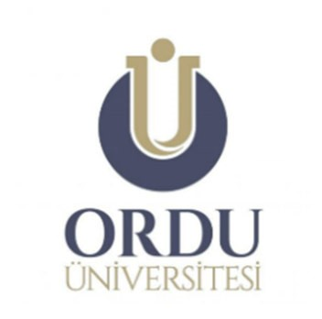

**7th INTERNATIONAL**

**CONFERENCE ON MEDICAL & HEALTH SCIENCES**

**July 06-08, 2023**

**Ordu, Türkiye**

**CONFERENCE PROGRAM**

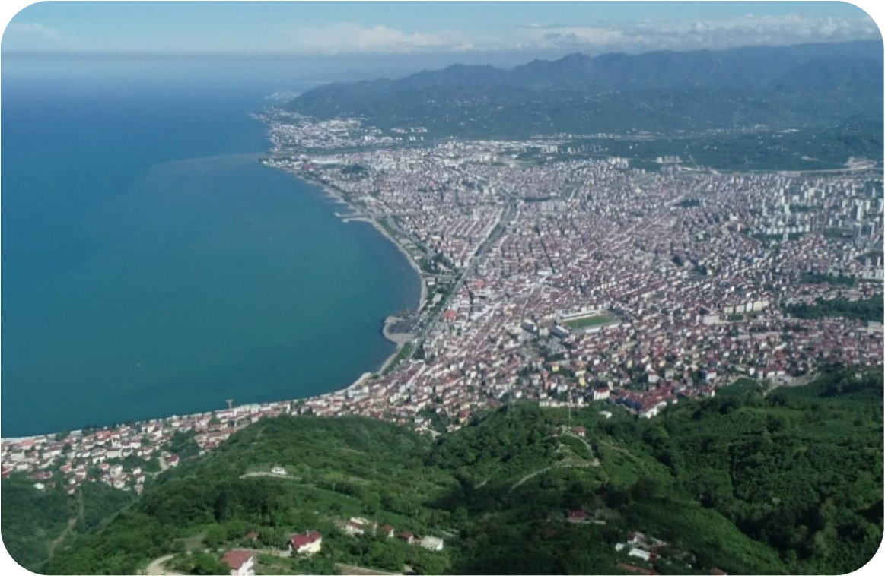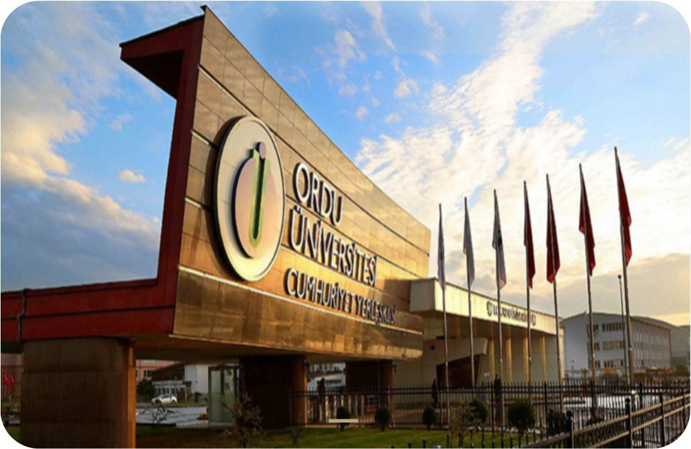

**Meeting ID: 893 0634 6339**

**Passcode: 060708**

**https://us02web.zoom.us/j/89306346339?pwd=cXpF**

**MlRLZGdPM0ZiQWVNakpSdGhoQT09**

**IMPORTANT, PLEASE READ CAREFULLY**

* To be able to make a meeting online, login via **https://zoom.us/join** site, enter ID instead of “Meeting ID
* or Personal Link Name” and solidify the session.
* The presentation will take a **maximum of 15 minutes** (including questions and answers).
* The Zoom application is free and no need to create an account.

|  |  |  |
| --- | --- | --- |
| * Ait Hamou Ouhesseine Rabab * Alami Lamiae * Berkani Mohamed | VALUATION OF ANTIBACTERIAL ACTIVITY  IN VEGETABLE OILS | 1713 |
| Busari M. B  Yusuf R. S Hamzah R. U.  Abubakar A. N.  Kolawole M. L.  Badmus M. D. | EFFECTS OF METHANOL EXTRACT OF  TAMINALIA CATAPPA LEAF ON LEAD  ACETATE-INDUCED LIVER AND KIDNEY TOXICITY IN WISTAR RATS | 1714-1724 |
| MEFTAH Sara MERGHACHE Salima | DEVELOPMENT OF TWO BIOMATERIALS  BASED ON SNAIL SHELL AND HAZELNUT  SHELL CHIMICAL MODIFIED FOR ELIMINATION DYE TEXTILE | 1725 |
| Iroghama Iyobosa Asoro | NEUROMODULATORY EFFECTS OF pCHLOROPHENYLALANINE METHYL ESTER ON  5-HYDROXYLTRYPTAMINE IN WISTAR RATS | 1726 |
| MERZOUKI MOHAMMED  BOUAMMALI Boufelja  Allal CHALLIOUI Allal | FLAVONE DERIVATIVES AS POTENTIAL  INHIBITORS OF SARS-COV-2 RDRP PROTEIN THROUGH COMPUTATIONAL STUDIES | 1727 |
| Moulouda El Mouftaria  Fatima Zahra Mahjoubia  Fouzia Kzaiberb  Wafa Terouzib  Gomaa A. M. Alic  Said Souhassoua  Abdelkhalek Oussamaa | STUDY OF OLEASTER OIL’S FALSIFICATION BY ATR-FTIR AND CHEMOMETRICS TOOLS | 1728 |
| Moulouda EL MOUFTARI  Fatima Zahra MAHJOUBI  Fouzia KZAIBER  Abdelkhalek OUSSAMA | METHODOLOGICAL AND CHRONOLOGICAL  EVOLUTION OF OLIVE OIL QUALITY CONTROL BY ANLYTICAL METHODS: REVIEW | 1729 |
| El Mouftari Moulouda  Houmani Safa  Kzaiber Fouzia  Boutoial Khalid  Souhasou Said  Mahjoubi Fatima Zahra  Oussama Abdelkhalek | THE USE OF DIGITAL FTIR-CHEMOMETRICS  APPROACH FOR THE DETECTION OF  ADULTERATION OF BLACK CUMIN OIL | 1730-1731 |
| Sidem GÜL  Hilal Nida CEDİMAĞAR  Zişan Nur KILIÇ  Ahmet TÜFEKÇİ | TERATOGENIC EFFECT OF ANTIEPLEPTIC DRUGS IN EPILEPTIC PREGNANCY | 1732-1734 |
| Halis Emre ÇIFTÇI  Adem KURTULUŞ | COMPARISON OF HORMONE AND PATHOLOGY RESULTS OF PITUITARY MASSES | 1735-1736 |
| Mahmut Sami ÇOLAK  Sima CEBECIK ÇAKIR  Halil KUL  Pınar ÖZIŞIK | ETIOLOGY OF PATIENTS WITH NEWBORN INTRAVENTRICULAR BLEEDING | 1737-1739 |
| Zeynep GENCE ÖZ Serdar CENGIZ | RETROSPECTIVE EVALUATION OF PATIENTS DIAGNOSED INTRACRANIAL CAVERNOMA | 1740-1741 |
| Betül DİLER DURGUT Emine TEKIN | EVALUATION OF CLINICAL FINDINGS OF PATIENTS WITH NEUROFIBROMATOSIS TYPE 1 | 1742-1743 |
| Faruk TONGA Sinan BAHADIR | INTRACEREBRAL HEMORRHAGE AFTER  TREATMENT OF SUPERIOR SAGITTAL SINUS  THROMBOSIS WITH ANTICOAGULANTS IN A  PATIENT WITH SARS-CoV-2: A CASE REPORT | 1744-1750 |
| Didem EROL | RARE ADULT ONSET ACUTE NECROTIZING ENCEPHALOPATHY: A CASE REPORT | 1751-1755 |
| İbrahim ÇALTEKIN | MAJOR BLEEDING AND COAGULOPATHY AFTER TRAUMA | 1756-1762 |

**EFFECTS OF METHANOL EXTRACT OF *TAMINALIA CATAPPA* LEAF ON LEAD ACETATE-INDUCED LIVER AND KIDNEY TOXICITY IN WISTAR RATS**

**Busari M. B**

Department of Biochemistry, Federal University of Technology Minna, PMB 65, Minna,

Niger, Nigeria, Federal University of Technology Minna

**Yusuf R. S.**

Department of Biochemistry, Bauchi State University

**Hamzah R. U.**

Department of Biochemistry, Federal University of Technology Minna, PMB 65, Minna,

Niger, Nigeria, Federal University of Technology Minna

**Abubakar A. N.**

Department of Biochemistry, Federal University of Technology Minna, PMB 65, Minna, Niger, Nigeria, Federal University of Technology Minna

**Kolawole M. L.**

Department of Biochemistry, Federal University of Technology Minna, PMB 65, Minna,

Niger, Nigeria, Federal University of Technology Minna

**Badmus M. D.**

Department of Biochemistry, Federal University of Technology Minna, PMB 65, Minna,

Niger, Nigeria, Federal University of Technology Minna

**ABSTRACT**

Lead toxicity has been categorized among the top ten major public health concern by the World Health Organization. Lead is a multi-organ toxicant that has been implicated in various organs damage including liver and kidney. In search of cheap and readily available drug for lead-induced liver and kidney damage, methanol extract of *Taminalia catappa* leaf (METCL) was assessed in lead acetate induced hepato-renal damage in Wistar rats. The phytochemicals and *in vitro* antioxidant activities of the extract were also determined using standard methods. Fifteen Wistar male rats comprised of five groups of three rats per group were used for the study while five rats were used for the acute toxicity study. Exact 0.5 ml/kg body weight (bw.), 1000 mg/Kg bw. of lead acetate solution and 100 mg/kg bw. of Silymarin, 1000 mg/Kg bw. of lead acetate solution and 0.5 ml/kgbw., 100 and 200 mg/kg bw. of METCL were administering orally to naïve, positive, negative control groups and extract treated groups respectively daily for 10 days. The extract shows appreciable 2, 2-diphenyl picryl hydrazyl radical scavenging activities (DPPH), ferric reducing antioxidant power (FRAP) and inhibition of lipid peroxidation at high concentration of 500 µg/mL. Phytochemical analysis of the extract reveal the presence of flavonoids (30.29 mg/g), total phenols (65.97 mg/g) with trace quantities of alkaloids (65.79 µg/g) and saponins (101.45 µg/g). Significant increase (P < 0.05) in alanine transaminase (ALT), aspartate transaminase (AST), alanine phosphatases (ALP), urea, sodium, chlorine, potassium and creatinine were observed in negative control rats when compared with the treated groups. The liver and kidney histology of the treated animals also show severed less damage when compared to that of negative control groups.

Therefore, METCL possesses ameliorative effects which is more pronounced at 200 mg/kgbw on lead acetate-induced liver and kidney damage in Wistar rats. **Keywords:** Lead toxicity, *Taminalia catappa,* Liver, Kidney, Histology

**Introduction**

Liver and kidney diseases are gradually increasing in developing and developed countries currently as a result of contamination of the environment by the pollutants such as lead (Busari et al., 2021a). Both organs are mutually linked physiologically and pathologically in a reciprocal fashion as Kidney disease occurs in 20%–25% of patients with liver disease (Morelli et al., 2021).

Lead caused various range of physiological and biochemical abnormality to many cells, tissues, organs and systems in all mammals (Busari et al., 2021a). Myriads of evidences have implicated lead in activating excessive production of reactive oxygen species (ROS) which lead to breakdown of tissues and substantial health challenge (Hamzah et al., 2018). Liver and kidney are very important and delicate organs due to their metabolic and excretory roles towards several poisonous substances (Busari et al., 2015). Most chelating agents used for lead toxicity therapy show various side effects. Some of these side effects include residual toxicity, poor activities, high cost and pro-oxidative activities. For these reasons, it is necessary to search for alternative drugs from natural sources.

*Terminalia catappa* Linn. (Combretaceae) commonlyrefer to as Tropical almond is a large tree that grow in tropical countries. It is a native to Australia, Cambodia, India, Japan, Laos, Malaysia, Thailand and Vietnam (Orwa *et al.,* 2009). *T. catappa* is now widely distributed across the globe with a maximum height of 35 m, being upright, with horizontal branches and symmetrical crown (Owolabi et al., 2013). Different parts of this plant have long been used as folk medicine in India, Philippines, Malaysia, Indonesia, Benin for antidiarrhoetic, antipyretic, anti-inflammatory, anti-carcinogenic and haemostatic purposes (Ladele *et al*., 2006; Biego *et al.,* 2012). Many researchers have also reported various part of the plants to possessed the following activities; Anticancer (Pandya *et al*. 2013, Yeh *et al*. 2012), Antimutagen (Chen *et al*. 2000), Immunomodulatory (Aimola *et al*. 2014), Antibacterial

(Taganna *et al*. 2011), Wound healing (Khan *et al*. 2013), antidiabetic (Divya *et al.,* 2014; Ahmed, 2005) and hepatoprotective (Kinoshita *et al*. 2007). Hence, the effects of methanol extract of *Taminalia catappa* leafonlead acetate-induced liver and kidney toxicity in Wistar rats

**Plant Materials and Authentication**

The *Taminalia catappa* fruit were obtained in Minna, Niger State and were authenticated at the plant Biology Department of Federal University of Technology, Minna by Dr. Daud

O.A.Y.

**Experimental Animals**

Wistar rats (125.00 ± 3.16g) were obtained from the animal facility of Federal University of Technology, Minna. The animals were housed in polypropylene cages under a controlled environment with 12 hours light/dark cycles, temperature of 28 ± 3◦C and relative humidity of 45-50%. The animals were maintained on pelleted diet (Vital Feeds, Jos Nigeria) with supply of water *ad libitum.*

**Chemicals, Kits and Reagents**

The biochemical kits used were obtained from AGAPE Laboratories, Hombrechtikon,

Switzerland. The chemicals and reagents used were obtained from Sigma- Aldrich Chemical Company St. Louis, USA. The reagents include methanol, acetone, ethylacetate, Ferric chloride, DPPH, lead acetate, hematoxylin and eosin among others.

**Methods**

**Extraction Procedures**

The fruits of the *T. catappa* plant were washed with clean water to remove dust and sand, airdried at room temperature. The dried fruits were pulverized using a blender, kept in an air tight container at room temperature (28 ± 2°C) until further use. Fifty grams (50 g) of the powdered samples were placed in a round bottom flask and extract with absolute methanol at room temperature for 72 hours. The extract were filtered with muslin cloth after which the methanol was evaporated under reduced pressure in a rotary vacuum evaporator. The filtrate of *T. catappa* leaf were lyophilized to obtain a crude extract that was stored at -40C until further use.

**Acute toxicity study (OECD)**

The median lethal dose (LD50) of the plant extract and fractions was conducted using the method described by organization for economic and cooperation for development (OECD, 2010). Five (5) rats were given 2000 mg/kg body weight of the extract from *T. catappa* leaf orally. They were observed for 24hrs for signs of toxicity and death. The observation was extended to 14 days for any delay toxicity.

**Quantitative Determination of secondary metabolites**

The following methods were used for the determination of various phytochemicals; total phenol (McDonald *et al.,* 2001), Flavonoids (Chang *et al*., 2012), Alkaloids and Saponins (Oloyede, 2005), Tannins (A.O.A.C, 1984).

**Antioxidants Screening**

**Scavenging Activity against 1, 1-Diphenyl-2-Picryl Hydrazyl Radical (DPPH)**

The scavenging activity against DPPH was done as reported by Oyaizu, (1998) with little modification. A known weight of 0.05g of dry extract as well as vitamin C (standard) was weighed in a separate beaker follow by 50mL of methanol, 2mL of 0.004% DPPH solution in methanol and 1mL of plant extracts, gallic acid and vitamin C in methanol at various concentrations (125, 250, 500, 1000µg/mL). The mixture were mixed and incubated at 25°C for 30 minutes. The absorbance of the test mixture was read against the reagent blank at 517 nm using a spectrophotometer. All experiments was performed in triplicate. Percent inhibition was calculated using the following expression:

% Inhibition = (Ablank – Asample /Ablank) x 100

**Ferric Reducing Antioxidant Power Assay**

The reducing antioxidant power of the extracts was determined by preparing different concentrations of plant extracts and vitamin C (125, 250, 500, 1000µg/mL) in 1mL of distilled water. The prepared extracts was mixed with phosphate buffer (3.0mL, 0.2M, pH 6.6) and potassium ferricyanide [K3Fe(CN)6] (2.5mL, 1%). The mixtures was incubated at 50ºC for 20 minutes. Then, 2.5mL of trichloroacetic acid (10%) was added to the mixture, centrifuge for

10 minutes at 3000 rpm.

The upper layer of solution (2.5mL) was mixed with distilled water (2.5mL) and FeCl3

(0.5mL, 0.1%). The absorbance was read at 700 nm against a blank (Aiyegboro and Okoh, 2010)

**Inhibition of Lipid Peroxidation**

A modified thiobarbituric acid reactive substances (TBARS) of Ruberto and Baratta, (2000) assay was used to measure the lipid peroxide formed using egg yolk homogenate as lipid-rich media (Ruberto and Baratta, 2000). Egg homogenate (0.5 mL, 10 % v/v) was added to 0.1 mL of extract or vitamin C (10 mg/mL) and the volume made up to 1 mL with distilled water. Thereafter, 0.05 mL of FeSO4 was 4 added and the mixture was incubated for 30 minutes. Acetic acid of 1.5 mL of was then added followed by 1.5 ml of thiobarbituric acid in sodium dodecyl sulphate. The resulting mixture was vortexed and heated at 95oC for 60 minutes. After cooling, 5 mL of butan-1-ol was added and the mixture was centrifuged at 3000 rpm for 10 minutes. The absorbance of the organic upper layer was read at 532 nm and converted to percentage inhibition using the formula: (1 - E / C) x 100

Where: C = Absorbance of fully oxidized control and E = Absorbance in the presence of extract.

**In-Vivo Antioxidants Study**

**Animal Grouping**

* Group 1: Non-toxic rats (Normal 0.5mL/kgbw of 0.5% Normal saline)
* Group 2: Lead acetate induced (1000mg/kgbw) and silymarin (100mg/kgBW)
* Group 3: Negative Control, were induced with lead acetatewith Normal 0.5mL/kgbw
* Group 4: Lead acetate induced (1000mg/kgbw) and 100MEF (100mg/kgBW)
* Group 5: Lead acetate induced (1000mg/kgbw) and 200MEF (100mg/kgBW)

All the animals were euthanized by cardiac puncture at the end of 10 days for the collection of various specimen.

**Serum and Tissue Preparations**

**Serum Preparation**

Serum were prepared using the procedure described by Yakubu et al. (2009) and Ajiboye et al. (2014). Briefly, the rats were euthanized by cervical dislocation at the end of the experiment and blood samples were collected by cardiac puncture from the inferior vena cava of the heart into serum sample bottles. The blood samples were allowed to clot at room temperature and serum were obtained by centrifuging at 3000 rpm for 10 minutes.

**Biochemical Assay**

Marker enzymes and metabolites of liver and kidney damage were carried out using appropriate manual in the biochemical kits.

**RESULTS**

**Quantitative phytochemical constituent**

Table 1 show the quantitative phytochemicals constituents of methanol extract of *Taminalia catappa* leaf extract. Total phenol is the highest among the remaining set of phytochemicals followed by flavonoids, tannins, saponins and alkaloids.

**Table 1: Quantitative phytochemical Constituents of Methanol Extract of *T. catappa***

Tannins Flavanoid T. Phenols Alkaloids Saponins

(mg/g) (mg/g) (mg/g) (µg/g) (µg/g)

10.72±0.21 30.29±0.10 65.97±0.48 85.79±0.40 101.43±1.65

Values of mean ± standard error of mean (SEM) of triplicate

**Percentage Scavenging Activity against 1, 1-Diphenyl-2-Picryl Hydrazyl Radical (DPPH)** Table 2 showed the radical scavenging activity of methanol extract of *T. catappa* leaf extract against 1, 1-Diphenyl-2-Picryl Hydrazyl Radical (DPPH). The DPPH radical scavenging activity of methanol extract of *T. catappa* leaf extract are in dose dependent manners. Highest DPPH radical scavenging is observed in the highest concentration (500 µg/mL) of the extract and decrease as concentration reduced. The activities of the extract follow same trends with that of standard (Vitamin C) and relatively close in values at all concentrations.

**Table 2: Percentage Scavenging Activity against 1, 1-Diphenyl-2-Picryl Hydrazyl**

**Radical (DPPH) of Methanol Extract of *T. catappa***

|  |  |  |  |
| --- | --- | --- | --- |
| **Concentrations (µg/mL)** |  | **Vitamin C** | **Methanol Extract** |
| 500 |  | 92.50 ± 0.04 | 89.14±1.04 |
| 250 |  | 91.35 ± 0.00 | 88.08 ± 0.44 |
| 125 |  | 61.35 ± 0.19 | 61.83±1.08 |
| 62.5 |  | 30.24 ± 0.19 | 25.63±1.12 |

**Values of mean ± standard error of mean (SEM) of triplicate**

**Ferric reducing antioxidant power (FRAP)**

Table 3 showed the ferric reducing antioxidant power of methanol fraction of *T. catappa* leaf extract as compared with ascorbic acid. FRAP of methanol extract of *T. catappa* leaf extract are also in dose dependent manners like that of DPPH radical scavenging activities. Highest FRAP activities was also observed in the highest concentration (500 µg/mL) of the extract and decrease as concentration reduced. The activities of the extract follow same trends closely with Vitamin C.

**Table 3: Ferric reducing antioxidant power (FRAP) of Methanol Extract of *T. catappa*** **Extract**

**Concentrations (µg/mL) Vitamin C Methanol Fraction**

500 2.50 ± 0.00 1.52±0.31

250 2.05 ± 0.04 1.04±0.20

125 1.00 ± 0.15 0.78±0.12

62.5 0.56 ± 0.05 0.78±0.12

**Values of mean ± standard error of mean (SEM) of triplicate experiment.**

**Percentage inhibition of lipid peroxidation**

Table 4 showed the percentage Inhibition of lipid peroxidation by methanol extract of *T. catappa* leaf as compared with ascorbic acid. The trends through which methanol extract of *T. catappa* leaf inhibit lipid peroxidation is quite different from that of DPPH and FRAP.

There are little differences between the activities observed in the high concentration (500 µg/mL) of the extract when compared respectively with the low concentration which follow the same trends with Vitamin C.

**Table 4: Percentage Inhibition of lipid peroxidation of Methanol Extract of *T. catappa***

**Extract**

|  |  |  |  |  |
| --- | --- | --- | --- | --- |
| **Concentrations (µg/mL)** |  | **Vitamin C** |  | **Methanol Fraction** |
| 500 |  | 41.73 ± 0.16 |  | 48.33±0.11 |
| 250 |  | 40.01 ± 0.08 |  | 35.92±1.44 |
| 125 |  | 37.46 ± 0.11 |  | 36.32±1.05 |
| 62.5 |  | 37.16 ± 0.10 |  | 38.95±1.11 |

**Values of mean ± standard error of mean (SEM) of triplicate experiment.**

**Acute Toxicity study**

Weakness, inactivity, insensitivity, shivering were observed at first 20 minutes of administration of the extracts but all these activities became normal after 20 minutes of administration of the extract. However, no mortality is recorded after 7 days of daily monitoring.

**Liver function biomarker enzymes**

Table 4 showed the result of the liver function enzymes of the rats treated with 100 mg/kg bw and 200 mg/kg bw of *T. catappa* extract after lead-acetate induced toxicity. Lead-acetate significantly (p < 0.05) increase the level of ALT, AST and ALP when compare with normal control (non-toxic). Treatment with 100 mg/kg bw and 200 mg/kg bw of methanol extract of *T. catappa* leaf significantly (p < 0.05) reduced the enzymes and well comparable with the standard drug silymarin.

**Table 4:** **Effect of methanol extract of *T. catappa* leaf on serum liver enzymes of the experimental rats.**

|  |  |  |  |
| --- | --- | --- | --- |
| Groups | ALP(µ/L) | AST(µ/L) | ALT(µ/L) |
| Non-Toxic | 14.32 ± 1.38 a | 9.63± 0.28 a | 11.60± 0.23 a |
| 100 mg/kg bw Silymarin | 27.70 ± 7.03 ab | 9.75± 0.29 a | 20.33± 2.15 a |
| Negative Control | 47.50 ± 4.33 c | 20.93 ± 0.26 b | 25.72 ± 0.20 b |
| 100 mg/kg bw METCL | 36.133 ± 2.3b | 10.70± 0.43 a | 15.27± 0.00 a |
| 100 mg/kg bw METCL | 30.33 ± 4.86 c | 10.21± 0.81 a | 12.056 ± 0.62ab |

**Values of mean ± standard error of mean (SEM) of 3 experiment rats.**

**Values with different superscripts and on the same column are significantly different (p<0.05).**

**Effects of methanol extract of *T. catappa* leaf on serum liver damage biomarkers of the experimental rats**

Table 5 showed the effects of *T. catappa* extract on serum liver damage biomarkers of the experimental rats treated with 100 mg/kg bw and 200 mg/kg bw after lead-acetate induced toxicity. Lead-acetate significantly (p < 0.05) increase the level of conjugated bilirubin and albumin while the level of protein is significantly (p < 0.05) reduced when compare with normal control (non-toxic).

Treatment with 100 mg/kg bw and 200 mg/kg bw of methanol extract of *T. catappa* leaf significantly (p < 0.05) reversed the changes but not comparable with the standard drug silymarin.

**Table 5:** **Effects of methanol extract of *T. catappa* leaf on serum liver damage biomarkers of the experimental rats.**

|  |  |  |  |
| --- | --- | --- | --- |
| Groups | Conj. Bilirubin (mg/dL) | Protein (mg/dL) | Albumin (mg/dL) |
| Non-Toxic | 1.19 ± 0.26a | 4.25 ± 0.32 a | 2.40 ± 0.00 c |
| 100 mg/kg bw Silymarin | 2.75 ± 0.03a | 3.25 ± 0.90 b | 2.05 ± 0.00 c |
| Negative Control | 5.40 ± 0.38c | 2.45 ± 0.20 b | 1.85 ± 0.32 a |
| 100 mg/kg bw METCL | 3.75 ± 1.43c | 3.05 ± 0.29 a | 1.25 ± 0.09 b |
| 100 mg/kg bw METCL | 2.45 ± 0.32c | 4.65 ± 1.29 b | 2.92 ±0.10 b |

**Values of mean ± standard error of mean (SEM) of 3 experiment rats.**

**Values with different superscripts and on the same column are significantly different (p<0.05).**

**Effects of methanol extract of *T. catappa* leaf on serum kidney damage biomarkers of the experimental rats.**

Table 5 showed effect of methanol fraction of *T. catappa* leaf on serum kidney damage indicators of lead acetate induced toxicity in rats treated with 100 mg/kg bw and 200 mg/kg bw after lead-acetate induced toxicity. Lead-acetate significantly (p < 0.05) increase the level of urea, creatinine, sodium, potassium and chloride when compared with normal control (nontoxic). Treatment with 100 mg/kg bw and 200 mg/kg bw of methanol extract of *T. catappa* leaf significantly (p < 0.05) reversed the changes but not comparable with the standard drug silymarin.

**Table 5: Effect of methanol fraction of *T. catappa* leaf on serum kidney damage indicators of lead acetate induced in rats.**

GroupsUrea (mg/dL) Creatinine Sodium Potassium Chloride

(mg/dL) (mmol/l) (mmol/l) (mmol/l)

Non-Toxic 32.73±1.44a 1.54±0.23 3.10±0.08 a 59.33±3.09 a

a

106.00±0.58

a

100 mg/kg bw 38.73±5.19b 2.74±0.11b 118.47±0.86b 3.44±0.08 a 68.80±1.13b Silymarin

Negative 98.16±5.70d 4.17±0.11d 136.51±5.70d 13.21±0.23c 99.60±0.29c

Control

100 mg/kg bw 40.59±2.59c 3.16±0.13c 121.73±0.57c 4.65 ± 1.15b 77.10±0.13d METCL

200 mg/kg bw 42.30±0.32c 2.66±0.14b 121.43±9.25c 4.30 ±1.15b 74.55±1.15d METCL

**Values of mean ± standard error of mean (SEM) of 3 experiment rats.**

**Values with different superscripts and on the same column are significantly different (p<0.05).**

**Histology of the liver and kidney of the experimental rats**

The histology of the liver of the METCL treated rats showed mild cell necrosis and hepatocytes regeneration when compared with untreated group that showed marked hepatocytes necrosis (Plate 1).

The histology of the kidney of the untreated rats showed nephrons degeneration when compare to non-toxic and other treated groups which showed normal histological features (Plate 2).

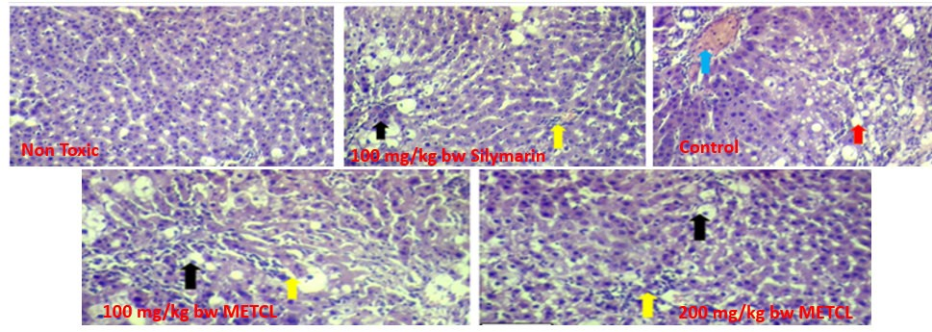

**Plate 1: Cross section of the Liver after oral administration of METCL(H & E; X 400).**

Black arrow: Hepatocytes regeneration; Yellow arrow: Mild hepatocytes necrosis and vacuolar degeneration; Red arrow: Marked hepatocytes necrosis and vacuolar degeneration; Green arrow: Cytoplasmic degeneration engorged with haemolysed blood

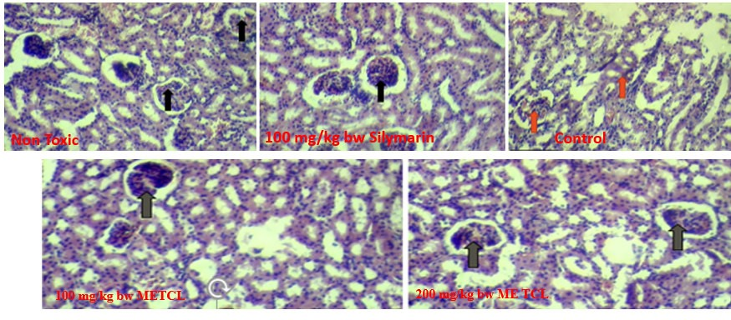

**Plate 2: Cross section of the kidney after oral administration of METCL(H & E; X 400).**

Black arrow: Normal histological features; Red arrow: Capsular and tubular degeneration **DISCUSSION**

Various environmental toxicant and clinically useful drugs, can cause severe organ toxicities through the metabolic activation to highly reactive free radical (Bharti, 2012). Liver and kidney are one of the most important organs in our body. The DPPH assay is one of the most acceptable methods of determining antioxidant activity of any medicinal materials that can act as hydrogen donors or free radical scavengers. In addition other methods such as Ferric reducing antioxidant power and Inhibition of lipid peroxidation are also part of available methods used in conjunction with DPPH to derive accurate conclusion on antioxidant activities of a particular material. The high; DPPH radical scavenging activity, Ferric reducing antioxidant power as well as high inhibition of lipid peroxidation exhibited by METCL actually supports its secondary metabolites constituents which is rich in phenols, tannins and flavonoids which is tandem with report of Ko *et al.*(2002). According to OECD, if oral dosage of a particular substance is greater than 2000 mg/kg bw (LD50 >2000 mg/kg bw) as shown in the case of METCL, such a substances is said to be relatively safe for consumption (OECD, 2010).

The significant higher activities of serum AST, ALT, ALP, bilirubin, urea and albumin with corresponding decrease in total proteins similar to the report of Azoz and Raafat (2012). Increasing in the levels of these enzymes of liver damage in the lead acetate-treated rats signify damage to the structural integrity of the liver (Busari et al., 2021b). It is mainly due to the leakage of these enzymes from the liver cytosol into the blood stream (Concepcion *et al.,* 1993). Releasing of AST and ALT from the cell cytosol can occur as secondary changes to cellular necrosis (Gaskill *et al*., 2005). The high AST and ALT activities are accompanied by high liver microsomal membrane fluidity, free radical generation and alteration in the liver tissue (Ibrahim *et al.,* 2012). Elevated level of ALP suggests biliary damage or an obstruction of the biliary tree, which disrupts the flow of blood to the liver. Some of this enzymes also present in the kidney and other organs including kidney. The decrease of these enzymes in the serum may be due to the prevention of their leakage due to antioxidant and chelating activities of phenols, tannins and flavonoids in the extract. The increase of bilirubin values in rats treated with lead acetate in this study may be due to excessive heme destruction and blockage of biliary tract resulting in inhibition of the conjugation reaction and release of unconjugated bilirubin from damaged hepatocytes (Ali *et al.,* 2010) as a result of lead toxicity. Lead acetate administration in this study caused significant increase in serum urea level as well as increase in serum creatinine level couple with increase in electrolytes. The oxidative stress induced by lead couple with the disruption of calcium homeostasis might have been resulted from lead induced kidney damage. The restoration of biochemical paramtres after METCL treatment point to the fact that METCL exhibit ameliorative effects via its phytochemical constituents and this in turn confer appreciable antioxidant activities on the extract.

**CONCLUSIONS**

Conclusively from the research, it show that METCL is safe andpossessed ameliorative effects on Lead-induced liver and renal damage as evidenced from biochemical and histological parameters. This might be as a result of its antioxidant activities due to the phenolics compounds endowed in the extract..

#### **References**

Ahmed, S.M., Vrushabendra, Swamy, B.M., Gopkumar, P., Dhanapal, R., Chandrashekara, V.M. (2005). Anti‑Diabetic Activity of *Terminalia* *catappa* Linn. Leaf extracts in alloxan‑induced diabetic rats. *Iranian Journal of Pharmacology and Therapeutics*, 4:36‑9.

Aimola, I.A., Inuwa, H.M., Nok, A.J., Mamman, A.I. (2014). Induction of foetal haemoglobin synthesis in erythroid progenitor stem cells: Mediated by water‑soluble components of *Terminalia catappa*. *Cell Biochemistry and Function*, 32:361‑7.

Aiyegoro, A.O., Okoh, A.I. (2010). Prelimary phytochemical screening and in vitro antioxidant activities of the aqueous extract of *Helichrysum longifolium*. *BMC Complementry and Alternative Medicine*, 10: 2–8.

Ajiboye, T.O., Raji, H.O., Muritala, H.F., Ojewuyi, O.B., Yakubu, M.T. (2013). Anthocyanin extract of *Lannea microcarpa* fruits stall oxidative rout associated with aflatoxin B1 hepatocarcinogenesis*. Food Bioscience,* 4: 58-67.

AOAC (2000). Official methods of analysis. 17th ed. Official Methods of Analysis of AOAC International. Gaithersburg (MD): CAB publisher.

Bharti, D.T., Raghunath, T.M., Manojkumar, Z.C., Namrata, V.N.(2012). Nephroprotective plants: a review. *International journal pharmacy and pharmaceutical sciences;* 4(1): 8-16.

Biego GHM, Konan AG, Douati TE, Kouadio LP. Physicochemical quality of kernels from *Terminalia catappa* L. and sensory evaluation of the concocted kernels. Journal of Sustainable Agriculture Research*.* 2012; 1(2):1-6.

**Busari M. B**, Hamzah R. U, Muhammad H. L, Yusuf R. S, Madaki F. M, Adeniyi J. O, Ibrahim Y. O, Berinyuy E. B. (2021a). Phenolic rich-extracts from *Nauclea latifolia* fruit restored lead acetate-induced liver and kidney damaged in Wistar rats. *Clinical*

*Phytosciences*, 7:87. https://doi.org/10.1186/s40816-021-00322-z

**Busari, M. B**., Hamzah, R. U., Muhammad, H. L., Yusuf, R. S., Adeniyi, J. O., Ibrahim, Y. O., & Adakole, J. O. (2021a). Phenolics-rich extracts of *Nauclea latifolia* fruit ameliorates lead acetate-induced haematology and lung tissues toxicity in male Wistar rats. *Scientific African*, *11*, e00686. https://doi.org/10.1016/j.sciaf.2020.e00686

Chang, C.C., Yang, M.H., Wen, H.M. and Chern, J.C. (2002). Estimation of total flavonoid content in propolis by two complementary colorimetric methods. *Journal of Food and Drug Analysis,* 10: 178-182.

Chen, P.S., Li, J.H., Liu, T.Y., Lin, T.C. (2000). Folk medicine *Terminalia catappa* and its major tannin component, punicalagin, areeffective against bleomycin‑induced genotoxicity in Chinesehamster ovary cells. *Cancer Letter*, 52:115‑22.

Divya, N., Vijaya, A.A. (2014). Phytochemical investigation and *in vitro* anti‑diabetic activity of *Terminalia catappa* leaves. *International Journal of Phytopharmacology*, 4:132‑4.

Gaskill, C. L., Miller, L. M., and Mattoon, J. S. (2005). Liver histopathology and liver and serum alanine aminotransferase and alkaline phosphatase activities in epileptic dogs receiving phenobarbital. *Veterinary Pathology*. 42, 147–160.

Hamzah, R.U. Jigam, A.A. Makun, H.A., Egwim, E.C., Muhammad, H.L., Busari, M.B., Ibikunle, G.F., Abubakar-Akanbi, S.K. (2018). Effect of Partially Purified Subfractions of *Pterocarpus mildbraedii* Extract on Carbon Tetrachloride Intoxicated Rats. *Integrative Medicine Research,* 7: 149–158.

Ibrahim, N. M., Eweis, E. A., El-Beltagi, H. S., & Abdel-Mobdy, Y. E. (2012). Effect of lead acetate toxicity on experimental male albino rat. *Asian Pacific journal of tropical biomedicine*, *2*(1), 41-46.

Khan, A.A., Kumar, V., Singh, B.K., Singh, R. (2014). Evaluation of wound healing property of *Terminalia catappa* on excision wound models in Wistar rats. *Drug Research* (Stuttg), 64:225‑8.

Kinoshita, S., Inoue, Y., Nakama, S., Ichiba, T., Aniya, Y. (2007). Antioxidant and hepatoprotective actions of medicinal herb, *Terminalia* *catappa* L. from Okinawa Island and its tannin corilagin. Phytomedicine, 14:755‑62.

Ko, T.F., Weng, Y.M. and Chiou, R.Y. (2002). Squalene content and antioxidant activity of Terminalia catappa leaves and seeds. *Journal of Agricultural and Food Chemistry* 50:5343-8

Ladele Bérenger, Kpoviessi Salomé, Ahissou Hyacinthe, Gbenou Joachim, KpadonouKpoviessi ,Herent Marie-France, Bero Joanne, Larondelle Yvan, Quetin-Leclerq and

Moudachirou Mansourou (2006). Chemical composition and nutritional properties of *Terminalia catappa* L. oil and kernels from Benin. *Comptes* *rendus.* Chimie, 19(7):876-883.

McDonald, S., Prenzler, P. D., Antolovich, M., and Robards, K. (2001). Phenolic content and antioxidant activity of olive extracts. *Food Chemistry*, 73:73-84.

Morelli, M. C., Rendina, M., La Manna, G., Alessandria, C., Pasulo, L., Lenci, I., ... & Burra, P. (2021). Position paper on liver and kidney diseases from the Italian Association for the Study of Liver (AISF), in collaboration with the Italian Society of Nephrology (SIN). *Digestive and Liver Disease*, *53*, S49-S86.

OECD (2010). Sediment-water Lumbriculus toxicity test using spiked sediment. OECD Guideline for the Testing of Chemicals 225

Owolabi, M.S., Lawal, O.A., Ogunwande, ,I.A., Hauser, R.M., and Setzer. W.N. (2013). Chemical composition of the leaf essential pil of *Terminalia catappa* L. growing in southwestern Nigeria. American Journal of Essential Oils and Natural Products, 1(1): 51-54 Oloyede, O.I., (2005) Chemical profile of unripe pulp of *Carica papaya*. *Pakistan Journal of Nutrition*, 4(6): 379-381.

Oyaizu, M. (1986). Studies on products of browning reactions: Antioxidant activities of products of browning reaction prepared from glucosamine. *Japan Journal of Nutrition,* 44: 307-315.

Pandya, N.B., Tigari, P., Dupadahalli, K., Kamurthy, H., Nadendla, R.R. (2013). Antitumor and antioxidant status of *Terminalia* *catappa* against Ehrlich ascites carcinoma in Swiss albino mice. *Indian Journal of Pharmacology,* 45:464‑9.

Ruberto, G., Baratta, M.T. (2000). Antioxidant activity of selected essential oil components in two lipid model systems. *Food Chemistry*, 69:167-174.

Taganna, J.C., Quanico, J.P., Perono, R.M., Amor, E.C., Rivera, W.L. (2011).

Tannin‑rich fraction from *Terminalia catappa* inhibits quorum sensing (QS) in *Chromobacterium violaceum* and the QS‑controlled biofilm maturation and LasA staphylolytic activity in *Pseudomonas aeruginosa. Journal of Ethnopharmacology*, 134:865‑71.

Yakubu, M. T., Oladiji, A. T. and Akanji, M. A. (2009). Mode of cellular toxicity of aqueous extract of *Fadogia agrestis* (Schweinf. Ex Hiern) stem in male rat liver and kidney. *Human and Experimental Toxicology*, 28: 469-478.

Yeh, C.B., Hsieh, M.J., Hsieh, Y.S., Chien, M.H., Lin, P.Y., Chiou, H.L., *et al*. (2012). *Terminalia catappa* exerts antimetastatic effects on hepatocellular carcinoma through transcriptional inhibition of Matrix Metalloproteinase‑9 by modulating NF‑B and AP‑1 activity. *Evidence Based Complement and Alternative Medicine*, 12:595292.