**Revitalising School Library Services in Niger State using Digital Technologies**

By

Sadiat Adetoro Salau (PhD, CLN)

[adetoro@futminna.edu.ng](mailto:adetoro@futminna.edu.ng)

&

Isah Yahaya Abdullahi

[yahaya.isah@futminna.edu.ng](mailto:yahaya.isah@futminna.edu.ng)

&

Edimeh Augustine

[austine.edimeh@futminna.edu.ng](mailto:austine.edimeh@futminna.edu.ng)

University Library Services, Federal University of Technology, Minna.

*A paper presented at the 38th Annual Conference of the Nigerian School Library Association held at the Department of School Library and Media Technology, University of Ibadan on 23rd-27th, October 2023*

**Abstract**

This presentation describes some important digital technologies and tools school libraries in Niger State can leverage to revitalise the poor services school libraries in in the state offer. A peruse of existing literature and verbal interaction with some school librarians in Niger state by the researchers revealed that, abysmal services related to digital technologies were provided in schools where libraries existed. Some of the school libraries do not have computers and electronic resources, because the focus of those schools has shifted to the Information and Communication (ICT) laboratories/rooms. The researchers inferred that this shift and poor services may be due to the fact that school librarians have not been able to champion the use of digital technologies to enhance learning in their libraries. Thus, this paper highlights some of the tools can used to revitalise library services in post-primary schools in Niger-State to make them vibrant learning spaces for users in the fourth industrial revolution.

**1.0 Introduction**

Education is focused on the intellectual growth of children, and to fulfil its aims and objectives, it needs the right tools and abilities (Ilori, et.al., 2020). Consequently, the library provides information resources to help achieve the objectives of education by improving learning activities. School libraries are pertinent infrastructures in post-primary institutions because they meet the teaching and learning needs of both the teachers and pupils. There are several definitions of school libraries, however, the definition of Petters and Ottong (2012) resonates with what school libraries should be in the fourth industrial revolution. According to the authors, a school library as a learning laboratory that provides opportunities for pupils to develop information skill.

In line with this definition, the International Federation of Library Association (IFLA) Guidelines on School library (2015) explained that school libraries exist throughout the world as learning environments that provide space (physical and digital), access to resources, and access to activities and services to encourage and support student, teacher, and community learning.

The advent of Information and Communication Technology necessitated computers and the Internet as educational tools, thus integrating technology education into the responsibilities of school librarians. (Everylibrary, 2021). School libraries are now expected to integrate digital technologies and tools, and teach students to access resources and information online to meet their information needs. Librarians had to adapt, as technology-based resources rose to be at par with print resources as a pertinent component of teaching and learning. School librarians in developing countries hesitated in this new role partly due to lack of capacity and knowledge (Arif & Khalid, 2012), as technology was not part of core librarianship *ab initio*, thus, ICT laboratories took over these responsibilities in post-primary schools. However, the gap of librarians was visible; the use of digital and media technologies for searching and retrieval had to be taught and librarians have since evolved and adopted digital technologies into their workflow. Services school libraries are expected to provide include in the fourth industrial revolution era in addition to the traditional library services include but by no means limited, to the following: Provision of electronic books, ICT skill training for pupils, reading and online/web resource lists to pupils and teachers and computer classes for pupils/users. (Adomi, 2012).

Now, are school libraries in Niger State, vibrant centres of learning or just spaces for reading? A peruse of existing literature on the state of school libraries in Niger State (Akawu, et.al., 2017; Abdullhamid & Yusufu, 2016; Abdullhamid et. al. 2017; Oyedum,et.al., 2019) and verbal interaction with some school librarians in Niger state by the researchers revealed that, abysmal services related to digital technologies were provided, where school libraries exist. Some of the school libraries do not have computers and electronic resources, because the focus of these schools has shifted to the Information and Communication (ICT) labs/rooms. The researchers inferred that this shift and poor services may be due to the fact that school librarians have not been able to champion the use of digital technologies to enhance learning in their libraries. Interestingly, this assertation is not peculiar to Niger State alone; Muazu, et. al. (2021) stated that lack of technical knowledge and exposure of librarians to library automation affect the efficient use of information technologies in school libraries in Giwa Local Government Area in Kaduna State.

In today's rapidly evolving digital world, the integration of technology has proven to be a driver for transformation across various sectors, including education. As educational paradigms shift towards more dynamic and interactive learning environments, the role of libraries within schools becomes even more critical. Consequently, this paper highlights some of the tools that can be used to revitalise library services in post-primary schools in Niger-State to make them vibrant learning spaces for users in the fourth industrial revolution. By leveraging these technologies, students and teachers can gain access to a wealth of resources and opportunities that traditional libraries alone cannot provide; thus, bringing back school libraries to its place of pride.

**2.0 Digital Technologies that can improve School library services**

1. **Digitisation & Digital Libraries using calibre**

Digitisation in this context refers to the conversion of print information resources (question papers, notes of lesson, newsletters) whose copyright are owned by the school to digital information resources using a simple scanning machine and a computing device. Apart from the digitised resources, open education resources in both academic and other genres that are free of copyright restrictions are available online and can be accessed. Interestingly, some textbooks and reference materials like Dictionaries and Atlases also have soft copies that can curated and managed in the libraries.

There are a number of digital tools that are useful for the curation and management of these digital resources. Notable amongst them is the *calibre* E-book Management software. The application can be installed on computer devices in the libraries. Although *calibre* application has advance features from acquisition to dissemination which are the crux of librarianship, school libraries can adapt features that works for them inother to avoid been overwhelmed. Any library that wants to adopt its usage must develop its own in-house cataloguing and sorting scheme to enable easy search and retrieval. (Salau, 2015).

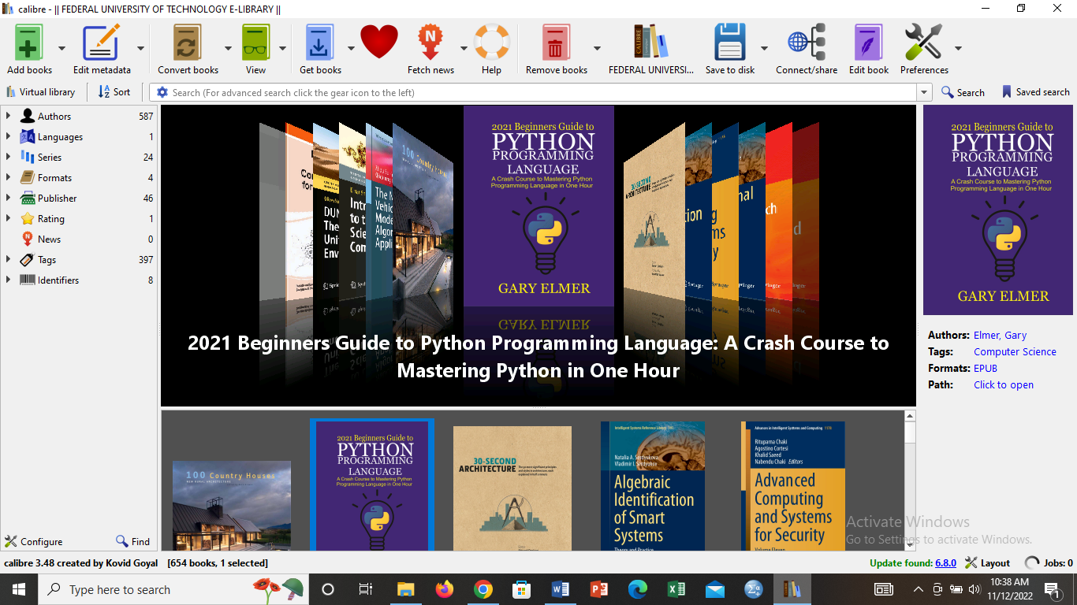

Figure 1: Calibre interface on display with digital books

1. **Current Awareness Services using Open Educational Resources**

Open education resources and teaching and learning materials in any format that are free of any copyright restrictions. Libraries can leverage these resources to revamp their current awareness services. A number of open education resources repositories exists that school libraries can leverage to provide current awareness to their students, particularly in areas outside core academics like robotics, public speaking to mention but a few. Libraries can provide OERs to school clubs to facilitate their activities. Some of the free OER sites include Khan Academy, OER Commons, Academy Earth, Learning Pod, Open Learning Initiative, DOAB.

1. **Digital Educational Games**

Games offer narratives and information that are presented in novel ways that promote critical thinking and problem-solving while achieving teaching and learning goals. Consequently, with the ubiquitous nature of digital technologies, digital game-based learning is now been discussed as one of the twenty-first century global pedagogical approaches (Kukulska-Hulme et al., [2021](https://stemeducationjournal.springeropen.com/articles/10.1186/s40594-023-00424-9#ref-CR48)), with unique advantages in enhancing education compared to other pedagogical strategies (Ishak et al., [2021](https://stemeducationjournal.springeropen.com/articles/10.1186/s40594-023-00424-9#ref-CR37)). Digital games have become pertinent in the learning space and no longer play only the function of entertainment, but could assist students in more active learning and deeper and broader learning, when being applied to instructions. (Yen-Chun, 2017). Furthermore, digital educational games can serve as an effective learning environment, providing players with ample opportunities for simulation, real-world questions, and rich instructional support (Gui et. al., 2023).

Librarians can benefit by proactively, creatively, and most importantly affordably incorporating gaming into the services and initiatives already provided at school libraries. According to the Aina (2013), gaming programmes frequently ranked among the most well-liked ones that a library can provide. According to the researcher, libraries are now more than ever focusing on video games in an effort to entice teens back inside. Thus, given all of the advantages of digital games, school libraries as support hubs for learning must position themselves and leverage the use of digital educational games to revitalise their services.

1. **Digital Reading/Book Clubs**

Reading is indispensable in the everyday activities of humans; whether it is devotional, recreational or achievement, reading makes one mentally alive at all times and keeps one abreast of the latest developments in and around the world (Nnaemeka et al., 2023). However, over the years, reading has become an avoided activity for students; the reading culture has dropped significantly due to a lot of distraction especially social media.

White (2017) believes that to create a reading culture school librarians must, *“Work with teachers and parents to find ways to instil in students the joy of reading while helping them build the reading habit.”* One of such ways is the creating and management of reading/book clubs and by extension digital reading clubs. Freeware, cross platform applications like WhatsApp and Telegram are examples of digital tools that can be leveraged to form digital book clubs. A rule of thumb in the administration of the digital book clubs is that reading-activities must be fun-driven as it is a chance for children to enjoy reading and discussing their views of books with others. For instance, due to the interoperable nature of digital tools, the social media handles of authors whose books have been read can be tagged for comments to encourage the students. (<https://literacytrust.org.uk/blog/library-lifeline-part-5-running-a-school-library-book-club/>).

It is pertinent to note that in the context of this paper, most post-secondary students may not have access to their own mobile devices for the digital book clubs, However, the devices of the parents or guardians can serve. It can run at alternate times with the physical reading clubs. Digital club can be active while the students are on holidays, while the physical club will be active while the students are in school. Thus, digital reading clubs will be the stop-gap measures for sustaining the reading culture while the students are on holidays.

**Maker Space**

Makerspace generally refers to physical spaces where people have access to digital and physical tools and community members' expertise in making, it also includes the intangible communities and programming for creating and sharing Soo Hyeon (2022). School libraries in Niger state can collaborate with science-related school clubs to either provide spaces for their activities or provide Do-It-Yourself tools which can range from simple home tools like sewing needles, glue, scissors, cardboards, drill bits to other advanced tools like 3D printers and drones.

The use of school library makerspace by secondary school students is critical if they are to develop important skills associated with problem solving and critical thinking. These skills can be sharpened with the interactions with colleagues and collaborative opportunities that the makerspace provides. Keshinro, Deborah and Oyewole, Olawale (2021)

**Conclusion**

Incorporating digital technologies into school library services in Niger State is not merely an option but a vital step toward ensuring relevance and quality education. This article has highlighted the potential of digital integration and provided insights into implementing these changes effectively. By embracing these strategies, school libraries in Niger State can pave the way for enhanced learning experiences and improved services.

**References**

1. Ilori, M.E., Oluwafemi, V. S., & Odusina, E. S. (2020) School Library Services as a Catalyst for the Better Basic Education in Nigeria. *Indian Journal of Information Sources and Services*, 10(1), 1-6.
2. Petters, S. J. and Ottong, E. J. (2012). Correlates of School Library Development in Calabar, Nigeria: Implications for Counselling. *Journal of Education and Practice*, 3(12), Pp. 67- 71
3. Murjanatu Abdullhamid, M. & Yusufu, A. (2017). Assessment of Information Resource Provision in the Staff School Libraries of Niger State. [*Journal*](https://www.ajol.info/index.php/sjis) *of Information Resource Management.* 5(2).
4. Adomi EE. (2012). Basic Computer Application in School Library Services. *Delta Library Journal* (1& 2) 43-49.
5. Everylibrary, (2021). The Rise of School Libraries as Technology Hubs. Accessed from [https://medium.com/everylibrary/the-rise-of-school-libraries-as-technology-hubs-e85e71a1ce42 on 5/9/2023](https://medium.com/everylibrary/the-rise-of-school-libraries-as-technology-hubs-e85e71a1ce42%20on%205/9/2023)
6. Oyedum, G.U., Abubakar, A. S., Obaje, A. M., Uno, C. A. (2019). Use of School Library and Students' Satisfaction in two Secondary Schools in Minna, Niger State. [*University of Ibadan Journal of Library and Information Science*](https://journals.ui.edu.ng/index.php/uijlis/issue/view/63)*.* 2(2). Pp64-77
7. Arif, D. & Mahmood, Khalid. (2012). The Changing Role of Librarians in the Digital World: Adoption of Web 2.0 Technologies in Pakistani Libraries. *The Electronic Library*. 30. 469-479. 10.1108/02640471211252184.
8. Aina, A.J. (2013) The roles of libraries in the use of games as strategy for pedagogy of primary science in schools. *International Journal of Library and Information Science*. 5(8) Pp. 240-246.
9. Yen-Chun C., (2017) Empirical Study on the Effect of Digital Game-Based Instruction on Students’ Learning Motivation and Achievement. *Eurasia Journal of Mathematics, Science and Technology Education* 13(7). DOI: [10.12973/eurasia.2017.00711a](http://dx.doi.org/10.12973/eurasia.2017.00711a)
10. Gui, Y., Cai, Z., Yang, Y. et al. (2023). Effectiveness of digital educational game and game design in STEM learning: a meta-analytic review. *IJ STEM Ed*10 (36) <https://doi.org/10.1186/s40594-023-00424-9>
11. Ishak, S. A., Din, R., & Hasran, U. A. (2021). Defining digital game-based learning for science, technology, engineering, and mathematics: A new perspective on design and developmental research. *Journal of Medical Internet Research,* 23(2), e20537. <https://doi.org/10.2196/20537>
12. Kukulska-Hulme, A., Bossu, C., Coughlan, T., Ferguson, R., FitzGerald, E., & Gaved, M. (2021). Innovating pedagogy: Open university innovation report 9. The Open University.
13. Salau, S.A. (2015) Managing E-Books in Nigerian Academic Libraries Using Calibre Software: A Case of Federal University of Technology Minna Library. *Middlebelt Journal of Library and Information Science*
14. White, Briana, "Recreational reading in secondary schools through book clubs" (2017). Graduate Research Papers. 216. <https://scholarworks.uni.edu/grp/216>
15. Soo Hyeon Kim, Yong Ju Jung, Gi Woong Choi, (2022) A systematic review of library makerspaces research. *Library & Information Science Research*, 44(4)
16. Nnaemeka, U. E, Udemezue J. O.& Amarachi Jovita Ikeagwuani (2023). Towards Enhancing Reading Culture in an Era of social media and Get-Rich-Quick Syndrome Distraction: The Nigerian Perspective. *Global Online Journal of Academic Research (GOJAR),* 2(1).
17. Keshinro, D. and Oyewole, O (2021). Predictors of Use of School Library Makerspace by Secondary School Students in Ibadan, Nigeria. *Library Philosophy and Practice (e-journal).* 5608. https://digitalcommons.unl.edu/libphilprac/5608