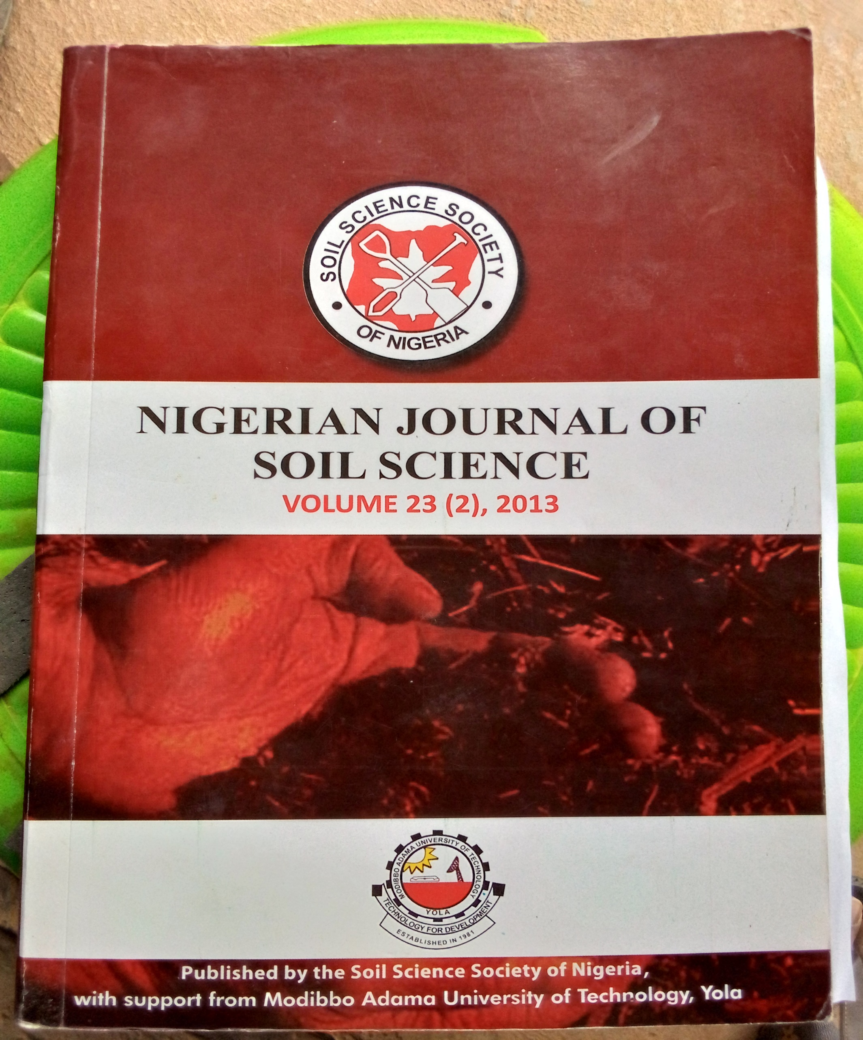

**THE IMPACT OF VARIOUS FERTILIZER INPUTS ON THE GROWTH, NODULATION AND YIELD OF SOYBEAN (GLYCINE MAX) CULTIVATED ON AN ALFISOL IN MINNA, SOUTHERN GUINEA SAVANNA OF NIGERIA**

**Uzoma, A.O., Okoh, J., Bala, A., Adeboye, M.K.A., and Osunde, A.O.**

**Department of Soil Science, Federal University of Technology, P.M. B 65, Minna.**

**\* Correspondence: uzo_ozo@yahoo.com**

**ABSTRACT**

Growth and yield response of soybean variety TGX 1448-2E to various fertilizer inputs was evaluated in a field experiment at the Teaching and Research Farm of the Federal University of Technology Minna during the 2010 cropping season. Treatment consist of five fertilizer combinations as follows: Zero fertilizer application at 0 kg P ha-1,Rock phosphate at 30 kg P ha-1, single super phosphate at 30 kg P ha-1, combination of single super phosphate at 30 kg P ha-1 and Urea at 20 kg N ha-1 and a combination of single super phosphate at 30 kg P ha-1 and Agrolyzer at 900g ha-1 The experimental layout was arranged in a randomized complete block design with 3 replicates. Result revealed that plants supplied with P fertilizer either in sole or combined form had significant growth improvement compared with their unfertilized counterparts. SSP in water. Obviously, TGX 1448-2E grew better when SSP was supplied at the rate of 30 kg P ha-1 than when Rock phosphate was applied at the same rate.. To obtain a yield of 2104kg ha-1, TGX 1448-2E will need a fertilizer combination of SSP at the rate of 30 kg P ha-1 and Urea at the rate of 20 kg N ha-1.

**Key words:** Alfisol, Fertilizer levels, Soybean variety, Southern Guinea Savanna

**INTRODUCTION**

Soybean (*Glycine max* (L.),Merr.) is the most important grain legume crop in the world in terms of total production and international trade (Gan *et al.,* 2003). Soybean was introduced into Nigeria in the year 1909 (Anon, 1984) and its cultivation was for a long time confined to Southern Guinea Savannah region. Its production has, however, expanded to the Northern and Southern parts of Nigeria as a result ofincreased demand for soybean seeds by the vegetable oil and livestock industries.

Soybean growth is influenced by climate and soil characteristics and performs well in the Southern and Northern Guinea savannas of Nigeria where rainfall is more than 700 mm. However, short-duration varieties can thrive in the much drier Sudan savanna when sown early and with an even distribution of rainfall throughout the growing period. The time for planting soybean depends upon temperature and day length. Soybean is a short-day plant and flowers in response to shortening days. It can be grown on a wide range of soils with pH ranging from 4.5 to 8.5. Soybean should not be planted in sandy; gravelly, or shallow soils to avoid drought stress. It should not be grown in waterlogged soils or soils with surfaces that can crust, as this will lead to poor seedling emergence (Dugje*et al.,* 2009).

This legume crop is also known for its ability to formsymbiotic association with root nodulating bacteria (rhizobia). The compatible rhizobia induce root nodules, where atmospheric nitrogen (N) is fixed. The number of the nodules and their rate of N fixation are determined by the effectiveness and the number of rhizobia in the soil (Ayanabe*et al.,* 2001). Furthermore, the level of effectiveness of rhizobia results in variation in the color of nodules (pink which is effective, white which is ineffective in nitrogen fixation). The variation in nodule number and color in turn induce variation in growth and yield of the host due to variation in fixed N (Amijee and Giller, 1998). Soybean nitrogen (N) requirements are met in a complex manner, as this crop is capable of utilizing both soil N (mostly in the form of nitrate) and atmospheric N (through symbiotic nitrogen fixation) (Milic*et al.*, 2002). Not only the amount of nitrogen applied per unit area as fertilizer, but its form is also important, urea is one of the most commonly used sources of fertilizer nitrogen to soybean as starter N- source (20kg N ha-I) (Randall and Schmitt, 1998). There are however other inputs that are important in the cultivation of soybean notably phosphorus and micronutrients.

*Nodulation and yield of soybeans and fertilizer*

Phosphorus (P) is a critical macro nutrient for nodulation and subsequent N2 fixation (Aulakh*et al.,* 2003), it is however unavailable to terrestrial plants in organic forms in which up to 60% to 80% is myoinositolhexakisphosphate (phytate) (George and Richardson, 2008). The alternative to these is to use other forms of phosphorus that are readily available to plants when applied to the soil. Rock Phosphate (RP) and Single Super Phosphate (SSP) are option with advantages. Rock Phosphate is composed of phosphate minerals high enough in apatite while Single Super. Phosphate (SSP) is a straight phosphatic multi-nutrient fertilizer which contains 16% water soluble P205, 12% Sulphur, 21% calcium and some other essential micro nutrients in small proportions. Even though it is often time referred to as poor farmer's fertilizer price-wise, it is an option to optimize the use of phosphatic fertilizers.

Micronutrients come in various trade name, Agrolyzer is a micronutrient product sold as a commercial liquid fertilizer, designed to provide growers with a uniform, stable and easy to apply fish-based nutrients for either foliar or soil fertility use which contains micronutrient. Micronutrient or minor elements are required by plants in very small quantities, usually less than a pound per acre per year. This does not diminish their importance. Most micro nutrient deficiencies or toxicities are not wide spread, but when they occur, plant abnormalities, reduced growth, crop failure can result (Michalski *et al.,* 2003). In Minnesota, Randall and Schmitt (1998) summarized that soybean yield could be increased by addition of soil applied fertilizer, however responses were inconsistent and varied with season, variety, rate, fertilizer source,application timing and other yield limiting factors.

As part of the objective of N2Africa Project to select multi-purpose legumes providing food, high quality crop residues for enhanced BNF and integrate improved varieties into our resource-poor farming systems, response of soybean variety TGX 1448-2E to five fertilizer input combinations (No fertilizer application at 0 kg ha-1 Sole SSP fertilization at 30 kg P ha-1, Sole Rock Phosphate fertilization at 30 kg P ha-1,Combination of SSP at 30 Kg P ha -1 and Urea at 20kg N ha-1, and a Combination of SSP at 30kg P ha-1 and Agrolyzer at 900g ha-1) was evaluated in a field experiment. The aim was to select the best input or input combinations that will ensure good growth and yield performance of TGX 1448-2E cultivated on an Alfisol in Minna, Southern Guinea Savanna Zone of Nigeria.

**MATERIALS AND METHODS**

**Study Area and Soil Description**

The research was carried out at the Teaching and Research Farm of the School of Agriculture and Agricultural Technology, Federal University of Technology permanent site which is located along kilometer 16 Minna-Bida road, from the month of July to November 2010. Minna lies approximately on longitude 06°31' E and latitude 09°41' N.

Soils of Minna are derived from the basement complex rock. They range from shallow to very deep soils overlying deeply weathered gneisses and magmatite, some are underlain by iron pan to varying depth. They are strong brown to red sandy clay or clay with often gravelly loamy sand or sandy surface soil layer (FDALR1, 1999). The most predominant soil type is the ferruginous tropical soils which are basically derived from the Basement Complex rocks, as well as from old sedimentary rocks. Such ferruginous tropical soils are ideal for the cultivation of millet (*Panicummiliaceum*), maize (*Zea mays*), guinea corn (*Andropgonspp*) and groundnut (*Arachishypogaea)*. The vegetation is characterized by woodlands and tall grasses interspersed with tall dense species.

***Soil Sampling and Analysis***

The soil samples were collected fresh from the field prior to planting from 20 points selected at random on the field at depth 0-20 cm using a soil auger. A total of 20 soil samples were collected and air-dried till maximum drying was obtained. The samples were lightly crushed and sieved with a 2mm sieve to remove contaminants and to obtain a composite sample. Sub sample were taken thereafter for determination of physico-chemical properties by standard method as follows, soil particle size distribution was determined by the hydrometer method (Bouyoucous, 1962). pH was measured by using the pH meter in both water and 0.01M CaCl2 (soil solution ratio 1:2:5) (Roswell, 1994). Total nitrogen was estimated by kjedhal method (Bremner and Mulvaney, 1982) and organic carbon in the soil by dichromate oxidation and titrating with ferrous ammonium sulphate (Walkley, 1947). Available P was determined colorimetrically after Bray-1 extraction. Exchangeable bases were extracted with neutral 1N NH4OAc. Total Na+ and K+ were measured by using a flame photometer, Ca2+ and Mg2+ by Na-EDTA titration (Agbenin, 1995). Exchangeable-acidity was extracted with IN KC1.

***Land Preparation, Experimental Design and Treatment***

The total land area of 24.5m by 25m i.e. 0.06125 hectare was cleared, harrowed and ridged. The land was divided into six blocks i.e. two blocks representing one replicate. Each of the blocks was further divided into plots of size 4.5m by 3m with 0.5m space between the plots. The spacing between blocks was 1m while spacing between replicates was 2m. The treatments are five fertilizer input combinations (No fertilizer application at 0 kg ha-1 , Sole SSP fertilization at 30 kg P ha-1, Sole Rock Phosphate fertilization at 30 kg P ha-1,Combination of SSP at 30 Kg P ha -1 and Urea at 20kg N ha-1, and a Combination of SSP at 30kg P ha-1 and Agrolyzer at 900g ha-1) The reference soybean variety was (TGX 1448-2E) obtained from N2 Africa Project. This variety with proven high BNF potential and sufficient seed availability in target impact zones of N2 Africa is promiscuous, medium maturing, high biomass and high grain yielding, dual purpose and drought resistant. The experiment was arranged in a randomized complete block design as shown below.

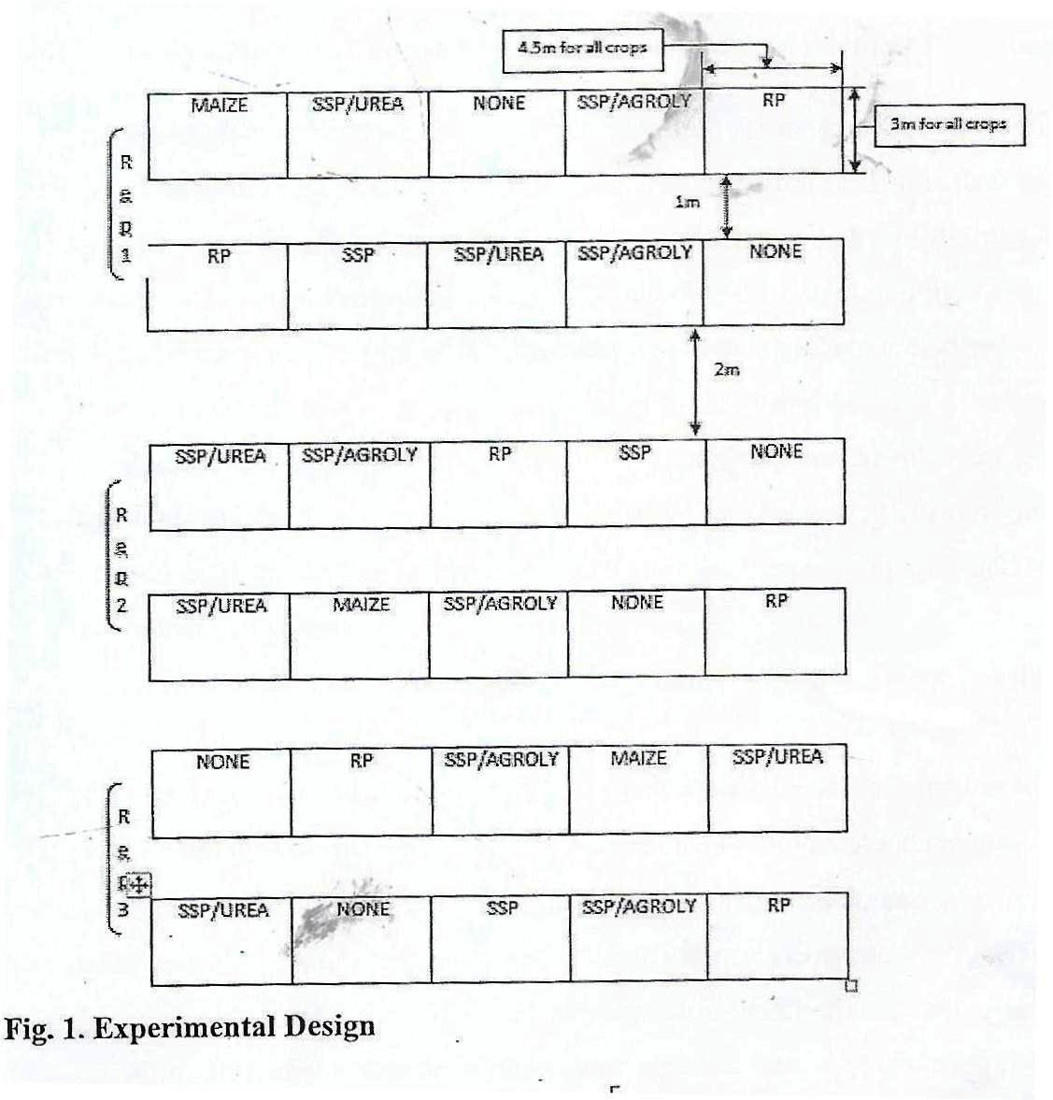

*Nodulation and yield of soybeans and fertilizer*

***Planting and Crop Management***

Two soybean seeds were planted on the 24thof July, 2010 at intra and inter row spacing of 5cm x 75cm plot-1. The plants were thinned to one plant per stand at 2 weeks after planting (WAP). The weeding was manual on two different occasions at 2 and 6 WAP. Bonds were constructed to prevent externally generated runoff into the plots.

**Tissue Sampling and Harvesting**

Shoot biomass of soybean was sampled at mid flowering; the inner two ridges were destructively sampled from the two inner ridges by selecting four plants at random. Harvesting was done at physiological maturity by hand pulling and threshing.

***Determination of Nitrogen and Phosphorus in Plant Tissue***

***Determination of Tissue Nitrogen (micro Kjeldahl method) Procedure***

0.5g of grinded plant sample was weighed into digestion flask. One Kjeldahl tablet catalyst was added together with 20m1 of concentrated H2SO4. The digestion flask was then heated for about 2 hours until when the digestion was clear. After cooling the flask, a little distilled water was added and the content was transferred into a 100m1 volumetric flask and then distilled water was added to make up to mark. 10m1 of the digestion was then taken into a distillation flask. 10m1 of 2% HBO3 was taken into a flask with 3-4 drops of bromocresol green and methyl red indicator and placed under the condenser of the distillation apparatus 10m1 of 40% NaOH was added to the10rn1 digest in the digestion flask

and the distillation process carried out until the distillate reached 35ml mark of the HB03 flask. This distillate was then titrated with 0.01N HC1. A blank was run without soil sample.

***Determination of Phosphorus in Plant Tissue (Dry Ashing method)*Procedure**

0.5g of finely grounded and oven dried (60°C) plant material was contained in a 30m1 porcelain crucible. The sample was placed in a muffle furnace for 6-8 hours at a temperature of 450°C to a grayish white ash. The sample was cooled on top of asbestos sheet, and then 20m1 of 20% HC1 was added and placed on a hot plate under ventilation to evaporate to dryness. Then 10m1 of 0.1N HC1 was added and filtered into a 50m1 volumetric flask and made up to volume with 0.1N HCL solution.

1ml of the sample solution was pipetted into a test tube, followed by 5m1 of distilled water and then 4m1 of vanado-molybdate to a yellowcoloration.The percentage transmittance was then determined at 400um by plotting it against the standard curve for P pipetted at 0, 2, 4, 6, 8 and 10ml. 25m1 P standard solution was then pipetted into a series of 100ml volumetric flasks and colour developed according to the same procedure stated.

***Data Collection and Statistical Analysis***

The growth, nodulation .and yield data were subjected to oneway analysis of variance (ANOVA) and the least significant difference (LSD) was used for mean separation, also Pearson correlation analysis was used to determine whether linear relationship exist between the parameters.

**RESULTS AND DISCUSSIONS**

***Soil Texture, Reaction and Exchangeable Bases****.*

The results of the physical and chemical properties of the soil at 0-20cm depth are shown in (Table 1). The soil was classified as sandy clay loam, with sand % as 75.88, clay % 23.42 and silt % 0.70. The soil was slightly acidic with pH of 6.91 in water and pH of 6.41 in CaCl2, and the percentage Organic Carbon was low (6.50 g Kg-I). Available phosphorus was low (9.00 mg Kg-1) and consequently, Total Nitrogen was low (< 0.3g Kg-I) justifying the need for exogenous N supply in the form of pre-plant N application or in-season N fertilizer application. Lamb *et al*., (1990) observed that pre-plant N application increased the yield of soybean grown on soils with low inorganic N supply, low soil organic matter, low residual soil nitrate.

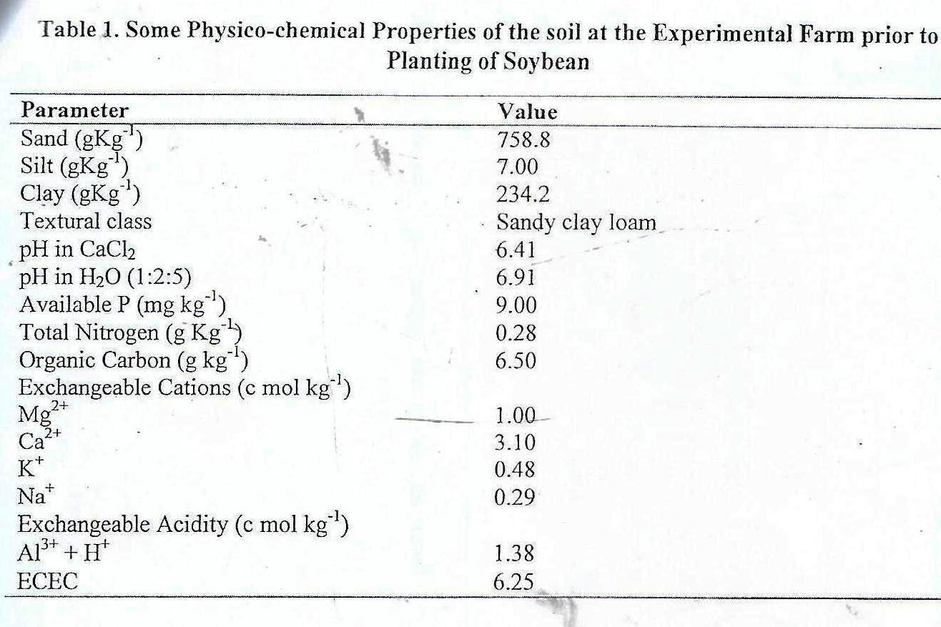

***Correlation Coefficient between the Pairs of Growth and Yield parameters***

*Nodulation and yield of soybeans and fertilizer*

Pearson correlation coefficient between the pair of growth and yield parameters are shown in Table 2. Days to 50% flowering had a negative correlation with %P in leaf, %N in seed and %N in leaf; This is an indication that as plants flowered earlier, they accumulated less P in leaves and less N in seeds and leaves. Also, days to 50% podding had a negative correlation with the number of nodules, number of pods, %P in seed, and %N in leaf. This is signifying that as plants podded early, they accumulated less P in seeds, less. N in leaves and less nodules. Plant height was positively and highly correlated with number of leaves, shoot biomass, number of nodules, weight of nodules, number of pods and yield; indicating that as plants grew taller, they nodulated better, accumulated More biomass, eventually podded and yielded better. Number of nodules was positively and highly correlated with weight of nodules, number of pods, %N in leaf and yield meaning also that nodulation increased these parameters.

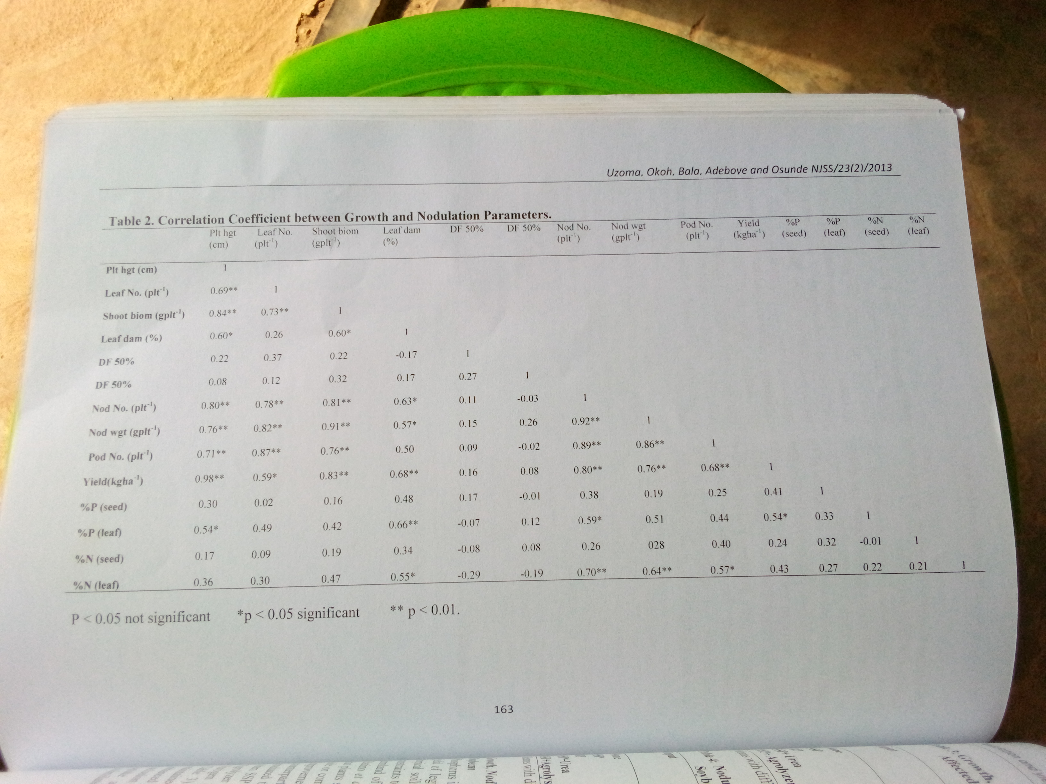

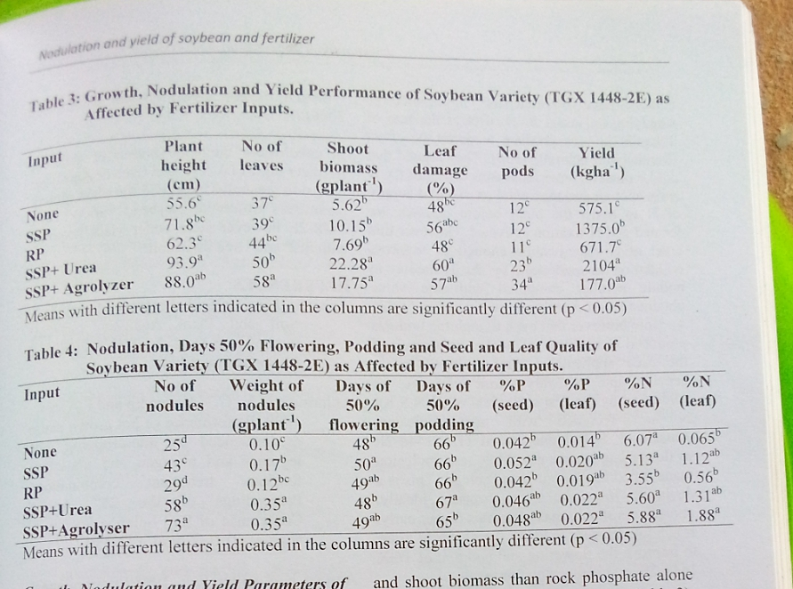

*Nodulation and yield of soybeans and fertilizer*

**Growth, Nodulation and YieldParameters of Soybean**

Phosphorus is critical for optimum growth and yield of leguminous crops. Its deficiency in tropical soils is considered one of the main constraints to food production in large areas of farmland of sub-humid and semi-arid Africa (Batino*et al*., 1996) Our results have proven that plants supplied with P fertilizers either in sole or combined form had significant growth improvement compared with their unfertilized counterparts (Table 3). TGX 1448-2E produced the best growth response especially when SSP was combined with either urea or Agrolyzer implying that the inclusion of Nitrogen increased dry matter accumulation (Table 3).Oplinger and Bundy(1998) also maintained that vegetative growth was enhanced with the application of N. Agrolyzer inclusion on the other hand probably improved uptake and translocation of nutrients and assimilates. SSP alone improved plant height and shoot biomass than rock phosphate alone compared with the control treatment (Table 3). This may be because of the solubility of SSP in water (Akinrinde*et al.,* 1999). That may also explain why the leaf damage as a result of the inclusion of Urea to SSP was highest (60%) in our result (Table 3). Rock phosphate treatment gave a lower leave damage as the control (48%) compared to Single super phosphate but this did not translate to better yields(Table 3). Although it was expected that higher leaf damage should result to poorer yield, studies have shown that possibility only when more of the photosynthetic leaves are damaged. That also explains why the lower leaf damage as a result of the Rock phosphate produced less dry matter at the shoots and stems. Obviously, TGX144-2E will grow better when SSP is supplied than when rock phosphate is used and will need inclusion of Urea at the rate of 20 Kg N ha-1 to improve growth significantly. Before now, several authors have reported the importance of supplying an initial level of N at the rate of 20Kg N ha-1 to produce a starter N effect (Randall and Schmitt, 1998). They argued that unlike most legumes, soybeans do not fix N early enough and may need an external supply of N to assist the plant before nodules are formed and N fixation activated. However, this level of N may just be enough to suppress nodulation as evidenced by the reduction in nodule number compared with the value obtained when Agrolyzer was included (Table 4). Note however that even though the nodules produced were fewer in number as a result of the urea application, they weredefinitely heavier and probably more effective as evidenced by the best seed yield of 2104.9 Kg N ha-1 recorded with urea inclusion. Amazingly, SSP Alone caused TGX1448-2E to flower late by one day while urea inclusion made it pod late by one day(Table 4). This is a deviation fromthe norm because ideally, phosphorus should make legumes flower early. It is however safer to apply Agrolyzer in order to improve the flowering and podding of TGX 1448-2E as evidenced by our result.

Leaf and seed quality were also affected by phosphorus application (Table 4). Partitioning of the N and P averagely favored the seeds than the leaves, probably suggesting that the sinks(floral parts) were more active than the sources(foliar parts). SSP applied alone produced better seed and leaf P and N values than Rock phosphate alone. This is also attributed to the water solubility of SSP and its higher assimilation by TGX 1448-2E. Inclusion of Agrolyzer to SSP averagely produced better seed and leaf quality suggesting that the assimilation of N and P could be enhanced by micronutrients availability (Awoniyi and Olofintoye, 2008). The best yield of 2104.9Kg N ha-1 obtained by combining SSP with urea emphasizes the importanceof N application to soybeans. Although this could result to the reduction of nodules as evidenced by our result, the nodules were heavier and probably more efficient in Nitrogen fixation (Awoniyi and Olofintoye, 2008).

In conclusion, the combination of different fertilizer inputs i.e. SSP and Urea or Agrolyzer inclusion generally improved the plant growth parameters observed. Soybean variety TGX 1448-2E however gave better yield response with SSP and Urea inclusion.

**REFERENCES**

Agbenin, J.O. (1995). Laboratory Manual for Soil and Plant Analysis. (selected method and Data Analysis). Published by the author. 140pp.

Akinrinde, E.A., G.T Arreyndip and F.AOjo, 1999. Performance of pot grown maize as influenced by intercropping with legumes and nitrogen and phosphate fertilizer treatment combinations. Proceedings of the 25th annual conference of Soil Science Society of Nigeria, 21-25th Nov. 142-150.

Amijee, F. &Giller, K.E. 1998.Environmental constraints to nodulation and nitrogen fixation of Phaseolus vulgaris L. in Tanzania, 1.A survey of soil fertility, root nodulation and Multilocational responses to rhizobi-um inoculation. African Crop Science, 6: 159-169.

Anonymous, (1984).Role of soyabean in Nigeria economy. Fourth Meeting of soyabeanScientists.Obafemi Awolowo University, Ile-Ife, Nigeria. 1984.

AulakhM.S, Pasricha N.S., Bahl GS (2003).Phosphorus fertilizer response in an irrigated soybean-wheat production system on a subtropical, semiarid soil. Field Crops Res., 80: 99-109.

Aune J.B, Lal R. (1997) Agricultural productivity in the tropics and critical limits of properties of Oxisols, Ultisols, and Alfisols. Trop Agric 74:96-103

*Nodulation and yield of soybeans and fertilizer*

Awoniyi, O.A. and Olofintoye, J.A. (2008) Response of Soybean (Glycine max. L. Merill) to Phosphorus and Micronurient Fertilizer in Southern Guinea Savanna of Agroecology in Nigeria

AynabebaAdamu,FassilAssefa, AsfawHailemariam&EndashawBekele. 2001. Studies of Rhizobium inoculation and fertilizer treatment on growth and production of faba bean (Viciafaba) in some yield depleted and yield sustained regions of Semien Showa. SINET: Ethiopian Journal of Science, 24:197-211.

Bationo, A., Chien, S. H. Christianson, C. B. and Mokwunye, A. U. 1990. Agronomic evaluation of two unacidulated and partially acidulated phosphate rocks indigenous to Nigeria. Soil Sci. Soc. Am. J. 54: 1772 - 1777.

Bationo, A., Rhodes, E., Smaling, E.M.A., Visker, C., 1996. Technologies for restoring soil fertility. In Mokwunye, A.U., de Jager, A., Smaling, E.M.A, (Eds) Restoring and Maintaining productivity of West Africa Soil. Key to Sustainable Development. IFDC-Africa, LEI DLO and SC. DLO.

Bouyoucos, G.J. (1962). Hydrometer method improved for making particle size analysis of soils. Agronomy journal. 54:464-465

Bremner, J.M and C.S Mulvaney 1982, Nitrogen-Total.P 595-624. In A.L page et al. (ed.) Methods of Soil analysis part 2. 2nd ed. Agron. Monogr. 9. ASA and SSSA, Madison, WI.

Dugje, I.Y., L.O. Omoigui, F. Ekeleme, R. Bandyopadhyay, P. Lava Kumar, and A.Y. Kamara. 2009. Farmers' Guide to Soybean Production in Northern Nigeria. International Institute of Tropical Agriculture, Ibadan, Nigeria. 21 pp.

FDALR 1990: Federal Department of Agriculture Land Resources, Soil Report vol.2 166pp.

Gan, Y., I. Stulen, H. Keulen, J. C. Pieter, 2003, Effect of N fertilizer top — dressing at various reproductive stages on growth, N2 fixation and yield of three soybean (Glycine max L. Merr.) genotypes. Field Crops Research 80, 147 — 155.

George TS, Richardson EA (2008) Potential and limitation of improving crops for enhanced phosphorus utilization. In PJ White, JP Hammond, eds, Ecophysiology of plant-Phosphorus Interactions. Springer, Dordrecht, The Netherlands, pp 247-270

Jordan, G.B., L.D. Streit, and J.S. Binkley. 1982. A Framework for Assessing the Effectiveness of Research Organizations. Los Alames NM: Sandia National Laboratories.

Juo, A.S.A. (1981). Characterization of soil in relation to crop production I.I.T.A Ibadan Nigeria.

Lamb, J.A. G.W. Rehm, R.K. Severson, and T.E. Cymbaluk. 1990. Impact of inoculation and Use of fertilizer nitrogen on soybean production where growing conditions are short. J.

Michalski, G., George T.S., blavio, J. and Macurvnicuv AS (2003). A multi-method impact evaluation of a therapeutic summer camp programe. Child and Adolescent Social Work Journal, 20(1), 53-76.

Milic Vera, NastasijaMrkovaeki, MilicaHrustie, 2002, Interrelationship of nitrogen fixation potential and soybean yield. A Periodical of Scientific Research on Field and Vegetable Crops 36, 133 — 139.

Oplinger, E.S. and L.G. Bundy. 1998. Nitrogen fertilization of soybean — Wisconsin results. p.120-129. InProc. 1998 Wisconsin Fertilizer, Aglime, and Pest Management Conf., Madison, WI. 19-21 Jan. 1998. Univ. of Wise., Madison, WI.

Randall, G.W. and M.A. Schmitt. 1998. Fertilizer or manure for soybeans. p. 110-119. In Proc.1998 Wisconsin Fertilizer, Aglime, and Pest Management Conf., Madison, WI. 19-21 Jan. 1998. Univ. of Wise., Madison, WI.

Roswell, D.A (1994). Soil science method and applications Longman scientific and technical, Singapore. Soil Biology and Biochemistry 23:709-713

Sanginga, N., Dashiell K, Okogun JA, Thottappilly G (2002) Nitrogen fixation and N contribution by promiscuous nodulating soybeans in the southern Guinea savanna of Nigeria. Plant and Soil 195:257-266

Walkley, A. (1947). A critical examination of a rapid method for determining organic carbon in the soil-effect of variation in digestion condition and of inorganic soil constituent. Soil Science Journal. 63 :251-264