DEVELOPMENT AND CHARACTERISATION OF HIGHLY CRYSTALLINE BORON DOPED MULTI-WALLED CARBON NANOTUBES AS POTENTIAL ADSORBENT FOR REFINERY WASTEWATER TREATMENT

*Kariim I.^{1,2,} Abdulkareem A.S.^{1,2}, Tijani J.O.^{2,3}, Abubakre O.K.^{2,4}
¹Chemical Engineering Department, Federal University of Technology, Minna, Nigeria
²Nanotechnology Research Group, Centre for Genetic Engineering and Nanotechnology,
Federal University of Technology, Minna, Nigeria
³Chemistry Department, Federal University of Technology, Minna, Nigeria
⁴Department of Material and Metallurgy Engineering, Federal University of Technology,
Minna, Nigeria
*Email of the Corresponding author: k.ishaq@futminna.edu.ng

ABSTRACT
The development of novel engineering materials for adsorption process has received numerous attentions from researchers around the globe following the discharge of harmful materials into the environment due to massive industrialization. In line of this challenge, this study focuses on the development and application of purified multi-walled carbon nanotubes (MWCNTs) and boron doped MWCNTs as novel adsorbents for the removal of phenol and cyanide. The boron doped MWCNTs was developed via impregnation method. The resulting boron-doped MWCNTs was characterized for its internal morphology, crystallinity, d-spacing, surface area and elemental composition using High-Resolution Transmission Electron Microscope (HR-TEM), X-Ray diffraction (XRD), Selected Area Diffraction (SAED), Braunner Emmett Teller (BET) and Energy Dispersion X-Ray (EDX) techniques respectively. The result of the simultaneous sorption of phenol and cyanide indicate that the optimum adsorption of 98.97 % and 96.84 % were observed at the residence time of 60 min, adsorbent dosage of 0.3 g and temperature of 60 ºC for B-MWCNTs adsorbent respectively. The study revealed that the developed boron-doped MWCNTs possessed promising sorption properties suitable for phenol and cyanide removal from refinery wastewater.
Keywords: Carbon Nanotube; Characterization; Phenol; cyanide; Adsorption

1. INTRODUCTION
The geometric progression in the area of urbanization and industrialization in some developed and developing countries have resulted to continuous discharge of harmful materials into the water bodies and the environment which poses serious health challenges to the ecosystem including man and animals. Such pollutants could either be mixed in the form of toxic liquid (phenol and cyanide), gases, viruses and bacterial. The need to develop an effective material for the removal of such pollutants from industrials effluents is paramount.

Carbon nanotube is one of the promising engineering materials that possesses active properties towards tailored applications and it’s reported to be one of the most active fields of research (Ayala et al., 2010). On the properties and area of applications of pristine carbon nanotubes, several literatures have revealed the enormous progress in recent time with an observable interest geared towards the improvement and the controlling of their inherent properties via novel functionalization techniques (Ramanathan et al., 2005; Francesca, 2009; Christopher and James, 2004). The remarkable technological changes are reportedly achieved on the properties of carbon nanotubes either by defect placing on the tubes sides or through doping with heteroatom (Tsang et al., 2007). Carbon nanotubes doping with heteroatoms have a potential of improving the structural, chemical, and electronic properties towards some areas of applications such as catalysis, composites, adsorption, electrochemistry, organic solar and photovoltaics (Blackburn et al., 2006; Lin and Xing, 2008; Li et al., 2002; Chen et al., 2007; Gong et al., 2000).

Refineries have been identified as one of the major producer of phenol and cyanide as one of the constituents of the discharged effluent which possess high risk to human and the aquatic habitat (Ilaboya et al., 2013). The concentration of phenol and cyanide over the allowable limit could be observed in other industries such as plastics, paints, agriculture. There is urgent need to device and develop an improved materials capable of treating wastewater containing cyanide and phenol from refinery wastewater before being discharged into the surrounding ecosystem.
Several researchers have worked extensively on numerous methods of wastewater removal. Such methods include reverse osmosis, nanofiltration, membrane separation, coagulation and flocculation, extraction, and adsorption process (Cataldo et al., 2016). Though membrane based processes such as ultrafiltration, microfiltration, nanofiltraton, and reverse osmosis are pressure-induced and but are costly to operate and maintain. High technicalities are required for efficient and effective design and operation of membrane based techniques compared to adsorption process. Therefore, there is need to develop an efficient and effective method of phenol and cyanide sorption from refinery wastewater through adsorption process.

In this present study, boron-doped multi-walled carbon nanotube was produced via wet impregnation method. The developed boron-doped MWCNT was characterized via transmission electron microscope (TEM), Selected area electron diffraction (SAED), X-Ray diffraction (XRD) and Energy dispersion X-ray (EDX) and applied as adsorbent for the removal of phenol and cyanide from refinery wastewater. The effects of residence time, adsorbent dosage and temperature were also investigated on the percentage removal of phenol and cyanide in a batch adsorption process.

2. MATERIALS AND METHODS
All the chemicals (boric acid by Sigma Aldrich, Distilled water was obtained from the Centre for Genetic Engineering and Biotechnology, FUT Minna) used in this study were of analytical grades with 99.99 % percentage purity. The properties of the MWCNTs used in this study have been reported elsewhere (Kariim et al., 2015). Wastewater was collected from Kaduna refinery and petrochemicals and the composition of phenol and cyanide were determined via titrimetric approach.

2.1 Development of boron doped MWCNTs Adsorbent
A known weight ratio of 80:20 wt % (g/g) of the MWCNTs to boric acid was mixed in 50 ml of distilled water in a beaker. The resulting mixture was stirred for a period of 24 hours and then dried at a temperature of 120 ºC for 10 h. The dried boron-doped MWCNTs was grinded then sieved through a 150 micrometre sieve size then stored in an airtight container for further analysis. The obtained nano-adsorbent was characterized using TEM/EDX, XRD, SAED and BET for the morphology/elemental composition, crystallinity, d-spacing and surface area respectively.

2.2 Characterization of the developed boron-doped MWCNTs adsorbent
The developed boron-doped MWCNTs was analysed for the crystallinity via the use of the XRD (Bruker AXS D8 X-ray diffractometer system), internal morphology/crystallinity/elemental composition (Zeiss Auriga HRTEM/SAED/EDX operated at 3950 V) and surface area via BET (Nova-e series).
The crystallite size of the boron-doped MWCNTs was calculated from the XRD data using the Scherer Equation as shown in Equation (1) (Chen et al.,2006).

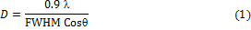

2.3 Adsorption Process
The percentage removal of phenol and cyanide onto the synthesized MWCNTs and B-MWCNTs adsorbent were determined in a batch reactor. The percentage removals of cyanide and phenol were determined using Equation 2.
(2)

Where C_{o} and C_{e}, V represent the initial concentration before the adsorption process (mg/L) and the final concentration after adsorption (mg/L respectively.

3 RESULTS AND DISCUSSION
The crystallinity of the produced boron doped MWCNTs is shown in Figure 1. In addition to the crystallinity extracted from the XRD result, the XRD spectral was also used to determine the average crystallite size, the lattice phase and the d-spacing of the atomic composition in the bulk of the boron doped MWCNTs.

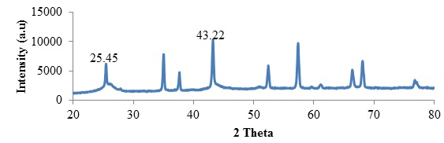
Figure 1: XRD Spectral of the Developed Boron Doped MWCNTS Adsorbent

From Figure 1, there are several identifiable peaks found in the spectra though the peaks at the 2 theta of 25.45 and 43.22 were assigned to the presence of graphitised carbon in the developed adsorbent. This observation of peaks formation is in agreement with the findings of Aliyu et al., (2017) who worked on the development of MWCNTs using the developed Fe-Ni supported on kaolinite clay. The remaining peaks could be attributed to the phases inherent from the catalyst particles used during the MWCNTs synthesis.

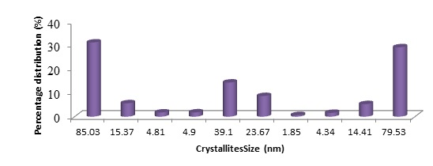
Figure 2: Crystallite Size Distribution of the Developed Boron Doped-MWCNTs Adsorbent

From Figure 2, the average crystallite size of the produced boron-doped MWCNTs was determined to be 22.75 nm using Scherer equation as illustrated in Equation 1. Furthermore, the crystallite particle sizes were found to exist within the ranges of 1.85 to 85.03 nm in the bulk of the boron doped MWCNTs adsorbent as depicted in Figure 2.
The result of the HR-TEM micrograph of the developed boron doped MWCNTs is shown in Figure 3.

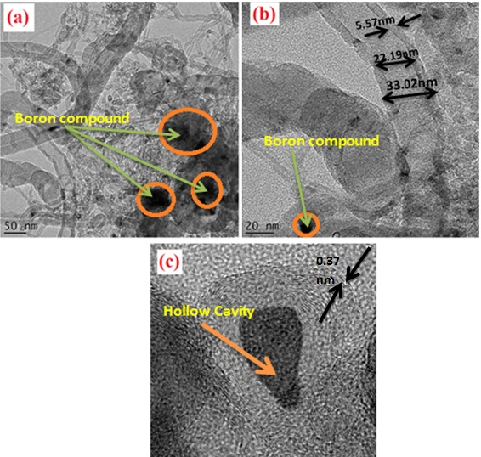

Figure 3: HR-TEM Micrograph of Boron Doped MWCNTS Adsorbent

The HR-TEM micrograph is as depicted in Figure 3(a-c). Figure 3a clearly shows the presence of long and continuous strands of MWCNTs formation. In addition to the noticeable observations on the Figure 3a, the presence of embedded boron compounds were associated with the darker part of the micrograph with oval shape indication. The wall thickness, internal and external diameter of the produced MWCNTs was estimated to be 5.57, 22.19 and 33.02 nm respectively as

depicted on Figure 3b. The obtained values show that the produced nanocomposites formed have its dimension in nanoscale hence, the obtained material is nanomaterial. From Figure 3c, the hollow nature of the developed nanocomposite was shown with several walls making the cavity. The presence of the concentric walls was a direct indication for the multi-walled nature of the formed nanocomposites as observed on the starting MWCNTs material. The result as indicated in Figure 3c further shows that the adopted doping process has no effect on the structural make-up of the starting material.

The crystals lattice as estimated from the Figure 3c was found to be 0.37 nm which was relatively higher than that of the staring as-synthesized and purified MWCNTS. The reason for this appreciable increases in the d-spacing could be linked to the contribution of the
adsorption of physiosorbed water molecules into the pores of the MWCNTS and the penetration of boron containing compound used for doping process into the wider formation of inter-particle spacing.

The results of the energy band of the constituent elements and the elemental composition are shown in Figure 4 a and b respectively.

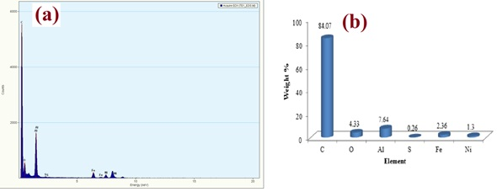

Figure 4: (a) EDX Spectra and (b) Elemental Composition of the Developed Boron Doped MWCNTs Adsorbent

The EDX spectrum of the developed boron doped MWCNTs is as presented in Figure 4a. The Figure 4a as presented shows the variable energy level of the constituent elements in the adsorbent mix. Primarily, C, O, Al, S, Fe and Ni were the observable elements composed in the developed boron doped MWCNTs adsorbent. The presence of both Fe and Ni at variable energy level is an indication of their unique properties one of which is the variable oxidation state; property exhibited by transition metals. At lower energy level, both the Fe and the Ni exist in the form of oxides although the occurrence of S in the bulk of the adsorbent could be associated with possible introduction of impurity during the course of sample preparation for the HR-TEM microscopy. On the other hand, the result in

Figure 4b shows the presence of six distinctive elements present in the developed adsorbent. The elements include Carbon, Oxygen, Aluminium, Sulphur, Iron and Nickel with weight percentage of 84.07, 4.33, 7.64, 0.26, 2.36 and 1.30 respectively. From these elements present, Carbon was found to have the highest weight percentage in the adsorbent mix. The presence of the observable highest percent of carbon could be as a result of the carbon nanotubes used as the main component of the developed adsorbent and possible inclusion from the carbon grid used during the electron microscope analysis. Furthermore, the presence of Ni and Fe elements was linked to the remnant of the metallic catalyst unremoved during the purification process. The BET surface area was determined to be 330 m²/g.
The result of the SAED Pattern of the developed boron doped MWCNTs is as presented in Figure 5.

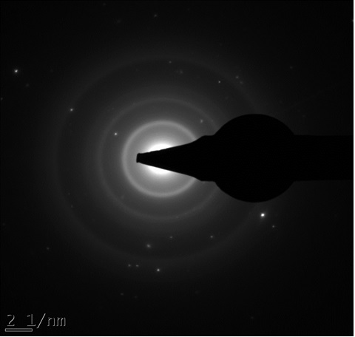
002
110
100
100
Figure 5: SAED Pattern of the Developed Boron Doped MWCNTS Adsorbent

The SAED pattern as shown in Figure 5 depicts several concentric rings representing different phases and respective d-spacing lattice in the crystals of the produced boron doped MWCNTs adsorbed. The crystallite sizes, the d-spacing and the lattice indexing is shown in Table 1.

Table 1: Crystallites Diameter and Phase Identification of Boron Doped MWCNTs Adsorbent
S/N |  | Ring Diameter  (nm) | Ring radius (1/nm) | Radius (nm) | Ring Radius (Å) | hkl indexing
1. |  | 4.988 | 2.493 | 0.401 | 4.010 | 002 (FCC)
2. |  | 8.976 | 4.488 | 0.2228 | 2.228 | 110 (BCC)
3. |  | 11.170 | 5.585 | 0.1790 | 1.790 | 100 (FCC)
4. |  | 15.220 | 7.610 | 0.1314 | 1.314 | 100 (FCC)

From the Table 1, the graphitic nature of the MWCNTs was depicted with the crystallite lattice of FCC and corresponding hkl indexing of (002).
The results of the effect of contact time on the removal of phenol and cyanide onto the surfaces and the pores of the developed adsorbents are presented in Figure 6 (a-b).

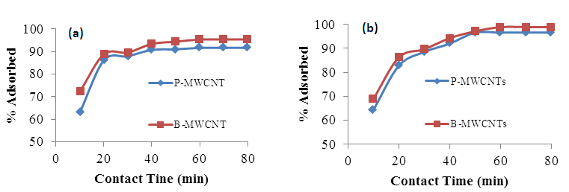

Figure 6: Effect of contact time on the percentage removal of (a) Cyanide and (b) Phenol onto MWCNTs and B-MWCNTs nanoadsorbent.

From Figure 6, the adsorption process was found to be swift at the initial stage. The rapid increase in the percentage adsorbed could be as a result of higher driving forces between the adsorbent and the sorbate. This was followed with a reduced adsorption percentage until equilibrium was attained at 60 minutes for the PMWCNTs and B-MWCNTs nanoadsorbents. At a period above the equilibrium point for both the cyanide and phenol adsorption, a smooth and nearly straight line curves were observed which indicates a saturation point. This finding is in agreement with the report of Saliihi et al., (2015). Furthermore, the percentage adsorbed on to the MWCNTs adsorbent increases from 61.95 to 94.534 % and from 68.97 to 97.85 % for cyanide and phenol respectively as shown in Figure 6 (a-b). The variation in the percentage adsorbed for each pollutant could be linked to the variation in their diffusion efficiency. There was a noticeable improvement in the percentage cyanide and phenol adsorbed when the adsorbent was doped with boron. The percentage adsorbed was found to increase from 72.22 to 95.97 % and from 68.97 to 98.74 % for both the cyanide and phenol respectively.

The effect of adsorbent dosage on the phenol and cyanide sorption was determined and the result is as presented in Figure 7.

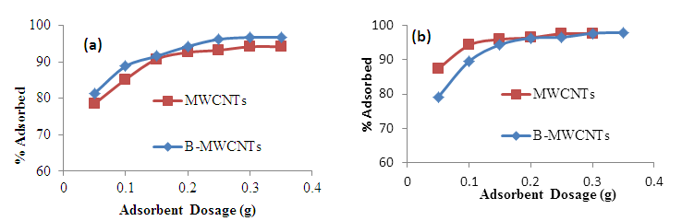
Figure 7: Effects of adsorbent dosage on the percentage removal of (a) Cyanide and (b) Phenol onto MWCNTs and B-MWCNTs nanoadsorbent.

From Figure 7 (a-b), the percentage removal of cyanide and phenol on to the purified MWCNTs increases from 78.49 to 94.15 % and from 76.75 to 97.57 % respectively while the adsorbent dosage was varied from 0.05 to 0.35 g. The appreciation in the percentage cyanide and phenol removal could be due to the present of increased active sites which aid adsorption process while the quantity of the adsorbent was increased. As the adsorbent dosage increases, the particles of the

adsorbent available for adsorption process also increases due to provision of available exchangeable sites for more molecular attachment to the surfaces and the pores of the adsorbent. The same observations were noticeable when the adsorption was carried out with B-MWCNTs nanoadsorbent. Furthermore, at 0.35 g adsorbent dosage, the adsorption process attained a plateau; a point where the increment in the adsorbent dosage has no positive impact on the adsorption efficiency. At this point, the percentage adsorbed becomes constant this is in accordance with the report of Kilic et al., (2011).

The effect of temperature on the removal efficiency of the developed adsorbents for the removal of cyanide and phenol were investigated and the result is as shown in Figure 8 (a-b).

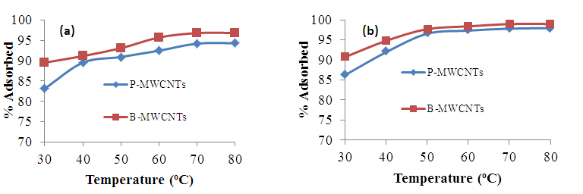
Figure 8: Effects of adsorbent dosage on the percentage removal of (a) Cyanide and (b) Phenol onto MWCNTs and B-MWCNTs nanoadsorbent.

As depicted in Figure 8 (a-b), an increase in temperature from 30 to 60 ºC resulted to an increase in the percentage of cyanide and phenol removal for both the P-MWCNT and B-MWCNTs adsorbents. This could be attributed to a possible increase in the inner pores of the adsorbents to encompass more sorbates than it could have removed at room temperature. For cyanide, the percentage removal increases from 83.148 to 94.231 %, and 89.573 to 96.844 % for P-MWCNTs and B-MWCNTs nanoadsorbents respectively while that of phenol also increased from 86.207 to 97.816 % and 90.713 to 98.966 % for P-MWCNTs and B-MWCNTs nanoadsorbents respectively.

4 CONCLUSION

Aligned and concentric multi-walled carbon nanotubes doped with boron was successfully developed. The HR-TEM micrograph images revealed the nano-size nature of the developed material with the inner and outer diameters of 22.19 and 33.02 nm respectively. The result of the simultaneous sorption of phenol and cyanide indicate that the optimum adsorption of 98.97 % and 96.84 % were observed at the residence time of 60 min, adsorbent dosage of 0.3 g and temperature of 60 ºC for B-MWCNTs adsorbent respectively. Thus, the developed boron doped MWCNTs nanoadsorbent depicts excellent sorption properties for the removal of phenol and cyanide from refinery wastewater.

ACKNOWLEDGEMENT
The financial support from the senate research based fund of Federal University of Technology, Minna with grant number (SENATE/FUTMINNA/2015/06) is much
appreciated. Support received for the use of facilities at Centre for Genetic Engineering and Biotechnology, CGEB, Federal University of Technology, Minna, Nigeria is also acknowledged.

REFERENCES

Aliyu A, Abdulkareem A. S, Kovo A. S, Abubakre O. K, Tijani J. O and Kariim I. (2017). Synthesis of Multi-walled Carbon Nanotubes Via Catalystic Chemical Vapour Deposition Method on Fe-Ni Bimetallic Catalyst Supported on Kaolin. Carbon letters, 21, 33-50.

Ayala P., Arenal R., Ru¨mmeli M, Rubio A and Pitcler T. (2010). The doping of carbon nanotubes with nitrogen and their potential applications, Carbon 48, 575 – 586.

Blackburn J. L., Yan Y., Engtrakul C., Parilla P.A., Jone K., Gennett T., Dillion C and Heben M. (2006). Synthesis and characterization of Boron doped Single-Walled Carbon Nanotubes Produced by the Lesser Vaporization Technique. Chemistry of Materials, 18, 234-240.

Cataldo, S., Gianguzza, A., Milea, D., Muratore, N. and Pettignano, A., (2016). Pb(II) adsorption by a novel activated carbon- alginate composite material. A kinetic and equilibrium study, International Journal of Biological Macromolecule, 92, 769-778.

Chen W., Duan L. and Zhu D Q. (2007). Adsorption of polar and nonpolar organic
chemicals to carbon nanotubes. Environmental Science and Technology, 41(24),
8295-8300.

Chen Y, Zhang, Y Q, Zhang T. H, Gan, C. H, Zheng C. Y, and Yu, G. (2006). Carbon Nanotube Reinforced Hydroxyapatite Composite Coatings Produced Through Laser Surface Alloying, Carbon, 44,37-45.

Christopher A D. and James M.T. (2004). Covalent functionalization of single-walled carbon nanotubes for materials applications. The journal of physical chemistry A, 108 (51), 11151-11159.

Francesca M T. (2009). Covalently functionalized carbon nanotubes and their biological applications, Thesis submitted for the degree of Doctor of Philosophy, Scuola Internazionale Superiore di studi Avanzati, International School for Advanced studies. 1-141.

Gong X., Liu J., Baskaran S., Voise R D. and Young J S. (2000). Surfactant-Assisted Processing of Carbon Nanotube/Polymer Composites. Chem. Mater. 12 (4), 1049-1052.
Ilaboya, I., Oti, E., Ekon, G. and Umukoro, L. (2013). Performance of Activated carbon from cassava peels for the treatment of effluent wastewater. Iranica Journal of Energy and Environment 4(4), 361-371.

Kariim I., Abdulkareem A S., Abubakre O K, Mohammed I A., Bankole M T. and Tijani J. O. (2015). Studies on the Suitability of Alumina as Bimetallic Catalyst Support for MWCNTs Growth in a CVD Reactor. International Engineering Conference (IEC2015). Book of proceeding, 296-305.

Kilic, M., Apaydin-Varol, E. and Putun, A.E. (2011). Adsorptive removal of phe¬nol from aqueous solutions on activated carbon prepared from tobacco residues: equilibrium, kinetics and thermodynamics. J Hazard Mater, 189(1-2), 397–403.

Klumpp C., Kostarelos K., Prato M. and Bianco A. (2006). Functionalized carbon nanotubes as emerging nanovectors for the delivery of therapeutics. Biochim. Biophys. Acta, (BBA) - Biomembranes 1758, (3), 404-412.

Saliihi, F., Mohammed, K.R., Mohammed, H.I., Nasiru, A. and Hammed, A. (2015). Biomass as low cost Adsorbents for removal of heavy metals from aqueous solution-A review of some selected Biomass, 2, 1-8.

