CHAPTER 12: ON THE NEED FOR LAND USE PLANNING AND GOVERNANCE IN SULEJA NIGER STATE, NIGERIA. WHAT IT IS AND WHAT IT OUGHT TO BE
¹MORENIKEJI Gbenga. Estate Management and Valuation Department, Federal University of Technology, Minna, Nigeria. https://orcid.org/0000-0003-4355-7290
²ADELEYE, Bamiji. Urban and Regional Planning Department, Federal University of Technology, Minna, Nigeria: https://orcid.org/0000-0001-7442-5682
³ADESINA, Ekundayo A., Surveying and Geoinformatics Department, Federal University of Technology, Minna, Nigeria: https://orcid.org/0000-0001-9526-4540
⁴ ODUMOSU, Joseph O., Surveying and Geoinformatics Department, Federal University of Technology, Minna, Nigeria: https://orcid.org/0000-0003-1604-4924
Contact: gbenga.morenikeji@futminna.edu.ng. +2347036411810
Abstract
Suleja has been witnessing rapid developmental changes in terms of physical landscape, city growth and urban sprawl since the movement of the Federal Capital Territory in 1991. This study examines the dynamics of urban growth, land consumption rate and forecast the future land risk in Suleja. The data source for the research was the documented materials as historical records and topographic map of Suleja which was collected from the Ministry of Lands and Survey, Minna, Niger State, Nigeria, Satellite imagery of the study (Enhance Thematic Mapper (ETM) 2000, 2005, 2010 and 2018) over a period of 18 years was analyzed to determine Land consumption trends. Thus, it was observed that Suleja population is growing steadily, the available land for both vegetation and built up are being consumed gradually and grown at 16% in 2018 while built-up at 13.6%. This research proposed that to maintain sustainable land management, valuable plots on the major and strategic locations has to be redesigned for ‘fit-for purpose’, immediately update of the existing master plan and adoption of computerized land records (GIS) for proper land registration and titling in the Suleja be provided.

Keywords: Urbanization, Land use Planning and Governance, Land Consumption, Remote Sensing

1.0 Introduction
System of land governance should behold land as a natural resource that must be sustainably developed and used. Land managers and administrators must operate within specific technical framework as land governance is concerned with social, legal, cultural and economic entity (Otubu, 2018). Land planning and governance is not negotiable amidst the population explosions at both urban and peri-urban areas. Lack of strategic planning or implementation of plans by the constituted authorities especially in the sub-Saharan Africa including Nigeria exacerbates various land issues. The problem of population growth is linked with urbanization that has created many negative effects on the urban and peri-urban land though the effect varies within communities. In response of the passive government to solve the issues of unplanned use and growing misuse of land in Nigerian cities, a number of laws and policies were formulated by the Nigerian government which is applicable to all levels as the case may be. These laws include Land Use Act of 1978, Urban Development Policy of 1992, Urban and Regional Planning Decree of 1992, and Housing and Urban Development Policy of 2002. It is sad to note that despite the enactment of these laws and policies, the anarchic system of land use activities still exists in Nigerian cities (Yahyaha and Ishiak, 2013). These call for strategic synergy among all actors in land planning and development towards sustainable land governance.
Land in Suleja is becoming scarce due to high demand and immense settlements expansion as a result of population influx to Suleja due to its strategic location. Suleja is experiencing expansion, growth and developmental activities due to its proximity to Abuja the Federal Capital Territory (FCT) of Nigeria. The movement of the FCT from Lagos in 1991 to Abuja had contributed to the massive movement of people from other parts of the country to settle in Suleja and also high cost of accommodation within the Abuja City that many low and middle income earners could not afford. Another factor responsible for the influx of men and women into Suleja was the demolition of illegal structures within the FCT and people from the North-Eastern part of the Nigeria who left their state due to activities of insurgents.
Suleja is about 20km North of Abuja the Federal Capital of Nigeria and about 100km North East of Minna the State Capital of Niger State (Buba, et al., 2013). Suleja has about ten (10) Wards within the Local Government Area. The existing land use of the study area includes residential, commercial, recreational, Industrial, educational and probably minute Agricultural land uses. These land use types create spatial imbalance due to human needs. The ethnic culture of the people in Suleja has influenced the types, pattern and design of housing construction.
Over the years, there have been signs of environmental stress such as loss of vegetation and valuable land, erection of substandard and illegal houses, overcrowding, unplanned settlement and slums with unpleasant living environment due to rapid population increase and migration leading to settlement growth with people competing for limited available land and other resources which could lead to an indelible damage to the study area. The concern of this work is centered on how to harmonize population pressure, urbanization and gradual loss of valuable land in Suleja.
Against this background, there is the need to clearly understand the relationship between population growth within urban areas and effect on peri- urban areas. In the light of the above, this study set to examine the dynamics of urban growth in relation to land consumption and also to forecast the future land risk in Suleja for sustainable planning and governance system.
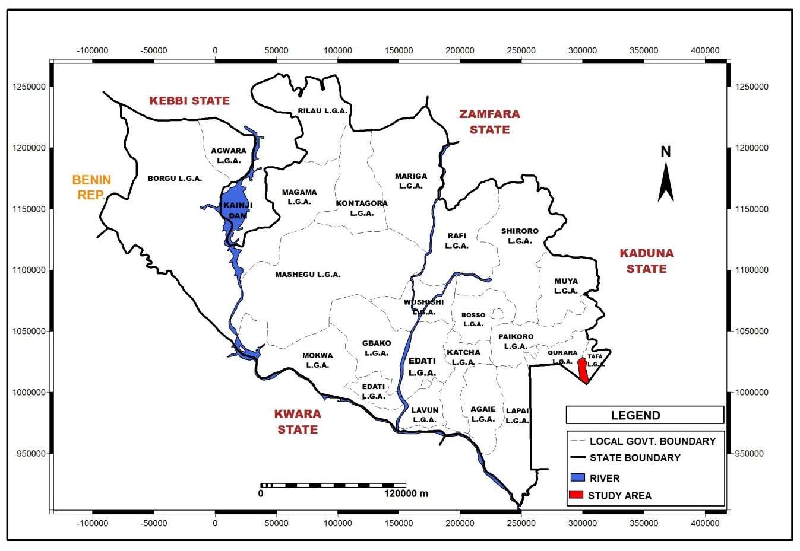
Figure 1: Map of the study area
Source: Department of Urban and Regional Planning, Federal University of Technology, Minna, (2018)

2.0 Literature Review
2.1 Land Use Planning
All around Africa and the world at large, land use impacts, occupation, allocations land rights are changing, the impact of these changes include increasing land scarcity, rapid urbanization and growing hazards which put larger numbers of people at risk, (de Vries, 2018). Land use planning in the modern world, why is it important? Land use Planning is regarded as one of the most sensitive issues across countries, it is politically connected as it affects people’s livelihoods and community’s essential needs, (Chigbu, Haub, Mabikke, Antonio, & Espinoza, 2016). Planning and governance in land use is inevitable. Land use is connected with individual wellbeing and also a support to environmental sustainability, to country’s economic growth and social inclusion (OECD, 2017). However, if that is what land use does, then it has to be planned. In planning, allocating available land resources to different land activities such as agricultural, residential, industrial must be judiciously planed, (Haseeb, 2018).
2.2 Need for Land Governance
Land governance is the process by which decisions are made regarding the access to and use of land, the manner in which those decisions are implemented and the way that conflicting interests are reconciled. (Global Tool Network). According to Hernandez (2017), lack of reliable land information for land use planning, zoning and administration is lacking in most countries. This lack has created negative effects on urban planning and design, infrastructure and socio-economic development. There is therefore need for urgent land governance as pressures keep mounting on land due to factors like rapid urbanization, growing population economic development, food insecurity, water and energy shortage, and the effects of conflicts and disasters.
2.3 Responsible Land Management
To attain a responsible land management in rural or Peri-urban areas, land has to portray some characteristics, such as, responsive, respected, reliable, robust, reflexive and recognizable, (de Vries & Chigbu, 2017). In view of that, a better understanding of the interrelationships and coordination mechanisms in linking ecological, social, cultural, political and economic dimensions by all stakeholders from local to national levels is important. Joint action at the community level towards participatory planning approaches will serve as tool for the sustainability of land development efforts, (Chigbu, 2013). Similarly, in developing Peri-urban areas, preconditions like Peri-urban planning, visioning, improving accessibility of growth centers, citizen’ participation, decentralization of responsibilities and local governance are to be the focus of the local, state and national government, (Magel, 2015).
2.4 Land Use Land Cover
The study of land use/land cover (LULC) has become an increasingly important especially when it comes to monitoring urban dynamics and land consumption rate. Mohajane et al, 2018), described land use/land cover (LULC) changes as one of the most important applications of Earth Observation (EO) satellite sensor data, one of its main function is that it provides a comprehensive and good understanding of ecosystem monitoring, and responses to environmental factors. In the same vein, remote sensing techniques have also been recognized as a powerful means to obtain information on Earth’s surface features at different spatial and temporal scales. It was used to assess the rate of urban expansion and loss of vegetation in Akure North and South Local Government Areas of Ondo State of Nigeria, the study utilized multi-temporal and multi-source satellite imageries of Landsat data for 1991, 2002 and 2016.The study concluded that substantial land use/land cover (LULC) changes have taken place and the built-up land and agricultural land have continued to expand over the study period; while the forest land, bare rock and water body have decreased. It was noted that the development of the urban built-up areas has resulted into reduction of the land under agriculture and other natural vegetation. The study recommended that monitoring of LULC through remote sensing and GIS should be institutionalized at local and state levels in order to provide co-ordination in environmental monitoring at all levels.
3.0 Methodology
3.1 Data collection
The study utilized data from secondary sources. The secondary data for the research was the documented materials such as population and annual growth rate (National Population Commission, NPC, 2006), historical records and topographic map of the study area which was collected from the Ministry of Lands and Survey, Minna, Niger State. Hence, the Satellite imagery of the study (Enhance Thematic Mapper (ETM) 2000, 2005, 2010 and 2018) over a period of 18 years were obtained from the National Remote Sensing Centre, Jos, Plateau State, Nigeria and analysed to determine Land consumption trends. To determine the population figure for the 2000 and 2005, the population figure of 1991, 108,561by the National Population Commission was projected to obtain years 2000 and 2005 figures.

Table 1: Land-use and land-cover classification scheme (Authors classification, 2019)
S/N | Classification | Description
1 | Built-up area | All residential, commercial and industrial areas, village settlement and transportation infrastructure.
2 | Bare Surface | Cropland and pasture, Orchards, groves, vineyards, nurseries, and ornamental, horticultural areas, Confirmed feeding operations.
3 | Vegetation | Trees, shrub land and semi nature vegetation, deciduous, coniferous and mixed forests, palms, orchids, herbs, gardens and grasslands.

3.2 Image processing techniques (classification)
The bands 3, 2, 1 satellite imagery was used to form the false colour composite for the study. On the bands 3, 2, 1, false colour composite, vegetation appears as red, built-up areas appear in cyan colour, and bare surfaces/degraded lands appears in white colour. The area of interest (Suleja) was clipped out from the four Satellite imageries (2000, 2005, 2010 and 2018) acquired and sample sets (built-up areas, vegetation and bare surfaces) were created for the respective years under study. A sample set stores locations of sampled pixels and the assigned class names. The sample sets created were then subjected to a supervised maximum likelihood classification on ILWIS 3.3 Academic software for the four satellite imageries used.
3.3 Overlay process
Image overlay operation is the geospatial process or procedure prior to the determination of spatial topological relationships. The aim of an image overlay operation is to determine “what spatial feature is on top of what”. An overlay operation is much more than mere merging of points, lines and polygonal features but it involves all the attributes of the features taking part in the overlay operations. For this study, the feature overlay analysis was carried out. In carrying out the feature overlay analysis, all the classified imageries were transformed from raster to polygon using ILWIS 3.3 Academic. The polygons for built-up areas were created on each of the four satellite imageries classified (2000, 2005, 2010 and 2018) the layers of the polygons were overlaid with the polygon of built-up area 2018 serving as the base year (See figure 2). The overlay of the built-up area shows how urban developments within Suleja has displaced/encroached other land uses/land cover.
4.0 Results
4.1 Examination of the dynamics of urban growth in Suleja Local Government Area
A population figure of 144,149 and 169,154 was obtained for the years 2000 and 2005 respectively. While the 2006 population figure for Suleja (216,578) was used for the projection of the population figure of the year 2010 and 2018. A population figure of 245,599 and 315,987 were computed for years 2010 and 2018. The population figure of the years under study was calculated by Equation (1): Pt =Po (1+r/100) n (1)
Po= the population figure for 1991i.e. 108,561
Pt = projected population
r =annual growth rate (3.2) of Suleja
n = time lag between the base year and the target year
Figure 2 shows that there was a percentage increase of 17% in the population of Suleja between 2000 and 2005, between 2005 and 2010 there was 45% increase while between 2010 and 2018 there was percentage increase of 29% in the population figure. The percentage increase was calculated by subtracting the previous population from the original or current population then; the totals was divided by the previous population and multiply by 100.
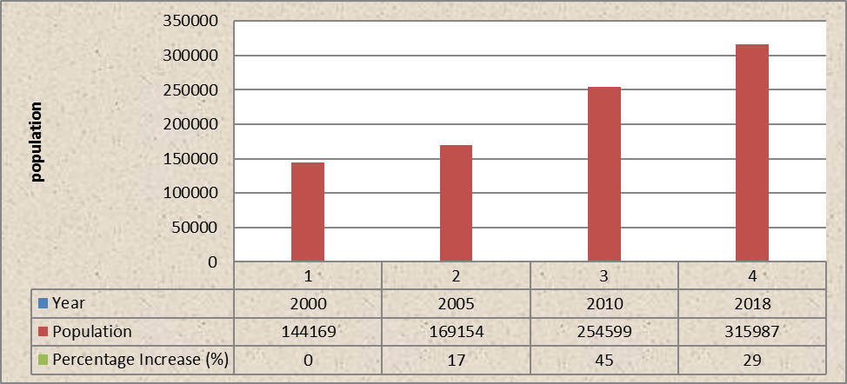
Figure 2: Percentage Increase in Population in Suleja between 2000 and 2018 (Authors Computation, 2018)

4.2 Examination of land consumption rates in Suleja
4.2.1 Change in land cover of Suleja between 2000 and 2018
Figure 3 shows the land cover of Suleja in the Year 2000. The bare surface covered land area of 9.23km2 (4.4%). Built-up area and vegetation covered 16.32km2(7.7%) and 186.08km2 (87.92%) respectively.
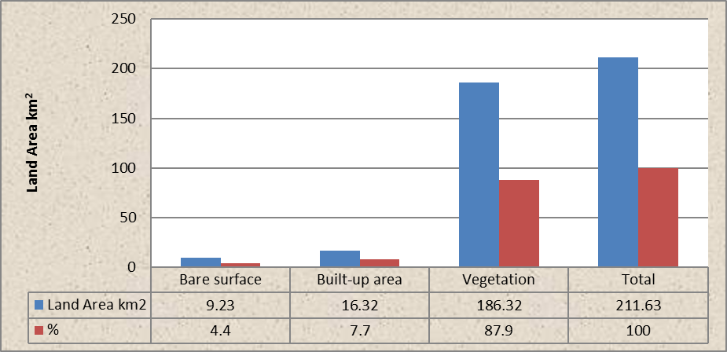
Figure 3: Land Cover of Suleja in 2000 (Authors Computation, 2018)
Figure 4 shows the land cover of Suleja in the year 2005. In the year 2005 there was a significant change in the land cover of Suleja. Also, it revealed that bare surface covers a land area of 5.37km2. Built-up area and vegetation covers 21.87km2 and 184.85km2 respectively.
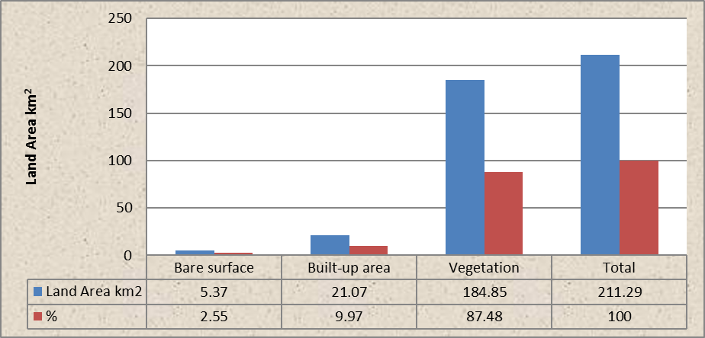
Figure 4: Land Cover of Suleja in 2005 (Authors Computation, 2018)
Figure 5 revealed the land cover of Suleja in the year 2010; however, it shows that bare surface covers a land area of 0.27km². Built-up area covers 27.10km² and vegetation covers 184.0km².

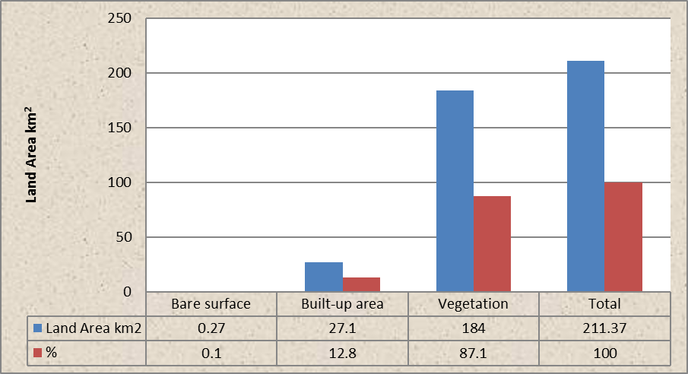
Figure 5: Land Cover of Suleja in 2010 (Authors Computation, 2018)
Figure 6 shows the extent of land cover of Suleja in the year 2018. Bare surface covers land area of 1.72km2; Built-up area covers 45.74km2and vegetation covers 289.4km2.
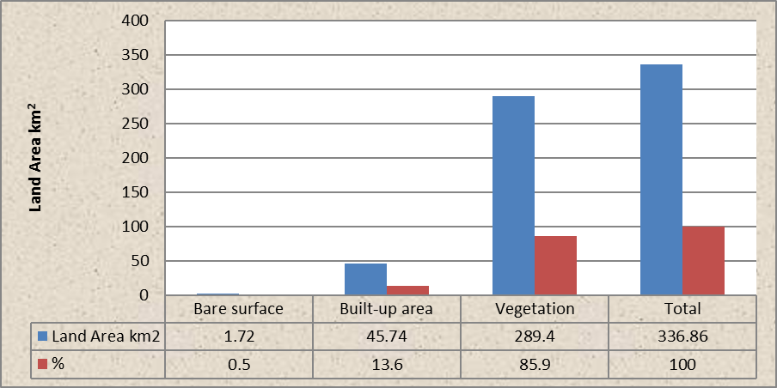
Figure 6: Land Cover of Suleja in 2018 ((Authors Computation, 2018)

4.3 Magnitude of change between years 2000 to 2005
In Table 2, the magnitude of change in Suleja (C) between the year 2000 and 2005 was gotten by subtracting the annual land use frequency A from B (Land use in 2000 from 2005). The annual frequency of change (D) is derived at by dividing the magnitude of change of each land use by 5 years (reference year). The percentages of change (E) were calculated by dividing the magnitude of change of each land use by A and multiply by 100. Table 2 shows Built-up has been growing at 0.95km2 yearly and Bare Surface has suffered a loss of -0.77km2 yearly.
Table 2: Magnitude and percentage of change in land cover between 2000 and 2005
(Authors Computation, 2018)
CLASSES | A 2000 | B 2005 | C MAGNITUDE OF CHANGE (B – A) | D ANNUAL FREQUENCY OF CHANGE C/5 | E PERCENTAGE OF CHANGE C/A * 1OO
Bare Surface | 9.23 | 5.37 | -3.86 | -0.77 | -41.82
Built-up Area | 16.32 | 21.07 | 4.75 | 0.95 | 29.11
Vegetation | 186.08 | 184.85 | -1.23 | -0.25 | -0.66
Total | 211.63 | 211.29 | -0.34 | 0.70 | -13.37

(Authors Computation, 2018)
4.4 Magnitude of change between years 2005 to 2010
In Table 3, the magnitude of change in Suleja (C) between 2005 and 2010 was arrived at by subtracting A from B (Land use in 2005 from 2010). The annual frequency of change (D) was arrived at by dividing the magnitude of change of each land use by 5 years (reference year). The percentages of change (E) were calculated by dividing the magnitude of change of each land use by A and multiply by 100. The table 3 shows Built-up has been growing at 1.21km2 yearly and Bare Surface growing at 1.02km2 yearly.
Table 3: Magnitude and percentage of change in land cover between 2005 and 2010
(Authors Computation, 2018

CLASSES | A  2005 | B  2010 | C  MAGNITUDE OF CHANGE (B – A) | D ANNUAL FREQUENCY OF CHANGE C/5 | E PERCENTAGE OF CHANGE C/A * 1OO
Bare Surface | 5.37 | 0.27 | -5.1 | 1.02 | 95.0
Built-up Area | 21.07 | 27.10 | 6.03 | 1.21 | 28.62
Vegetation | 184.85 | 184.00 | -0.85 | -0.17 | 0.50
Total | 211.29 | 211.37 | 0.08 | 2.06 | 124.12

(Authors Computation, 2018
4.5 Magnitude of change between years 2010 to 2018
In Table 4, the magnitude of change in Suleja (C) between 2010 and 2018 was calculated by subtracting A from B (Land use in 2010 from 2018). The annual frequency of change (D) was derived at by dividing the magnitude of change of each land use by 8 years (reference year). The percentages of change (E) were calculated by dividing the magnitude of change of each land use by A and multiply by 100. The table shows Built-up has been growing at 2.33km2 yearly but Bare Surface reduce at 0.18km2 yearly compare to 2005 and 2010.
Table 4: Magnitude and percentage of change in land cover between 2010 and 2018
(Authors Computation, 2018)

CLASSES | A  2010 | B  2018 | C  MAGNITUDE OF CHANGE (B – A) | D ANNUAL FREQUENCY OF CHANGE C/8 | E PERCENTAGE OF CHANGE C/A * 1OO
Bare Surface | 0.27 | 1.72 | 1.45 | 0.18 | 537.03
Built-up Area | 27.10 | 45.74 | 18.64 | 2.33 | 68.78
Vegetation | 184.00 | 289.4 | 105.4 | 13.175 | 57.28
Total | 211.37 | 211.37 | 125.50 | 15.70 | 663.1

(Authors Computation, 2018)

4.6 Land use pattern/cover of Suleja
Figure 10 shows the image characteristics of Suleja for the year 2000. The grey colour represents bare surface areas which covered 9.23km2 (4.4%). Built-up area represented by red is 16.32km2 (7.7%). Vegetation represented by green colour has a total area of 186.08km2 (87.92%). Figure 2 shows the image characteristics of Suleja in 2005. Bare surface area represented by grey colour has an area of 5.37km2 (2.5%). Built-up area in red covers an area of 21.07km2 (10%) and vegetation represented in green has an area of 184.85km2 (87.5%).
Hence, figure 2 depicts the spread of Suleja in 2010; the grey colour shows bare surface covering an area of 0.27km2 (0.1%). Built-up area in red covers an area of 27.10km2 (12.8%). Vegetation with an area of 184.00km2 (87.1%) was represented in green and Figure 2 also shows the spread of Suleja in 2018; the grey colour depicts bare surface covering an area of 1.72km2 (0.5%). Built-up area in red covers an area of 45.74km2 (13.6%). Vegetation with an area of 289.4km2 (85.9%) is represented in green.
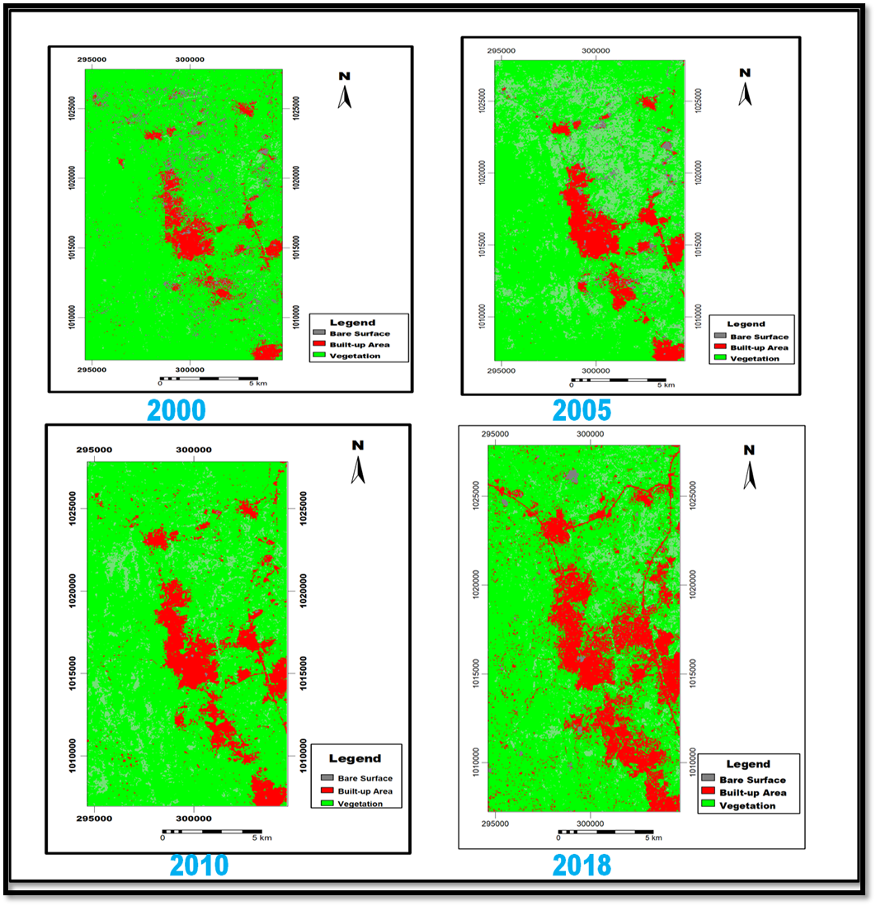
Figure 10: Suleja satellite image of year 2000-2018
4.7 Forecasting the future land risk in Suleja
Figure 11 shows that Suleja is growing toward south-east of the city which is the main express road linking Federal Capital Territory of Nigeria. Many scholars have identified failure to evolve master plan provision, general lack of development control, environmentally inconvenience, debilitating state of disorder, chaos, and high crime rate, massive backlog of infrastructure neglect and shortage of qualitative housing dwellings as part of Suleja problem emanating from incessant growth, these problems will double in 10 years’ time. Economic situation of the country has force more people to leave Federal Capital Territory Abuja of Nigeria to search for cheaper accommodation and cheaper life that is available in the study area. Likewise, people along this axis are vulnerable to flooding and epidemics.
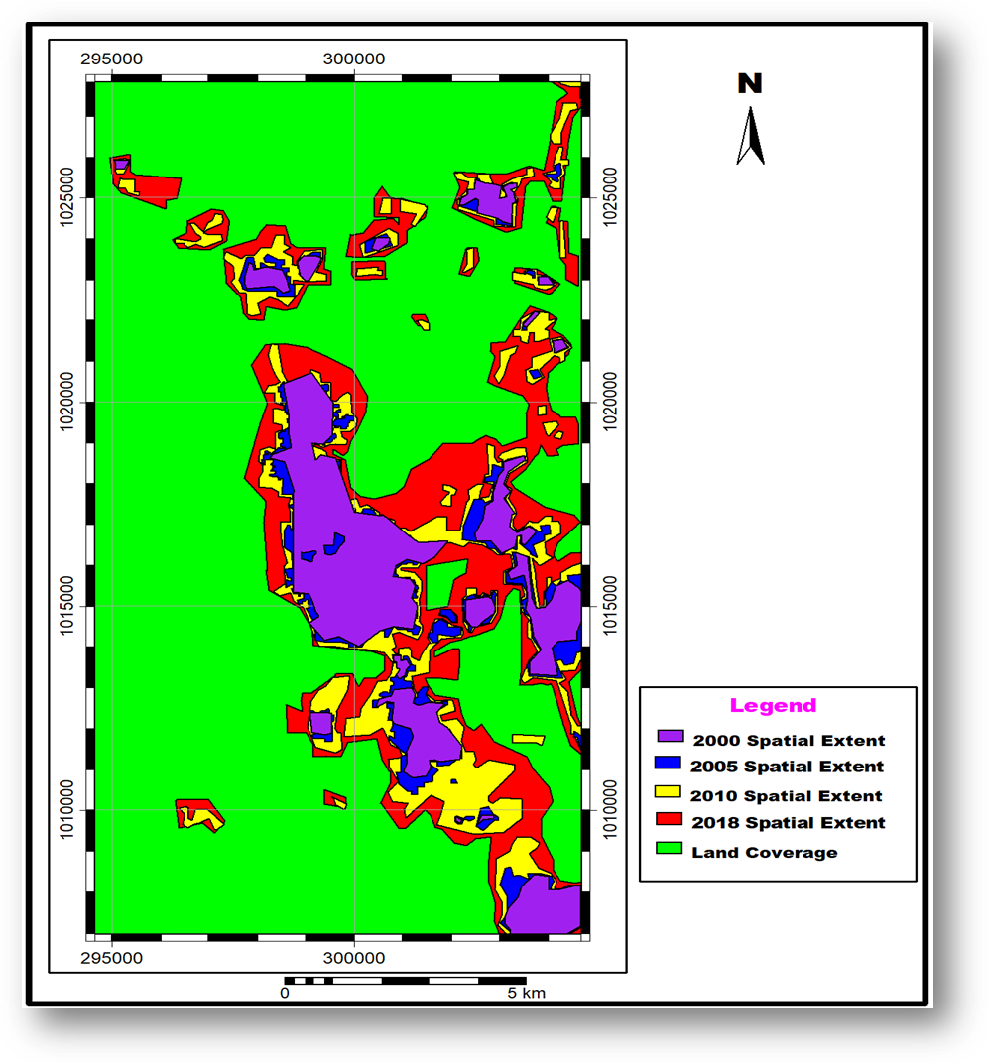
Figure 11: Overlay image of Suleja from 2000 to 2018
5.0 Conclusion
This study has shown the pattern and direction of growth of Suleja between year 2000 and 2018 using remote sensing and GIS tools. The results show that the city is growing at a rapid rate, there was a percentage increase of 17% in the population of Suleja between 2000 and 2005, between 2005 and 2010 there was 45% increase while between 2010 and 2018 there was percentage increase of 29%. The population figure also growing towards South-Eastern directions majorly along the main transportation routes, (See Figure 11). The growth pattern is largely influenced by factors such as low rent and cheap household commodities. The growth in Suleja as observed from the prediction may lead to high cost of housing, decline in agricultural lands, high cost of living, chronic slum generation, increased crime rate pattern and by extension high rate of unemployment.
In the next 10 to 15 years, many more areas not fit for habitation will be occupied, and many more will lose land rights through demolition as they continue to build towards FCT.
5.1 Recommendations
Based on this research, the following recommendations were made:
1. The research suggests that valuable plots of land on the major and strategic location be redesigned as fit-for purpose so as to regulate and stop leapfrog development,
2. State Government should partner with the National Centre for Remote Sensing and the Federal University of Technology, Minna for the training and capacity building of the staff of the Niger State Urban Development Board.
3. Immediate update of the existing master plan and adoption of computerized land records (GIS) for proper land registration and titling in the Suleja should commence.
Reference

Alemu, M. (2016) Sustainable Land Management. Journal of Environmental Protection, 7, 502- 506. doi: 10.4236/jep.2016.74045.

Buba Y. A, Makwin U. G &Ogalla M, (2016). Urban Growth and Landuse Cover Change in Nigeria Using GIS and Remote Sensing Applications. Case Study of Suleja L.G.A., Niger State. International Journal of Engineering Research & Technology (IJERT).5(8).

Chigbu, U. E., Haub, O., Mabikke, S., Antonio, D., & Espinoza, J. (2016). Tenure Responsive Land Use Planning: A Guide for Country Level Implementation. UN-Habitat: Nairobi, Kenya.

de Vries, W. T. (2018). Potential of big data for pro-active participatory land use planning. Geoplanning: Journal of Geomatics and Planning, 5(2).

de Vries, W. T., & Chigbu, U. E. (2017). Responsible land Management-Concept and application in a territorial rural context.fub. Flächenmanagement und Bodenordnung.

Haseeb, J. (2018). Land Use Planning - Techniques, Classification & Objectives.
https://www.aboutcivil.org/land-use-planning.html on 03/02/2019.

Hernandez, (2017). Responsible Land Governance in Urban Areas. https://equalrights4womenworldwide.blogspot.com/2017/04/responsible-land- governance-in-urban.html)

Global Tool Network, Good Land Governance Policy Paper

Magel, H. (2015). Where is the rural territorial Development Going? Reflections on the theory and practice. Geomatics, Land management and Landscape, 1, 55–67

Mohajane, M., Essahlaoui, A., Oudija, F., El Hafyani, M., Hmaidi, A. E., El Ouali, A., &Teodoro, A. C. (2018). Land Use/Land Cover (LULC) Using Landsat Data Series (MSS, TM, ETM+ and OLI) in Azrou Forest, in the Central Middle Atlas of Morocco. Environments, 5(12), 131.

OECD, (2017). The Governance of Land Use; Policy Highlight. (February)
https://www.oecd.org/cfe/regional-policy/governance-of-land-use-policy-highlights.pdf.

Otubu, A. (2018). The land use act and land administration in 21st century Nigeria: need for reforms. Journal of Sustainable Development Law and Policy, 9(1), 80-108.

World Bank (2006). Sustainable Land Management: Challenges, Opportunities, and Trade-offs. Agriculture and Rural Development. Washington, DC: World Bank. https://openknowledge.worldbank.org/handle/10986/7132 License:

Yahyaha, O. Y., & Ishiak, Y. (2013). Effective urban Land use planning in Nigeria: Issues and Constraints. Journal of Environmental Management and Safety, 4(2), 103-114.

