ESTIMATION OF PARTICLE SIZE DISTRIBUTION IN CARBONIZED MUNICIPAL SOLID WASTE USING DYNAMIC LIGHT SCATTERING METHOD
Alhaji A. Yakatun¹, Olalekan D. Adeniyi^{2*}, Mary I. Adeniyi², Manase Auta², Aisha A. Faruk² and Mohammed Alhassan²
¹Chemical Engineering Department, Federal Polytechnic, PMB 55, Bida, Nigeria
²Chemical Engineering Department, Federal University of Technology, PMB 65, Minna, Nigeria
Lekanadeniyi625@futminna.edu.ng ^{2*}

Abstract
The study on the estimation of particle size distribution in carbonized municipal solid waste (MSW) using dynamic light scattering (DLS) method was investigated for different solid wastes. The selected MSW are dried grass, waste paper, melon shell, saw dust and sugarcane bagasse. The analysis was conducted at room temperature of 25ºC and 0.2µ/m filter unit was used in transferring the dispersed mixture into a plastic cuvette. The Z – average and poly disparity index (PDI) reveals homogeneity, which are 135.2 nm and 0.453 respectively. Carbonized MSW has potential application in carbon nanotubes industry as conductors of electricity, heat generation and fuel cells.
Key words: Estimation, Potential, Carbonized, MSW, PDI, PSD and DLS.

1. INTRODUCTION
Nanotechnology is finding applicability in the field of environmental protection and has great potential in improving air, water, and energy generation (USEPA, 2007). MSW provide a mean of generating nanoparticle carbon fuel which could be used in fuel cells and other technologies. These particle sizes are significant in the applications of these technologies. Engineered nanoparticles can efficiently reduce toxic metal emissions from combustion systems thereby improving air quality by suppressing metal vapor nucleation, promoting metal nanoparticle condensation and coagulation (Babayemi and Dauda, 2009). These applications are often determined by the properties of the nanomaterial, such as size, surface properties, crystal structures and morphologies (Ujam and Eboh, 2012).
The efficacy and subsequent success of a processing product is strongly dependent on its shelf life and its stability under targeted desired conditions. A typical manifestation of formulation instability is an increase in particle size, due to aggregation of the analyzed or carrier. As the particle size increases, efficacy is diminished, primarily due to the decrease in the active surface area. The correlation between efficacy and size, particle sizing is quickly becoming a routine step in the development of more stable and effective formulations (Yakatun, 2015). On the other hand, the particle sizes could greatly enhance electrochemical conversion in direct carbon fuel cell (Adeniyi et al., 2014; Adeniyi and Ewan, 2012).

Accurate determination of nanomaterial size is crucial for developing nanoscale technologies, because size governs many of the physical and chemical properties of these materials. For instance, a good photo catalyst needs a large catalytic surface area and the primary size of catalyst nanoparticles defines the surface area available for adsorption and
decomposition of organic pollutants (Sørum et al., 2001). In the adsorption and reaction of sulfur dioxide on photocatalytic titanium dioxide nanoparticles, the inherent adsorption capacity of the smaller nanoparticles has been found to be larger because of the greater saturated surface coverage of sulfite adsorbed on the particles .The adverse effects of these materials on human health has prompted research globally to assess the toxicity of the nanomaterial in areas such as metals, metal oxides, fullerenes, and carbon nanotubes (CNT) (Abdulkareem et al., 2007; Sørum et al., 2001).
The excellent electrochemical properties, such as rapid electron kinetics, semi- and superconducting electron transport, high tensile strength composites, and hollow core suitable for storing guest molecules, have attracted attention as an electrode material for electrochemical sensors. The synergetic effects of CNTs and conducting polymer improves the electrical and mechanical properties of polymers in order to develop high performance sensor (Adeniyi et al., 2014; Afolabi et al., 2012).
Nanoscale changes the physical properties of particles, notably by increasing the ratio of surface area to volume, and the emergence of quantum effects. High surface area is a critical factor in the performance of catalysis and structures such as

electrodes, allowing Improvement in performance of such technologies as fuel cell and batteries. The large surface area also results in useful interactions between the materials in nanocomposites, leading to special properties such as increased strength and/or increased chemical/heat resistance. The fact that nanoparticles have dimensions below the critical wavelength of light renders them transparent, an effect exploited in packaging, cosmetics and coatings (Abdulkareem et al., 2007).
2. METHODOLOGY
MSW was pyrolysed at 350ºC to produce solid carbon. The size analyses of selected MSW carbon were carrying out at the Federal University of Technology, Minna. Dynamic light scattering (DLS) was used. The analysis was conducted at room temperature of 25ºC. 1 mg of the sample was dispersed in 10 ml of distilled water to form a dispersion liquid. 0.2 µm filter unit was used in transferring the mixture into a plastic cuvette using a string. The cuvette was then placed in dynamic light scattering equipment for analysis.
3. RESULTS AND DISCUSSIONS
The result obtained are presented in Figures 1 to 5. Figure 1 shows particle size distribution (PSD) by percentage volume graph of carbonized dried grass with the peaks. The z-average and poly disparity index (PDI) are 135.2 nm and 0.453 respectively. The PSD with size number of peak 1 (44.65 nm) and peak 2 (5386 nm) corresponds to percentage volume of 98.5 and 1.5, The duration used was 60 s. Carbon nanotube springs have the potential to indefinitely

store elastic potential energy at ten times the density of lithium-ion batteries with flexible charge and discharge rates and extremely high cycling durability (Adeniyi and Ewan, 2012; Abdulkareem et al., 2007; Sørum et al., 2001).
Figure 2 shows PSD by percentage volume graph of carbonized melon shell with one peak. The z-average
and PDI are 400.6 and 0.411. The PSD with size number of peak 1 (300.3 nm) corresponds to percentage volume (100.0 %). The exceptional electrical and mechanical properties of carbon nanotubes have made them alternatives to the traditional electrical actuators for both microscopic and macroscopic applications. Carbon nanotubes are very good conductors of both electricity and heat, and they are also very strong and elastic molecules in certain directions (Adeniyi and Ewan, 2012; Abdulkareem et al., 2007; Sørum et al., 2001).
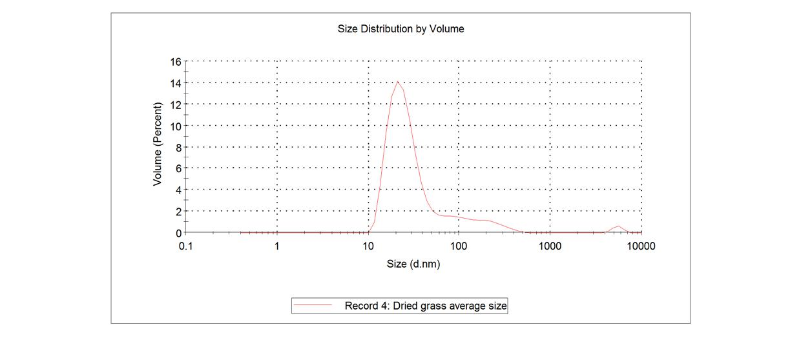
Fig.1: PSD of carbonized dried grass.
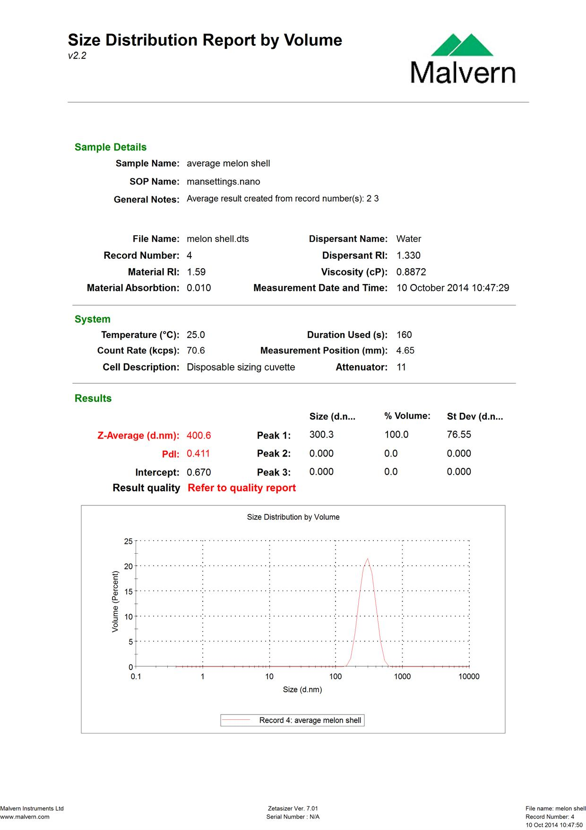
Fig.2: PSD of carbonized melon shell

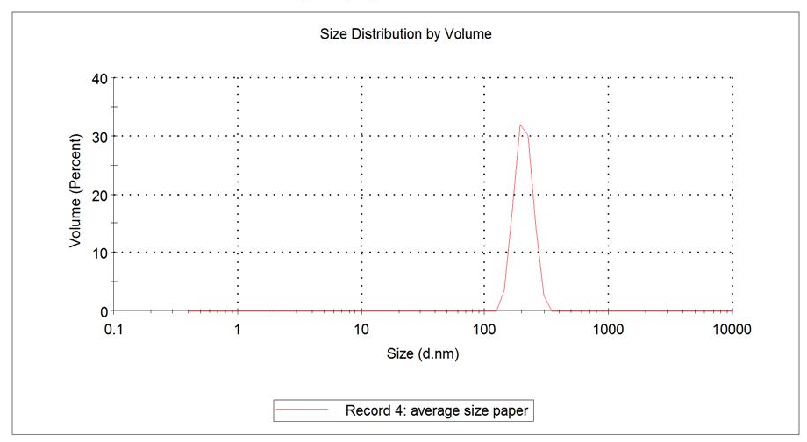
Fig.3: PSD of carbonized paper.
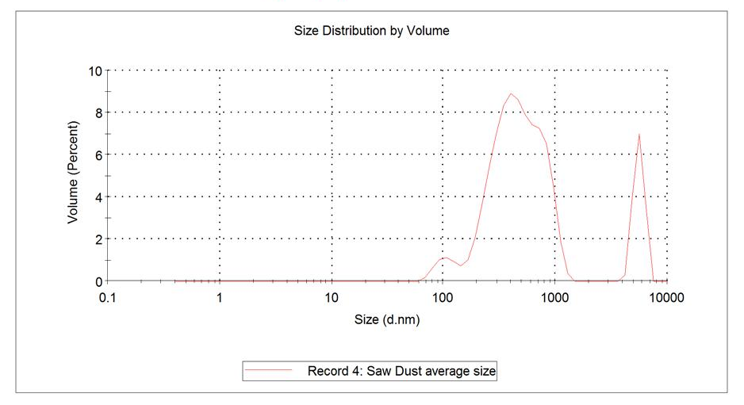
Fig.4: PSD of carbonized saw dust.

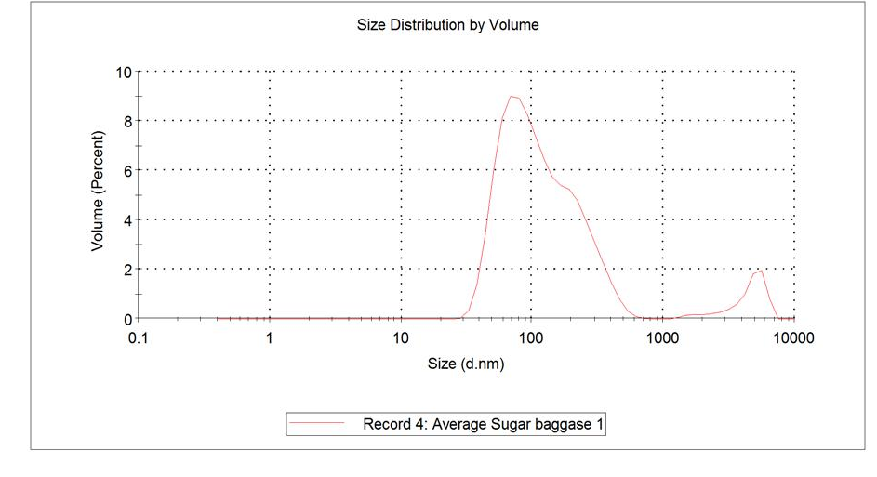
Fig.5: PSD of carbonized sugarcane bagasse.
Figure 3 shows the PSD of carbonized paper with one peak. The z-average and PDI are 1040 nm and 0.875. The PSD with size number of peak 1 (205.1 nm) corresponds to percentage volume (100.0 %). The duration used was 140 s. The carbon particle has potential applications in battery, direct carbon fuel cell, carbon assisted water electrolysis among others (Ewan and Adeniyi, 2013; Adeniyi and Ewan, 2012; Hackett et al., 2007; Cherepy et al., 2005; Hoogers, 2003).
Figure 4 shows the PSD of carbonized saw dust with three peaks. The z-average and PdI are 646.2 nm and 0.572. The PSD with size number of peak 1 (506.7 nm), peak 2 (106.3 nm) and peak 3 (5526 nm) which corresponds to percentage volume of 80.9, 4.6 and 14.5. Large structures of carbon nanotubes can be used for thermal management of electronic circuits. An approximately 1 mm–thick carbon nanotube layer was used as a special material to fabricate coolers, this material has very low density, ~20 times lower weight than a similar copper structure, while the cooling properties are similar for the two materials (Abdulkareem et al., 2007; Hoogers, 2003).

Figure 5 shows the PSD of carbonized sugarcane bagasse with three peaks. The z-average and PDI are 153.0 nm and 0.276. The PSD with size number of peak 1 (132.9 nm), peak 2 (1687 nm) and peak 3 (4691 nm) which corresponds to percentage volume of 92.4, 0.5 and 7.1. In addition to being able to store electrical energy, there has been some research in using carbon nanotubes to store hydrogen to be used as a fuel source. By taking advantage of the capillary effects of the small carbon nanotubes, it is possible to
condense gases in high density inside single-walled nanotubes. This allows for gases, most notably hydrogen (H₂), to be stored at high densities without being condensed into a liquid. Potentially, this storage method could be used on vehicles in place of gas fuel tanks for a hydrogen-powered car (Cherepy et al., 2005; Hackett et al., 2007; Hoogers, 2003).
4. CONCLUSION
The carbon particle morphology show that the high surface area and porosity enhanced storage capability of fuel cell. The particle size results also indicates potential application in nanocarbon tube for energy conversion and storage. The carbon particle has potential applications in battery, direct carbon fuel cell, carbon assisted water electrolysis. This would contribute in the abatement of environemtal degradation, renewable and susstainable energy generation for the future.
REFERENCES
Abdulkareem A. S., Afolabi .A.S., Iyuke S.E and
Piennar C. H vZ (2007): Synthesis of carbon nanotubes by swirled floating catalyst chemical vapour deposition reactor. Journal

of Nanoscience and Nanotechnology. American scientific publisher, 7 (9), 3233- 3238.
Adeniyi O.D. and Ewan B.C.R. (2012), Electrochemical conversion of switchgrass and poplar in molten carbonate direct carbon fuel cell, International Journal of Ambient Energy, Taylor & Francis Group LLC, London, U.K, 33:4, 204-208.
Adeniyi O.D., Ewan, B.C.R., Adeniyi M.I. and Abdulkadir M. (2014) The behaviour of biomass char in two direct carbon fuel cell designs, Journal of Energy Challenges & Mechanics (JECM), Aberdeen, Scotland, United Kingdom, Vol.1, Iss. 4, article 6, pp.1-6.
Afolabi A.S, Abdulkareem A.S, Iyuke S.E and Pienaar H.C.vZ (2012): Performance and Kinetics of Pt-CNT catalyst electrodes in a PEM fuel cell. Journal of material research. 27 (11), 1497-1505.
Babayemi, J.O., & Dauda, K.T. (2009). Evaluation of Solid Waste Generation, Categories and Disposal Options in Developing Countries: A Case Study of Nigeria. J. Applied. Sciences Environment Management: 13 : 83 -88.
Cherepy, N.J., R. Krueger, K.J. Fiet, A.F. Jankowski and J.F. Cooper (2005), “Direct conversion

of carbon fuels in a molten carbonate fuel cell”, J. Electrochemical Society, 152(1) : A80-A87.
Ewan B.C.R. and Adeniyi O.D. (2013), A demonstration of carbon assisted water electrolysis, Energies, Basel, Switzerland, 6 (3): 1657-1668.
Hackett, G.A., J.W. Zondlo and R. Svensson (2007), “Evaluation of carbon materials for use in a direct carbon fuel cell”, J Power Sources, 168:111-118.
Hoogers, G. 2003. Fuel Cell Technology Handbook. Florida,CRC Press LLC.
Sørum, L, Glarborg, P., Jensen, A., Skreiberg, Ø. and Dam-Johansen, K. (2001) “Formation of NO from Combustion of Volatiles from Municipal Solid Waste Components and Their Mixtures”, Comb. & Flame : 123:195- 212.
Ujam, A. J. and Eboh, F. (2012), Thermal analysis of a small-scale municipal solid waste-fired steam generator: Case study of Enugu state, Nigeria. Journal of Energy Technologies and policy. 2 (5) : 38-54.
Yakatun A.A. (2015), Evaluation of municipal solid waste for potential energy production, a case study of Bida metropolis, M.Eng. Thesis, Federal University of Technology, Minna, Nigeria

